Service Folder
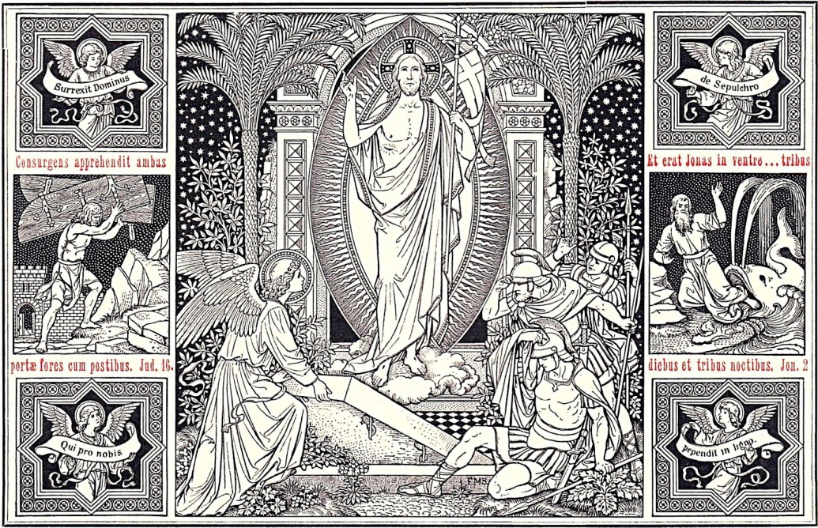
The Resurrection of Our Lord
April 16, 2017

Emmanuel Lutheran Church
4675 Bataan Memorial West
Las Cruces, New Mexico 88012
(575) 382-0220 (church office) / (575) 636-4988 (pastor cell)
www.GodWithUsLC.org pastor@godwithuslc.org

Sts. Peter & Paul Lutheran Mission
Silver City, New Mexico
www.peterandpaullutheran.org

Rev. Paul A. Rydecki, Pastor
member of the Evangelical Lutheran Diocese of North America (ELDoNA)

ANNOUNCEMENTS
Welcome! Emmanuel is a liturgical, traditional, historical, evangelical, catholic, orthodox, confessional Lutheran congregation, in fellowship with the Evangelical Lutheran Diocese of North America (ELDoNA). We believe that the Bible is the very Word of God, inspired and without any errors. We confess the truth of Scripture according to the Lutheran Book of Concord of 1580, without exception or reservation. We observe the calendar of the traditional Church Year and follow the Historic Lectionary. We celebrate the Divine Service (also known as the Mass) every Sunday and on other festivals, and we welcome visitors.
With regard to Holy Communion, we ask our visitors to respect our practice of closed Communion, which means that only communicant members of our congregation or of other congregations in communion with us are invited to commune at the Lord’s Table here, after they have been examined and absolved. Classes are offered throughout the year by the pastor so that those who are interested in joining our Communion fellowship have the opportunity to learn about the Christian faith and our confession of it.
The Order of Service is The Order of Holy Communion (page 15) from The Lutheran Hymnal (TLH). The entire service for today is printed in this Service Folder except for the hymns, which are sung from the red hymnal (TLH). The Scriptures are read from the New King James Version (NKJV).

EVENTS IN THE NEAR FUTURE…
Wed., Apr. 19 - Vespers, 6 PM
Sun., Apr. 23 - Bible class & Sunday School, 9 AM
- Divine Service 10:15 AM (Quasimodo Geniti)

The Order of the Holy Communion
HYMN TLH #199 - Jesus Christ Is Risen Today
Stand
THE CONFESSION OF SINS
Minister: In the name of the Father and of the T Son and of the Holy Ghost.
Minister: Beloved in the Lord: let us draw near with a true heart and confess our sins unto God our Father, beseeching Him in the name of our Lord Jesus Christ to grant us forgiveness. [Hebrews 10:22]
P Our help is in the name of the Lord, Psalm 124:8
P I said, I will confess my transgressions unto the Lord, Psalm 32:5
Congregation: O almighty God, merciful Father, I, a poor, miserable sinner, confess unto Thee all my sins and iniquities with which I have ever offended Thee and justly deserved Thy temporal and eternal punishment. But I am heartily sorry for them and sincerely repent of them, and I pray Thee of Thy boundless mercy and for the sake of the holy, innocent, bitter sufferings and death of Thy beloved Son, Jesus Christ, to be gracious and merciful to me, a poor, sinful being.
Minister: Upon this your confession, I, by virtue of my office, as a called and ordained servant of the Word, announce the grace of God unto all of you, and in the stead and by the command of my Lord Jesus Christ I forgive you all your sins in the name of the Father and of the T Son and of the Holy Ghost.

THE INTROIT
P (Antiphon) I have arisen, and I am still with You. Alle- | luia! *
You have laid Your hand upon me. | Alleluia!
Such knowledge is too wonderful | for me; *
It is high, I cannot attain it. Alleluia! | Alleluia!
C O Lord, You have searched me and | known me. *
You know my sitting down and | my rising up.
You comprehend my path and my ly- | ing down, *
And are acquainted | with all my ways.
If I ascend into heaven, You | are there; *
If I make my bed in hell, be- | hold, You are there.
Even there Your hand shall | lead me, *
And Your right | hand shall hold me.
P (Antiphon)
THE KYRIE
THE GLORIA IN EXCELSIS

THE SALUTATION and THE COLLECT FOR THE DAY
P The Lord be with you. 2 Timothy 4:22
P Let us pray.
The Minister says the Collect, concluding, “…one God, world without end.”
Sit. The Minister shall then read the Lessons from Holy Scripture.
THE EPISTLE 1 Corinthians 5:6-8
THE GRADUAL & HALLELUJAH Psalm 118:24, 1; 1 Corinthians 5:7b, 8a, c
P (sung) This is the day the Lord | has made; *
C We will rejoice and | be glad in it.
P Oh, give thanks to the Lord, for He | is good! *
C For His mercy en- | dures forever.
P Alleluia! Alleluia! Christ, our Passover, was sacrificed | for us. *
C Let us keep the feast with the unleavened bread of sincerity and truth. | Alleluia!
HYMN TLH #191 – Christ the Lord Is Risen Today; Alleluia
Stand
THE GOSPEL Mark 16:1-8
Minister: The Holy Gospel according to St. Mark chapter 16
After the reading:
Minister: The Gospel of the Lord.

THE NICENE CREED
I believe in one God, the Father Almighty, Maker of heaven and earth and of all things visible and invisible.
And in one Lord Jesus Christ, the only-begotten Son of God, begotten of His Father before all worlds, God of God, Light of Light, very God of very God, begotten, not made, Being of one substance with the Father, By whom all things were made; Who for us men and for our salvation came down from heaven and was incarnate by the Holy Ghost of the Virgin Mary and was made man; and was crucified also for us under Pontius Pilate. He suffered and was buried; And the third day He rose again according to the Scriptures; and ascended into heaven, and sitteth on the right hand of the Father. And He shall come again with glory to judge both the quick and the dead; whose kingdom shall have no end.
And I believe in the Holy Ghost, the Lord and Giver of Life, who proceedeth from the Father and the Son, who with the Father and the Son together is worshiped and glorified, who spake by the Prophets. And I believe one holy Christian and Apostolic Church. I acknowledge one Baptism for the remission of sins, and I look for the resurrection of the dead and the life of the world to come. Amen.
Sit
HYMN TLH #195 – Christ Jesus Lay in Death’s Strong Bands
THE SERMON
Stand after the sermon to sing:
HYMN TLH #189 – He Is Arisen! Glorious Word!
Sit
THE OFFERING
Stand
THE GENERAL PRAYER
Sit
HYMN TLH #192 - Awake, My Heart, with Gladness
Stand
THE PREFACE
P The Lord be with you. 2 Timothy 4:22

P Lift up your hearts. [Colossians 3:1]
P Let us give thanks unto the Lord, our God. [Psalm 136]
Minister: It is truly meet, right, and salutary that we should at all times and in all places give thanks unto Thee, O Lord, holy Father, almighty, everlasting God:
The Proper Preface for the Day follows, concluding:
Therefore with angels and archangels and with all the company of heaven we laud and magnify Thy glorious name, evermore praising Thee and saying:
THE SANCTUS Is. 6:3; Matt.21:9
THE LORD’S PRAYER Matt. 6:9-13
Our Father, who art in heaven, Hallowed be thy name. Thy kingdom come. Thy will be done on earth as it is in heaven. Give us this day our daily bread. And forgive us our trespasses, as we forgive those who trespass against us. And lead us not into temptation, But deliver us from evil. For thine is the kingdom, and the power, and the glory, forever and ever. Amen.
THE WORDS OF INSTITUTION
The Minister shall consecrate the elements for Holy Communion, proclaiming the Words of our Lord Jesus Christ by which He instituted the Sacrament of the Altar.
THE PAX DOMINI John 20:19
P The peace of the Lord be with you alway!
THE AGNUS DEI John 1:29
Sit
THE DISTRIBUTION
The Minister shall distribute the body and blood of the Lord to the communicants. Please note our closed Communion practice explained on the inside of the front cover. During the distribution, the congregation may sing the Distribution Hymn, as time permits.
DISTRIBUTION HYMN TLH #200 - I Know that My Redeemer Lives
Stand to sing The Nunc Dimittis.
THE NUNC DIMITTIS Luke 2:29-32
THE THANKSGIVING Psalm 107:1
P Oh, give thanks unto the Lord, for He is good.
The pastor says the Prayer, concluding, “…one God, world without end.”

THE SALUTATION and THE BENEDICAMUS Psalm 107:1
P The Lord be with you.
P Bless we the Lord.
THE BENEDICTION Numbers 6:24-26
Minister: The Lord bless thee and keep thee.
The Lord make His face shine upon thee and be gracious unto thee.
The Lord lift up His countenance upon thee and T give thee peace.
Sit
CLOSING HYMN TLH #205 - The Day of Resurrection

Ancient Sequence Hymn for Easter: Victimae Paschali
Christians, to the paschal Victim
Sacrifice your songs of praise!
The Lamb has redeemed the sheep!
Christ the sinless Lamb of God,
Has reconciled sinners
To the Father.
Death and life did once contend
In a strange and wondrous strife.
The Prince of life who died
Now living reigns.
Tell us, dearest Mary,
What did you see on the way?
“I saw the tomb of the Living,
And the glory of the risen Lord Christ;
Angelic witnesses,
The face cloth and the grave clothes.
Christ, my Hope, has now arisen
And goes before His own to Galilee.”
Truthful Mary Magdalena
Must surely be believed
More than the whole mob
Of deceitful Jews.
We know and are convinced that Christ
Is risen from the dead.
O victorious King,
Have mercy on us!

