Service Folder
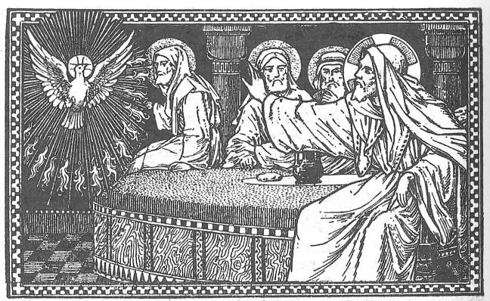
Fourth Sunday after Easter
Cantate
“Oh, sing to the Lord a new song!”
May 14, 2017

Emmanuel Lutheran Church
4675 Bataan Memorial West
Las Cruces, New Mexico 88012
(575) 382-0220 (church office) / (575) 636-4988 (pastor cell)
www.GodWithUsLC.org

Sts. Peter & Paul Lutheran Mission
Silver City, New Mexico
www.peterandpaullutheran.org

Rev. Paul A. Rydecki, Pastor
member of the Evangelical Lutheran Diocese of North America (ELDoNA)

ANNOUNCEMENTS
Welcome! Emmanuel is a liturgical, traditional, historical, evangelical, catholic, orthodox, confessional Lutheran congregation, in communion with the Evangelical Lutheran Diocese of North America (ELDoNA). We believe that the Bible is the very Word of God, inspired and without any errors. We confess the truth of Scripture according to the Lutheran Book of Concord of 1580, without exception or reservation. We observe the calendar of the traditional Church Year and follow the Historic Lectionary. We celebrate the Divine Service (also known as the Mass) every Sunday and on other festivals, and we welcome visitors.
With regard to Holy Communion, we ask our visitors to respect our practice of closed Communion, which means that only communicant members of our congregation or of other congregations in communion with us are invited to commune at the Lord’s Table here, after they have been examined and absolved. Classes are offered throughout the year by the pastor so that those who are interested in joining our Communion fellowship have the opportunity to learn about the Christian faith and our confession of it.
The Order of Service is The Order of Holy Communion (page 15) from The Lutheran Hymnal (TLH). The Scriptures are read from the New King James Version (NKJV). The Propers (the parts that change from week to week) are noted on the following page of this Service Folder.

EVENTS IN THE NEAR FUTURE…
Wed., May 17 - Vespers, 6:30 PM
Sun., May 21 - No Sunday School / Bible class
- Catechism Service, 10:15 AM (Pastor in Oregon)
Thur., May 25 - Divine Service for the Festival of the Ascension, 6:30 PM

Weekly Small Catechism: Sixth Commandment

PROPERS Easter 4

HYMNS
OPENING HYMN TLH #231 - We Now Implore God the Holy Ghost
HYMN (after the Creed) TLH #226 - Come Oh Come Thou (st. 1-5)
HYMN (after General Prayer) TLH #226 - Come Oh Come Thou (st. 6-9)
DISTRIBUTION HYMN TLH #206 - Jesus Christ, My Sure Defense

Epistle: James 1:16-21 Gospel: John 16:5-15

THE INTROIT (after the general Absolution) Psalm 98:1a, 2; Psalm 98:1b, 34
P (Antiphon) OH, SING to the Lord a new song! Alle- | luia! *
For he has done marvelous things; | Alleluia!
The Lord has made known His salvation; Alle- | luia! *
His righteousness He has revealed in the sight of the nations. | Alleluia!

C His right hand and His ho- | ly arm *
Have gained Him | the victory.
GLORIA PATRI (p.16): Glory be to the Father, and to the Son, and to the Holy Ghost; as it was in the beginning, is now, and ever shall be, world without end. Amen.
P (Antiphon)
The service continues with The Kyrie, p. 17, followed immediately by The Gloria.
THE GREATER HALLELUJAH (after the Epistle) Psalm 118:16; Romans 6:9
P Alle- | luia! *
Al- | — leluia!
C The right hand of the Lord is ex- | alted; *
The right hand of the Lord does valiantly. | Alleluia!
Christ, having been raised from the dead, dies | no more. *
Death no longer has dominion over Him. | Alleluia!
The service continues with The Gospel, p. 21.
We believe, teach and confess…

from the Formula of Concord, Solid Declaration: Article V
Christ’s Spirit must not only comfort, but also through the office of the Law “convict the world concerning sin” [John 16:8]. In the New Testament, as the prophet says, He must do a foreign work (to reprove), in order that He may ‹afterward› do His proper work, which is to comfort and to preach grace [Isaiah 28:21]. To this end the Spirit was obtained for us through Christ and sent. For this reason He is also called the Comforter, as Dr. Luther has explained in his comments on the Gospel for the Fifth Sunday after Trinity, in the following words:
Anything that preaches about our sins and God’s wrath (let it be done however or whenever it will), that is all a preaching of the Law. Again, the Gospel is such a preaching as shows and gives nothing else than grace and forgiveness in Christ. Yet it is true and right that the apostles and preachers of the Gospel (as Christ Himself also did) confirm the preaching of the Law. They begin the Law with those who do not yet acknowledge their sins nor are terrified at God’s wrath; as Jesus says, “When [the Holy Spirit] comes, he will convict the world concerning sin … because they do not believe in Me” (John 16:8–9). Yes, what more forceful, more terrible declaration and preaching of God’s wrath against sin is there than the suffering and death of Christ, His Son? But as long as all this preaches God’s wrath and terrifies people, it is not yet the preaching of the Gospel nor Christ’s own preaching, but that of Moses and the Law against the impenitent. For the Gospel and Christ were never ordained and given for the purpose of terrifying and condemning, but for comforting and cheering those who are terrified and timid.
And again, Luther wrote: Christ says, “[The Holy Spirit] will convict the world concerning sin” (John 16:8), which cannot be done except through the explanation of the Law.
So, too, the Smalcald Articles say: The New Testament keeps and urges the office of the Law, as St. Paul does when he says, “The wrath of God is revealed from heaven against all ungodliness and unrighteousness of men”…But to this office of the Law, the New Testament immediately adds the consoling promise of grace through the Gospel.

