Service Folder
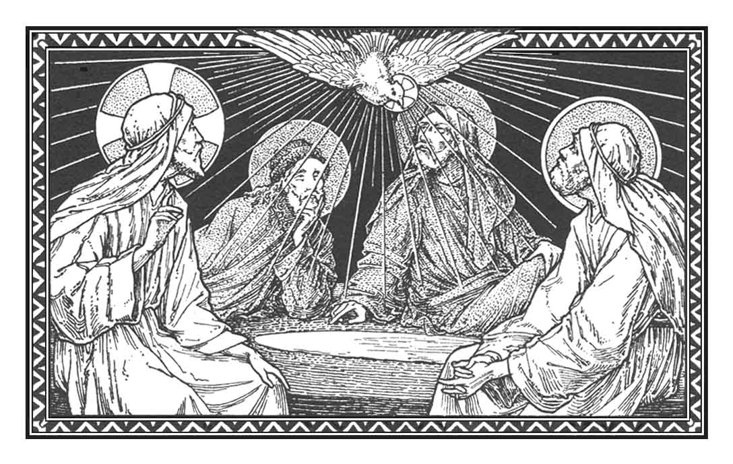
Sunday after the Ascension
Exaudi
“Hear, O LORD, when I cry!”
May 28, 2017

Emmanuel Lutheran Church
4675 Bataan Memorial West
Las Cruces, New Mexico 88012
(575) 382-0220 (church office) / (575) 636-4988 (pastor cell)
www.GodWithUsLC.org

Sts. Peter & Paul Lutheran Mission
Silver City, New Mexico
www.peterandpaullutheran.org

Rev. Paul A. Rydecki, Pastor
member of the Evangelical Lutheran Diocese of North America (ELDoNA)

ANNOUNCEMENTS
Welcome! Emmanuel is a liturgical, traditional, historical, evangelical, catholic, orthodox, confessional Lutheran congregation, in communion with the Evangelical Lutheran Diocese of North America (ELDoNA). We believe that the Bible is the very Word of God, inspired and without any errors. We confess the truth of Scripture according to the Lutheran Book of Concord of 1580, without exception or reservation. We observe the calendar of the traditional Church Year and follow the Historic Lectionary. We celebrate the Divine Service (also known as the Mass) every Sunday and on other festivals, and we welcome visitors.
With regard to Holy Communion, we ask our visitors to respect our practice of closed Communion, which means that only communicant members of our congregation or of other congregations in communion with us are invited to commune at the Lord’s Table here, after they have been examined and absolved. Classes are offered throughout the year by the pastor so that those who are interested in joining our Communion fellowship have the opportunity to learn about the Christian faith and our confession of it.
The Order of Service is The Order of Holy Communion (page 15) from The Lutheran Hymnal (TLH). The Scriptures are read from the New King James Version (NKJV). The Propers (the parts that change from week to week) are noted on the following page of this Service Folder.

EVENTS IN THE NEAR FUTURE…
May 29 – June 2 - Pastor at ELDoNA Conference in Malone, TX
Sun., June 4 - Bible class (no Sunday School for the summer), 9 AM
- Divine Service 10:15 AM (Pentecost)
Wed., June 7 - Vespers, 6:30 PM

Weekly Small Catechism: Eighth Commandment

PROPERS Sunday after the Ascension

HYMNS
OPENING HYMN TLH #215 - Draw Us to Thee
HYMN (after the Creed) TLH #223 - We Thank Thee Jesus Dearest Friend
HYMN (after General Prayer) TLH #264 - Preserve Thy Word O Savior
DISTRIBUTION HYMN TLH #306 – Lord Jesus Christ Thou Hast Prepared

Epistle: 1 Peter 4:7-11 Gospel: John 15:26 – 16:4

THE INTROIT (after the general Absolution) Psalm 27:7-9; Psalm 27:1
P (Antiphon) Hear, O LORD, when I cry with my voice! Alle- | luia! *
When You said, “Seek My face,” My heart said to You, “Your face, LORD, | I will seek.”
Do not hide Your face | from me. *
Alleluia! Al- | leluia!
C The LORD is my light and my sal- | vation; *
Whom | shall I fear?
GLORIA PATRI (p.16): Glory be to the Father, and to the Son, and to the Holy Ghost; as it was in the beginning, is now, and ever shall be, world without end. Amen.
P (Antiphon)
The service continues with The Kyrie, p. 17, followed immediately by The Gloria.
THE GREATER HALLELUJAH (after the Epistle) Psalm 47:8; John 14:18, 16:22
P Alle- | luia! *
Al- | leluia!
C God reigns over the | nations; *
God sits on His | holy throne.
I will not leave you orphans; I will come | to you, *
and your heart shall rejoice. Al- | leluia!
The service continues with The Gospel, p. 21.
We believe, teach and confess…

from The Augsburg Confession: Article III
[Christ] also descended into hell, and truly rose again on the third day. Afterward, He ascended into heaven to sit at the right hand of the Father. There He forever reigns and has dominion over all creatures. He sanctifies those who believe in Him, by sending the Holy Spirit into their hearts to rule, comfort, and make them alive. He defends them against the devil and the power of sin.

from The Apology of the Augsburg Confession: Article V (III)
Human nature is far too weak to resist the devil by its own powers. He holds as captive everyone who has not been freed through faith. There is need for Christ’s power against the devil. For we know that for Christ’s sake we are heard and have the promise. We may pray for the governance and defense of the Holy Spirit, that we may neither be deceived and err, nor be pushed to do anything against God’s will. Psalm 68:18 teaches this very thing: “You ascended on high, leading a host of captives in Your train and receiving gifts among men.” Christ has overcome the devil, and has given to us the promise and the Holy Spirit, in order that—by divine aid—we ourselves may also overcome. So 1 John 3:8 says, “The reason the Son of God appeared was to destroy the works of the devil.” Again, we teach not only how the Law can be kept, but also how God is pleased if anything is done. This is not because we satisfy the Law, but because we are in Christ.

