Service Folder
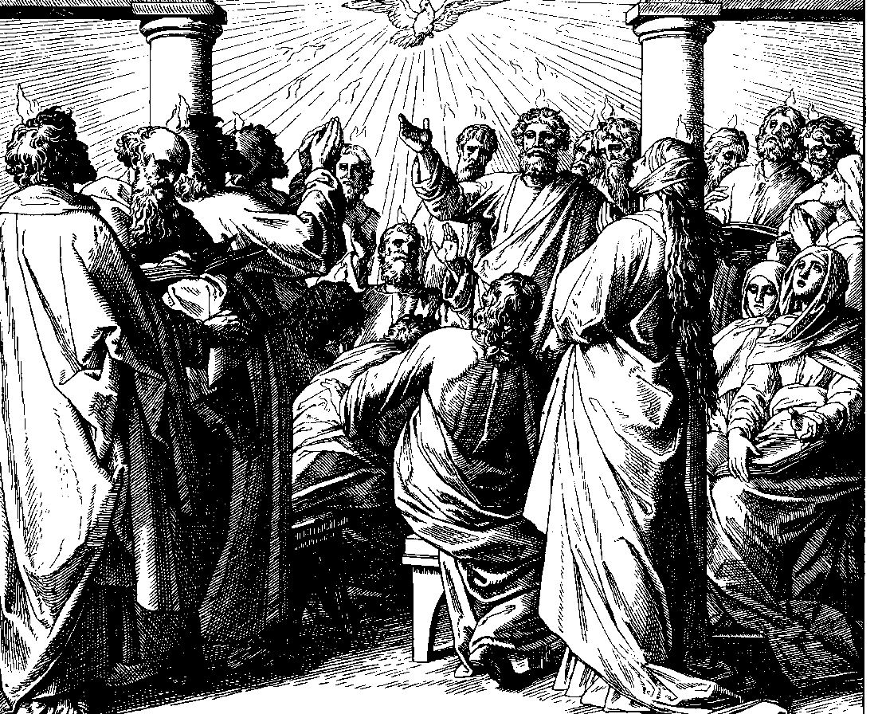
The Festival of Pentecost
Whitsunday
June 4, 2017

Emmanuel Lutheran Church
4675 Bataan Memorial West
Las Cruces, New Mexico 88012
(575) 382-0220 (church office) / (575) 636-4988 (pastor cell)
www.GodWithUsLC.org

Sts. Peter & Paul Lutheran Mission
Silver City, New Mexico
www.peterandpaullutheran.org

Rev. Paul A. Rydecki, Pastor
member of the Evangelical Lutheran Diocese of North America (ELDoNA)

ANNOUNCEMENTS
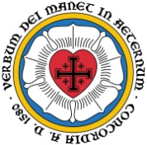
Welcome! Emmanuel is a liturgical, traditional, historical, evangelical, catholic, orthodox, confessional Lutheran congregation, in communion with the Evangelical Lutheran Diocese of North America (ELDoNA). We believe that the Bible is the very Word of God, inspired and without any errors. We confess the truth of Scripture according to the Lutheran Book of Concord of 1580, without exception or reservation. We observe the calendar of the traditional Church Year and follow the Historic Lectionary. We celebrate the Divine Service (also known as the Mass) every Sunday and on other festivals, and we welcome visitors.
With regard to Holy Communion, we ask our visitors to respect our practice of closed Communion, which means that only communicant members of our congregation or of other congregations in communion with us are invited to commune at the Lord’s Table here, after they have been examined and absolved. Classes are offered throughout the year by the pastor so that those who are interested in joining our Communion fellowship have the opportunity to learn about the Christian faith and our confession of it.
The Order of Service is The Order of Holy Communion (page 15) from The Lutheran Hymnal (TLH). The Scriptures are read from the New King James Version (NKJV). The Propers (the parts that change from week to week) are noted on the following page of this Service Folder.

EVENTS IN THE NEAR FUTURE…
Wed., June 7 - Vespers, 6:30 PM
Sun., June 11 - Bible class 9 AM (No Sunday School)
- Divine Service 10:15 AM (Trinity Sunday)

Weekly Small Catechism: Ninth Commandment

PROPERS Pentecost

HYMNS
OPENING HYMN TLH #224 - Come, Holy Ghost, God and Lord
HYMN (after the Creed) TLH #233 - Come, Holy Ghost, Creator Blest
HYMN (after General Prayer) TLH #236 - Creator Spirit, by Whose Aid
DISTRIBUTION HYMN TLH #235 - O Holy Spirit, Enter In

Epistle: Acts 2:1-13 Gospel: John 14:23-31

THE INTROIT (after the general Absolution) Wisdom of Solomon 1:7a; Ps. 68:3; 68:1
P (Antiphon) The Spirit of the | Lord fills the world. *
Alle- | luia!
Let the righteous be glad; let them re- | joice before God; *
Yes, let them rejoice exceedingly. Alleluia! Alle- | luia!
C Let God arise, let His ene- | mies be scattered; *
Let those also who hate Him flee be- | fore Him.
GLORIA PATRI (p.16): Glory be to the Father, and to the Son, and to the Holy Ghost; as it was in the beginning, is now, and ever shall be, world without end. Amen.
P (Antiphon)
The service continues with The Kyrie, p. 17, followed immediately by The Gloria.
THE GREATER HALLELUJAH (after the Epistle) Ps. 104:30; Veni Sancte Spiritus
P Al- | - -leluia! *
Alle- | luia!
C You send forth Your Spirit, they | are created; *
And You renew the face of the earth. Alle- | luia!
Come, Holy Spirit, fill the hearts | of the faithful, *
And kindle in them the fire of Your love. Alle- | luia!
The service continues with The Gospel, p. 21.
We believe, teach and confess…

from the Large Catechism: The Creed, Third Article
I cannot connect this article (as I have said) to anything better than Sanctification. Through this article the Holy Spirit, with His office, is declared and shown: He makes people holy. Therefore, we must take our stand upon the term Holy Spirit, because it is so precise and complete that we cannot find another. For there are many kinds of spirits mentioned in the Holy Scriptures, such as the spirit of man, heavenly spirits, and evil spirits. But God’s Spirit alone is called the Holy Spirit, that is, He who has sanctified and still sanctifies us. For just as the Father is called “Creator” and the Son is called “Redeemer,” so the Holy Spirit, from His work, must be called “Sanctifier,” or “One who makes holy.”
“But how is such sanctifying done?” Answer, “The Son receives dominion, by which He wins us, through His birth, death, resurrection, and so on. In a similar way, the Holy Spirit causes our sanctification by the following: the communion of saints or the Christian Church, the forgiveness of sins, the resurrection of the body, and the life everlasting. That means He leads us first into His holy congregation and places us in the bosom of the Church. Through the Church He preaches to us and brings us to Christ.”
Neither you nor I could ever know anything about Christ, or believe on Him, and have Him for our Lord, unless it were offered to us and granted to our hearts by the Holy Spirit through the preaching of the Gospel. The work of redemption is done and accomplished. Christ has acquired and gained the treasure for us by His suffering, death, resurrection, and so on. But if the work remained concealed so that no one knew about it, then it would be useless and lost. So that this treasure might not stay buried, but be received and enjoyed, God has caused the Word to go forth and be proclaimed. In the Word He has the Holy Spirit bring this treasure home and make it our own. Therefore, sanctifying is just bringing us to Christ so we receive this good, which we could not get ourselves.

