Service Folder
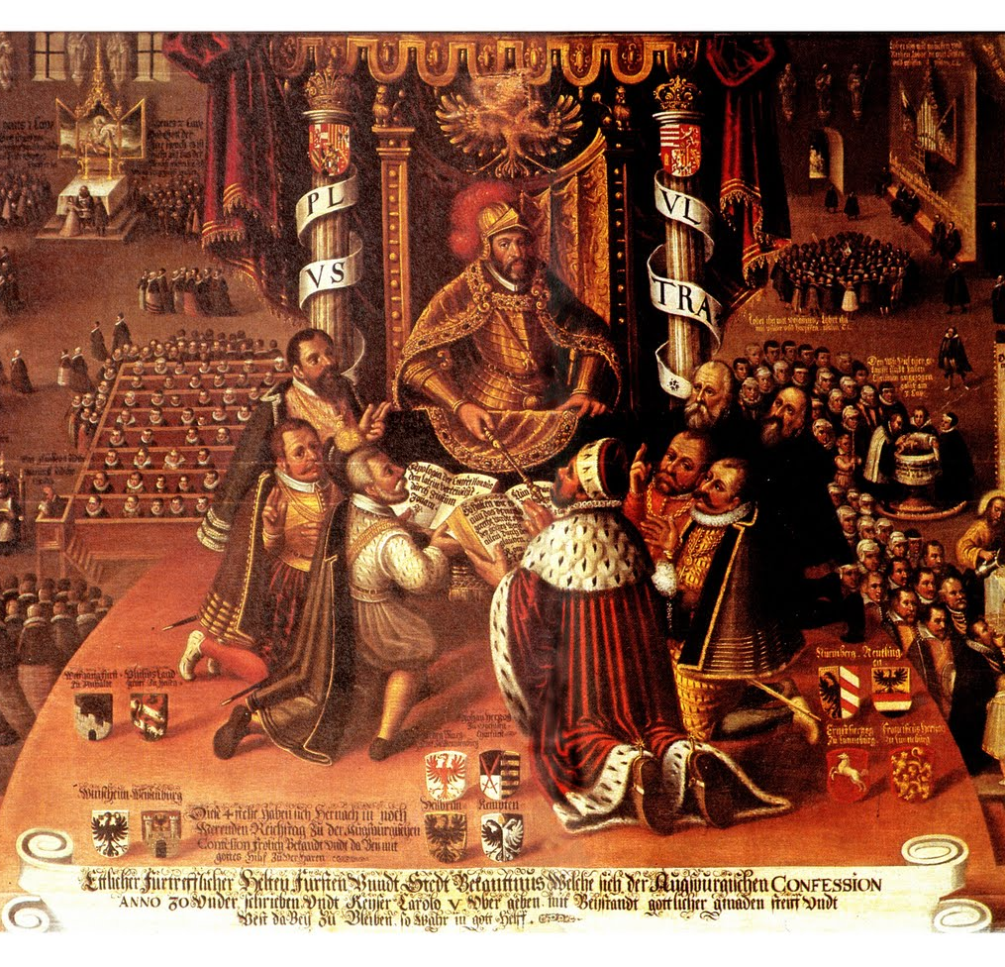
Commemoration of the
Presentation of the Augsburg Confession
June 25, 1530 - June 25, 2017
Emmanuel Lutheran Church
4675 Bataan Memorial West
Las Cruces, New Mexico 88012
(575) 382-0220 (church office) / (575) 636-4988 (pastor cell)
www.GodWithUsLC.org

Sts. Peter & Paul Lutheran Mission
Silver City, New Mexico
www.peterandpaullutheran.org

Rev. Paul A. Rydecki, Pastor
member of the Evangelical Lutheran Diocese of North America (ELDoNA)

ANNOUNCEMENTS
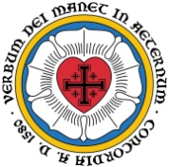
Welcome! Emmanuel is a liturgical, traditional, historical, evangelical, catholic, orthodox, confessional Lutheran congregation, in communion with the Evangelical Lutheran Diocese of North America (ELDoNA). We believe that the Bible is the very Word of God, inspired and without any errors. We confess the truth of Scripture according to the Lutheran Book of Concord of 1580, without exception or reservation. We observe the calendar of the traditional Church Year and follow the Historic Lectionary. We celebrate the Divine Service (also known as the Mass) every Sunday and on other festivals, and we welcome visitors.
With regard to Holy Communion, we ask our visitors to respect our practice of closed Communion, which means that only communicant members of our congregation or of other congregations in communion with us are invited to commune at the Lord’s Table here, after they have been examined and absolved. Classes are offered throughout the year by the pastor so that those who are interested in joining our Communion fellowship have the opportunity to learn about the Christian faith and our confession of it.
Today’s service commemorates the 487th anniversary of the Presentation of the Augsburg Confession, the foundational confession of the Lutheran Church, in which the German princes defended the Lutheran teachings before Emperor Charles V. Special Scripture readings will be used, and special congregational readings from the Augsburg Confession will be included in the service, replacing some of the hymns where we normally sing them. The sermon today will largely consist of further reading from the Augsburg Confession. Only two hymns will be sung, one after the Introit, and one during the Communion distribution.

EVENTS IN THE NEAR FUTURE…
Sun., July 2 - Bible class 9 AM (No Sunday School)
- Divine Service 10:15 AM (The Visitation)

Weekly Small Catechism: Close of the Commandments, Part 2

The Order of the Holy Communion
for commemorating the Presentation of the Augsburg Confession
Stand
CONFESSION & ABSOLUTION TLH, p. 15-16
INTROIT Psalm 119:46; Psalm 46:1-3,7
P (Antiphon) I will speak of Your testimonies also before kings, *
And will not be ashamed.
C God is our | refuge and strength, *
A very present | help in trouble. —
Therefore we will not fear, Even though the | earth be removed, *
And though the mountains be carried into the | midst of the sea; —
Though its waters roar | and be troubled, *
Though the mountains shake | with its swelling. —
The LORD of | hosts is with us; *
The God of Jacob | is our refuge. —
GLORIA PATRI (p.16): Glory be to the Father, and to the Son, and to the Holy Ghost; as it was in the beginning, is now, and ever shall be, world without end. Amen.
P (Antiphon)
Sit
HYMN TLH #266 – O God, Our Lord, Thy Holy Word
FIRST READING Augsburg Confession, Articles I - IV

Article I—God
First, it is taught and maintained with one accord, in conformity with the judgment of the Council of Nicaea, that there is only one divine Being who both is called and truly is God, and yet there are three Persons in this one divine Being, equally powerful, equally eternal: God the Father, God the Son, God the Holy Spirit. All three are one divine Being, eternal, undivided, infinite, of immeasurable might, wisdom and goodness; one Creator and Preserver of all things, visible and invisible. And with the word ‘Person’ is not understood a part or a quality in another, but that which subsists of itself, as the Fathers used this term in this matter.
Therefore, all heresies that are contrary to this Article are rejected, such as the Manichaeans, who proposed two gods, one evil and one good; likewise the Valentinians, Arians, Eunomians, Mohammedans, and all such; also the Samosatenes, both ancient and modern, who propose only one Person and indulge in Sophistry concerning these two—the Word and the Holy Spirit—claiming that they must not be distinct Persons, but that ‘Word’ signifies a spoken word or expression, and that the Holy Spirit is the movement created within created things.

Article II—Original Sin
It is furthermore taught among us that, after Adam’s fall, all men who are born naturally are conceived and born in sins, that is, that from their mother’s womb onward, they are full of evil desires and inclinations, and are by nature unable to have any true fear of God or true faith in God; that this inborn disease and original sin is also truly sin and condemns all who are under God’s eternal wrath—those who are not born again through Baptism and the Holy Spirit.
Accordingly, the Pelagians are rejected and others who do not consider original sin to be sin, pretending that a man’s nature becomes pious by means of natural powers, which is an insult to the suffering and merit of Christ.

Article III—The Son of God
It is likewise taught that God the Son became Man, born of the pure Virgin Mary, and that the two natures, divine and human, inseparably united in one Person, are one Christ; who is true God and Man, who truly was born, suffered, was crucified, died and was buried, so that He might be a sacrifice, not only for original sin, but also for all other sins, and appease God’s wrath.
Likewise, that this same Christ descended into hell, truly rose from the dead on the third day, ascended into heaven, and sits at the right hand of God, so that He may rule eternally and reign over all creatures; so that, through the Holy Spirit, He may sanctify, purify, strengthen and comfort all who believe in Him; so that He may also impart unto them life and all kinds of gifts and blessings; and that He may guard and protect them against the devil and against sin.
Likewise, that this same Lord Christ will finally come openly to judge the living and the dead, etc., in accord with the Apostles’ Creed.

Article IV—Justification
It is taught, furthermore, that we cannot obtain forgiveness of sins and righteousness before God through our merits, works and satisfactions, but that we receive forgiveness of sins and become righteous before God by grace, for Christ’s sake, through faith, when we believe that Christ suffered for us and that, for His sake, sins are forgiven to us, righteousness and eternal life are given to us. For God wishes to regard and reckon this faith as righteousness before Him, as St. Paul says to the Romans in the third and fourth chapters.
Stand
KYRIE & GLORIA IN EXCELSIS TLH, p.17-19
SALUTATION & COLLECT TLH, p.19
Sit
SECOND READING Augsburg Confession, Articles V - XI

Article V—The Preaching Office
That we may obtain such faith, God has instituted the preaching office; He has given the Gospel and the Sacraments, through which, as through means, He gives the Holy Spirit, who works faith, where and when He wishes, in those who hear the Gospel—the Gospel that teaches that, through Christ’s merit, not through our own merit, we have a gracious God, if we believe this.
And the Anabaptists and others are condemned who teach that we obtain the Holy Spirit apart from the spoken Word of the Gospel—through our own preparation, thoughts and works.

Article VI—New Obedience
It is also taught that this faith should produce good fruit and good works, and that one must do good works—every kind that God has commanded—for God’s sake; but not to rely on these works in order to merit grace before God by them. For we receive forgiveness of sins and righteousness by faith in Christ, as Christ Himself says in Luke 17:10: “When you have done all this, you should say: We are unworthy servants.” The Fathers also teach thus, for Ambrose says: “So it has been determined by God, that whoever believes in Christ should be saved and have forgiveness of sins, not by works, but only by faith, without merit.”

Article VII—The Church
It is also taught that there must always be and remain one holy Christian Church, which is the congregation of all believers, among whom the Gospel is purely preached and the holy Sacraments are administered in accordance with the Gospel.
For this is sufficient for the true unity of the Christian Church, that the Gospel be preached with one accord, according to a pure understanding, and that the Sacraments be administered in conformity with the divine Word. And it is not necessary for the true unity of the Christian Church that ceremonies instituted by men be observed uniformly in every place, as Paul says in Ephesians 4: “One body, one Spirit, as you were called to one hope of your calling, one Lord, one faith, one Baptism.”

Article VIII—What the Church Is
Likewise, although the Christian Church is properly nothing else but the congregation of all believers and saints, nevertheless, since there are many false Christians and hypocrites in this life, even open sinners remaining among the godly, yet the Sacraments are still effective, even if the priests by whom they are administered are not godly, as Christ Himself indicates in Matthew 23: “The Pharisees sit in Moses’ seat,” etc. Therefore the Donatists and all others are condemned who maintain otherwise.

Article IX—Baptism
Concerning Baptism, it is taught that it is necessary, and that grace is offered through it; that children are also to be baptized, who, through this Baptism, are commended to God and become pleasing to Him.
Therefore the Anabaptists are rejected, who teach that the Baptism of children is improper.

Article X—The Holy Supper
Concerning the Lord’s Supper, it is taught that the true body and blood of Christ are really present in the Supper under the form of bread and wine and are there distributed and received. Therefore the contrary teaching is also rejected.

Article XI—Confession
Concerning Confession, it is taught that private absolution should be retained in the Church and should not be allowed to fall out of use.
Yet in Confession, it is not necessary to recount all transgressions and sins, for surely this is not possible, Ps. 19: “Who knows his transgressions?”
EPISTLE Romans 10:5-17
GRADUAL & HALLELUJAH Ps. 146:5; Ps. 149:4; Ps. 84:12
P Happy is he who has the God of Ja- | cob for his help, *
Whose hope is in | the LORD his God, —
C For the LORD takes pleasure | in His people; *
He will beautify the humble | with salvation. —
P Al- | — leluia! *
Al- | — leluia! —
C O LORD of hosts, blessed is the man | who trusts in You! *
Al- | — leluia! —
THIRD READING Augsburg Confession, Articles XII - XVI

Article XII—Repentance
Concerning repentance, it is taught that those who have sinned after their Baptism obtain the forgiveness of sins whenever they come to repentance, and that Absolution is not to be refused to them by the Church. And true, genuine repentance is to have proper sorrow and contrition or terrors over sin, and yet, at the same time, to believe in the Gospel and Absolution, that sins are forgiven and grace obtained through Christ. This faith comforts the heart again and sets it at peace. Then amendment of life should also follow, and the abandoning of sins. For these must be the fruits of repentance, as John says in Matthew 3: “Produce genuine fruits of repentance.”
They are here rejected who teach that those who have once become godly cannot fall again.
Accordingly the Novatians are also condemned, who refused the Absolution to those who sinned after their Baptism.
Also rejected are those who do not teach that forgiveness of sins is obtained through faith, but through our own satisfaction.

Article XIII—The Use of the Sacraments
Concerning the use of the Sacraments it is taught that the Sacraments were not only instituted to be signs by which Christians may be outwardly known, but that they are signs and testimonies of the divine will toward us, to stir up and to strengthen our faith by means of them. For this reason, they also require faith, and are rightly used when they are received in faith and when faith is strengthened by them.

Article XIV—Ecclesiastical Government
Concerning ecclesiastical government, it is taught that no one should publicly teach and preach in the Church, or administer the Sacraments, without a legitimate call.

Article XV—Ecclesiastical Rites
Concerning ecclesiastical rites devised by men, it is taught that those should be observed that may be observed without sin and that foster peace and good order in the Church, such as certain holidays, festivals, and the like. But this is accompanied with instruction, that consciences are not to be burdened by them, as if such things were necessary for salvation. It is taught in this regard that all ceremonies and traditions devised by men for the purpose of appeasing God and meriting grace are contrary to the Gospel and to the doctrine concerning faith in Christ. For this reason, monastic vows and other traditions concerning the distinction of food, days, etc., by which people pretend to merit grace and to make satisfaction for sins, are useless and contrary to the Gospel.

Article XVI—Civil Affairs and Secular Government
Concerning civil affairs and secular government, it is taught that all authority in the world and all well-ordered governments and laws are good ordinances created and instituted by God; and that Christians may, without sin, hold the office of ruler, prince, and judge, pronounce judgment and determine sentence according to imperial and other established laws, punish evildoers with the sword, wage just wars, serve in the military, buy and sell, take oaths that are imposed on them, own property, enter into marriage, etc.
The Anabaptists are condemned in this matter, for they teach that none of the above-mentioned things are permissible for Christians.
Those also are condemned who teach that Christian perfection consists in physically abandoning house and yard, wife and child, and in depriving oneself of these things, when in fact true perfection consists in this alone: true fear of God and true faith in God. For the Gospel teaches, not an external, temporal disposition and righteousness, but an inner, eternal disposition and a righteousness of the heart; it does not overturn secular government, civil affairs, or marriage, but wants all these things to be considered legitimate ordinances of God, and for everyone to show Christian love and to perform genuinely good works in these estates, according to one’s vocation. Therefore, Christians ought to be subject to the authorities and obedient to their commands in all that may be done without sin. For if the authority’s command cannot be carried out without sin, then one must obey God rather than men (Acts 4).
Stand
GOSPEL John 15:1-11
NICENE CREED TLH, p.22
Sit
FOURTH READING Augsburg Confession, Articles XVII - XIX

Article XVII—Christ’s Return for Judgment
It is also taught that our Lord Jesus Christ will come on the Last Day to judge and will raise up all the dead; He will give eternal life and eternal joy to the believers and elect, but He will condemn the wicked men and the devils to hell and eternal punishment.
Therefore the Anabaptists are rejected, who teach that the devils and the damned will not endure eternal pain and suffering.
Likewise rejected here are certain Jewish teachings which are now also being circulated, that before the resurrection of the dead, only the saints—the godly—will have a worldly kingdom, and all the wicked will be eradicated.

Article XVIII—Free Will
Concerning free will, it is taught that man has a free will to some degree, to lead an outwardly decent life and to choose among those things that reason comprehends; but without the grace, aid, and working of the Holy Spirit, man is incapable of becoming acceptable to God, sincerely fearing or believing in God, or of expelling the inborn evil desires from the heart. All this takes place through the Holy Spirit, who is given through God’s Word. For Paul says in 1 Corinthians 2: “The natural man accepts nothing that comes from the Spirit of God.”
And that it may be understood that nothing new is being taught in this matter, these are the clear words of Augustine concerning free will, as cited here from Hypognostikon, Book III: “We confess that there is a free will in all men; for they all have natural, inborn understanding and reason—not that they are at all capable of dealing with God, to love or to fear God from the heart; but only in outward deeds of this life do they have freedom to choose good or evil. By ‘good,’ I mean that man’s nature has the ability to do something, such as working in the field or not, eating, drinking, going to see a friend or not, putting on or taking off a piece of clothing, farming, taking a wife, carrying on a trade, and doing similar useful and good things. None of this, of course, is done apart from God, but all things are from Him and through Him. Accordingly, man can also do evil by his own choice, such as bowing down before an idol, committing murder, etc.”

Article XIX—The Cause of Sin
Concerning the cause of sin, it is taught among us that, although God the Almighty created and preserves all of nature, nevertheless the perverted will works sin in all evil men and those who despise God. Such is the devil’s will, and the will of all the godless. No sooner does God remove His hand than their will has turned away from God to evil, as Christ says in John 8: “The devil speaks lies from his own.”
SERMON (includes reading of Article XX)
(Remain seated after the sermon. The Offertory canticle “Create in Me” is omitted.)
OFFERING
Stand
GENERAL PRAYER
The Service continues on TLH, p. 24, with The Preface.

During the distribution of the Lord’s Supper, the congregation sings:
HYMN TLH #305 – Soul, Adorn Thyself with Gladness

+++++++++++++++++++++++++++++++++++++

A Summary Statement at the End of the First and Chief Part of the Augsburg Confession
This is virtually a summary of the doctrine that is preached and taught in our churches for genuine Christian instruction and for the consolation of consciences, and also for the edification of believers, as we would never wish to place our own souls and consciences in the utmost and greatest jeopardy before God by misusing the divine Name or Word, nor to pass on or leave as an inheritance to our children and successors a different doctrine than that which is in accord with the pure divine Word and Christian truth. Since our doctrine is firmly rooted in Holy Scripture and, in addition, is neither contrary nor opposed to the common Christian—indeed, the Roman!—Church, so far as can be discerned from the writings of the Fathers, we also think that our adversaries cannot be at odds with us in the above-cited articles. Therefore, they treat us most unkindly, unjustly, and contrary to all Christian unity and love when they undertake to single out our teachers as heretics, to reject and to shun them without a single valid reason based on divine command or Scripture. For the dispute and quarrel is chiefly over certain traditions and abuses. Since, then, there is currently no discernable problem or fault with the chief articles, and since this confession of ours is godly and Christian, the bishops should really behave more gently, even if there were a fault among us with regard to traditions, although we hope to provide valid grounds and reasons why some traditions and abuses have been changed among us.

