Service Folder
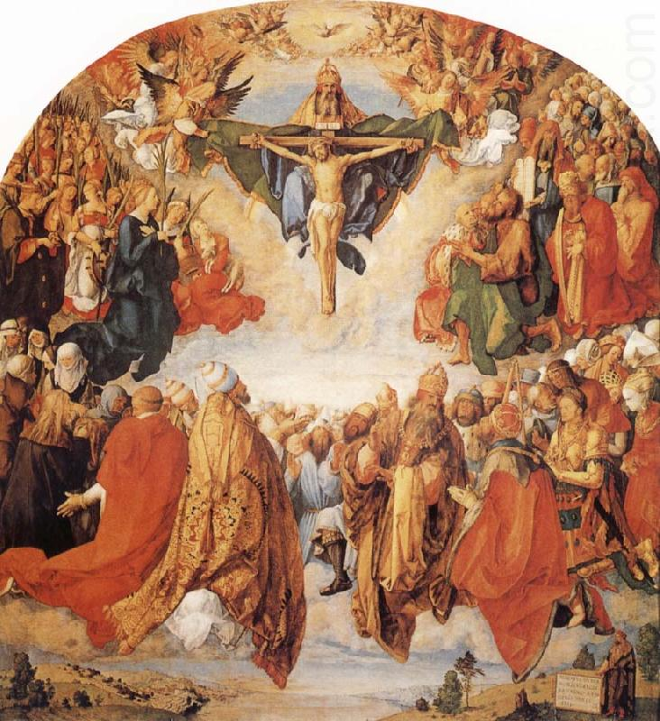

The Festival of the Holy Trinity
June 11, 2017
Emmanuel Lutheran Church
4675 Bataan Memorial West
Las Cruces, New Mexico 88012
(575) 382-0220 (church office) / (575) 636-4988 (pastor cell)
www.GodWithUsLC.org

Sts. Peter & Paul Lutheran Mission
Silver City, New Mexico
www.peterandpaullutheran.org

Rev. Paul A. Rydecki, Pastor
member of the Evangelical Lutheran Diocese of North America (ELDoNA)

ANNOUNCEMENTS
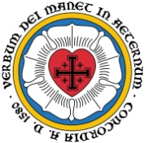
Welcome! Emmanuel is a liturgical, traditional, historical, evangelical, catholic, orthodox, confessional Lutheran congregation, in communion with the Evangelical Lutheran Diocese of North America (ELDoNA). We believe that the Bible is the very Word of God, inspired and without any errors. We confess the truth of Scripture according to the Lutheran Book of Concord of 1580, without exception or reservation. We observe the calendar of the traditional Church Year and follow the Historic Lectionary. We celebrate the Divine Service (also known as the Mass) every Sunday and on other festivals, and we welcome visitors.
With regard to Holy Communion, we ask our visitors to respect our practice of closed Communion, which means that only communicant members of our congregation or of other congregations in communion with us are invited to commune at the Lord’s Table here, after they have been examined and absolved. Classes are offered throughout the year by the pastor so that those who are interested in joining our Communion fellowship have the opportunity to learn about the Christian faith and our confession of it.
The Order of Service is The Order of Holy Communion (page 15) from The Lutheran Hymnal (TLH). The Scriptures are read from the New King James Version (NKJV). The Propers (the parts that change from week to week) are noted on the following page of this Service Folder.
The Athanasian Creed is historically confessed on Trinity Sunday. Please have your hymnal open to page 53 in your hymnal immediately after the Gradual, Hallelujah, & Triple Hallelujah.
Sunday School Break Reminder. Last week began our summer break for Sunday School. Remember to thank our faithful teachers, Amy, Marti, and Karin! Regular Bible class will continue through the summer, but Sunday School for the children will not be taught again until mid-to-late August. Children are welcome to attend Bible class with their parents during the summer, or they can play at the parsonage, with older children or adults taking turns watching them.
EVENTS IN THE NEAR FUTURE…
Sun., June 18 - Bible class 9 AM (No Sunday School)
- Divine Service 10:15 AM (Trinity 1)
Wed., June 21 - Vespers, 6:30 PM

Weekly Small Catechism: Tenth Commandment

PROPERS Trinity Sunday

HYMNS
OPENING HYMN TLH #246 - Holy, Holy, Holy
HYMN (after the Creed) TLH #237 - All Glory Be to God on High
HYMN (after the General Prayer) TLH #251 – We All Believe (second tune)
DISTRIBUTION HYMNS TLH #238 - All Glory Be to God Alone
TLH #252 - We All Believe in One True God

Epistle: Romans 11:33-36 Gospel: John 3:1-15

THE INTROIT (after general Absolution) Liturgical text, Tobit 13:1-2; Psalm 8:1
P (Antiphon) BLESSED be the Holy Trinity and the undivid- | ed Unity: *
Let us give glory to Him for He has shown mercy un- | to us.
C O | Lord, — our Lord, *
How excellent is Your name in all | the earth,
GLORIA PATRI (p.16): Glory be to the Father, and to the Son, and to the Holy Ghost; as it was in the beginning, is now, and ever shall be, world without end. Amen.
P (Antiphon)
The service continues with The Kyrie, p. 17, followed immediately by The Gloria.
GRADUAL & HALLELUJAH (after the Epistle) Prayer of Azariah 1:32, 34; 1:29
P Blessèd are You, O Lord, who | beholds the deep, *
And who dwells between the cher- | ubim.
C Blessèd are You, O Lord, in the firma- | ment of heaven, *
And greatly to be praised for- | ever.
P Al-| - -leluia! * Alle- | luia!
C Blessèd are You, O Lord God | of our fathers, *
And greatly to be praised and glorified forever. Alle- | luia!
After the Triple Hallelujah is sung, the congregation stands and confesses the Athanasian Creed (TLH, p. 53). The service then continues with The Gospel, p. 21.
We believe, teach and confess…

from the Augsburg Confession: Article I
Our churches teach with common consent that the decree of the Council of Nicaea about the unity of the divine essence and the three persons is true. It is to be believed without any doubt. God is one divine essence who is eternal, without a body, without parts, of infinite power, wisdom, and goodness. He is the maker and preserver of all things, visible and invisible. Yet there are three persons, the Father, the Son, and the Holy Spirit. These three persons are of the same essence and power. Our churches use the term person as the Fathers have used it. We use it to signify, not a part or quality in another, but that which subsists of itself.
Our churches condemn all heresies that arose against this article, such as the Manichaeans, who assumed that there are two “principles,” one Good and the other Evil. They also condemn the Valentinians, Arians, Eunomians, Muslims, and all heresies such as these. Our churches also condemn the Samosatenes, old and new, who contend that God is but one person. Through sophistry they impiously argue that the Word and the Holy Spirit are not distinct persons. They say that Word signifies a spoken word, and Spirit signifies motion created in things.
from the Apology of the Augsburg Confession: Article I
Our adversaries approve Article I of our Confession, in which we declare that we believe and teach that there is one divine, undivided essence. Yet, there are three distinct persons, of the same divine essence, and coeternal: Father, Son, and Holy Spirit. We have always taught and defended this article. We believe that it has sure and firm testimonies in Holy Scripture that cannot be overthrown. We constantly affirm that those thinking otherwise are outside of Christ’s Church, are idolaters, and insult God.
from the Formula of Concord: SD, Article XI
So the entire Holy Trinity—God the Father, Son, and Holy Spirit—directs all people to Christ, as to the Book of Life, in whom they should seek the Father’s eternal election…“For God so loved the world‹, that He gave His only Son, that whoever believes in Him should not perish but have eternal life” (John 3:16)›. The Father wants all people to hear this proclamation and desires that they come to Christ. Christ does not drive these people from Him, as it is written, “whoever comes to Me I will never cast out” (John 6:37). In order that we may come to Christ, the Holy Spirit works true faith through the hearing of the Word. The apostle testifies about this when he says, “faith comes from hearing, and hearing through the word of Christ” (Romans 10:17), that is, when it is preached in its truth and purity.

