Service Folder
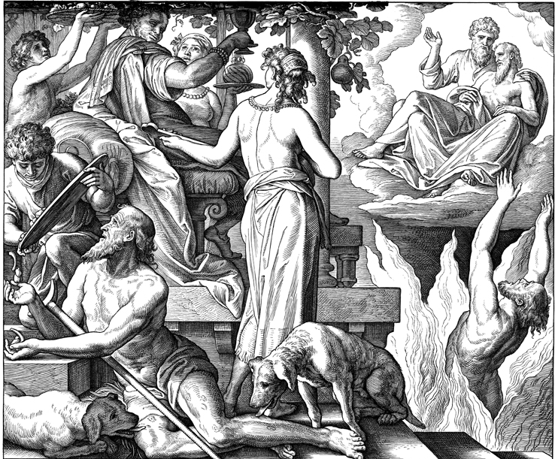
First Sunday after Trinity
June 18, 2017

Emmanuel Lutheran Church
4675 Bataan Memorial West
Las Cruces, New Mexico 88012
(575) 382-0220 (church office) / (575) 636-4988 (pastor cell)
www.GodWithUsLC.org

Sts. Peter & Paul Lutheran Mission
Silver City, New Mexico
www.peterandpaullutheran.org

Rev. Paul A. Rydecki, Pastor
member of the Evangelical Lutheran Diocese of North America (ELDoNA)

ANNOUNCEMENTS
Welcome! Emmanuel is a liturgical, traditional, historical, evangelical, catholic, orthodox, confessional Lutheran congregation, in communion with the Evangelical Lutheran Diocese of North America (ELDoNA). We believe that the Bible is the very Word of God, inspired and without any errors. We confess the truth of Scripture according to the Lutheran Book of Concord of 1580, without exception or reservation. We observe the calendar of the traditional Church Year and follow the Historic Lectionary. We celebrate the Divine Service (also known as the Mass) every Sunday and on other festivals, and we welcome visitors.
With regard to Holy Communion, we ask our visitors to respect our practice of closed Communion, which means that only communicant members of our congregation or of other congregations in communion with us are invited to commune at the Lord’s Table here, after they have been examined and absolved. Classes are offered throughout the year by the pastor so that those who are interested in joining our Communion fellowship have the opportunity to learn about the Christian faith and our confession of it.
The Order of Service is The Order of Holy Communion (page 15) from The Lutheran Hymnal (TLH). The Scriptures are read from the New King James Version (NKJV). The Propers (the parts that change from week to week) are noted on the following page of this Service Folder.
Next week Sunday falls on June 25th, marking the 487th anniversary of the Presentation of the Augsburg Confession, the foundational confession of the Lutheran Church. Special Scripture readings will be used, and special readings from the Augsburg Confession will be included in the service.

EVENTS IN THE NEAR FUTURE…
Wed., June 21 - Vespers, 6:30 PM
Sun., June 25 - Bible class 9 AM (No Sunday School)
- Divine Service 10:15 AM (Commemoration of the Presentation of the Augsburg Confession)

Weekly Small Catechism: Close of the Commandments, Part 1

PROPERS Trinity 1

HYMNS
OPENING HYMN TLH #409 - Let Us Ever Walk with Jesus
HYMN (after the Creed) TLH #407 - Farewell I Gladly Bid Thee
HYMN (after General Prayer) TLH #429 - Lord, Thee I Love with All My Heart
DISTRIBUTION HYMN TLH #395 - O God Thou Faithful God

Epistle: 1 John 4:16-21 Gospel: Luke 16:19-31

THE INTROIT (after general Absolution) Psalm 13:5–6; Psalm 13:1
P (Antiphon) O LORD, I have trusted | in Your mercy; *
My heart shall rejoice in Your sal- | vation.
I will | sing to the Lord, *
Because He has dealt bountifully | with me.
C How long, O Lord? Will You forget | me forever? *
How long will You hide Your face | from me?
GLORIA PATRI (p.16): Glory be to the Father, and to the Son, and to the Holy Ghost; as it was in the beginning, is now, and ever shall be, world without end. Amen.
P (Antiphon)
The service continues with The Kyrie, p. 17, followed immediately by The Gloria.
GRADUAL & HALLELUJAH (after the Epistle) Psalm 41:4, 1; Psalm 5:1
P I said, “Lord, be | merciful to me; *
Heal my soul, for I have sinned a- | gainst You.”
C Blessèd is he who con- | siders the poor; *
The Lord will deliver him in time of | trouble.
P Al-| - -leluia! *
Alle- | luia!
C Give ear to | my words, O Lord, *
Consider my meditation. Alle- | luia!
The service continues with The Gospel, p. 21.
We believe, teach and confess…

from the Large Catechism: Lord’s Prayer, Seventh Petition
But deliver us from evil. Amen.
In the Greek text this petition reads, “Deliver or preserve us from the evil one,” or “the hateful one.” It looks like Jesus was speaking about the devil, like He would summarize every petition in one. So the entire substance of all our prayer is directed against our chief enemy. For it is he who hinders among us everything that we pray for: God’s name or honor, God’s kingdom and will, our daily bread, a cheerful good conscience, and so forth.
Therefore, we finally sum it all up and say, “Dear Father, grant that we be rid of all these disasters.” But there is also included in this petition whatever evil may happen to us under the devil’s kingdom: poverty, shame, death, and, in short, all the agonizing misery and heartache of which there is such an unnumbered multitude on the earth. Since the devil is not only a liar, but also a murderer [John 8:44], he constantly seeks our life. He wreaks his vengeance whenever he can afflict our bodies with misfortune and harm. Therefore, it happens that he often breaks men’s necks or drives them to insanity, drowns some, and moves many to commit suicide and to many other terrible disasters [e.g., Mark 9:17–22]. So there is nothing for us to do upon earth but to pray against this archenemy without stopping. For unless God preserved us, we would not be safe from this enemy even for an hour.
You see again how God wishes for us to pray to Him also for all the things that affect our bodily interests, so that we seek and expect help nowhere else except in Him. But He has put this matter last. For if we are to be preserved and delivered from all evil, God’s name must first be hallowed in us, His kingdom must be with us, and His will must be done. After that He will finally preserve us from sin and shame, and, besides, from everything that may hurt or harm us.
So God has briefly placed before us all the distress that may ever come upon us, so that we might have no excuse whatever for not praying. But all depends upon this, that we learn also to say “Amen.” This means that we do not doubt that our prayer is surely heard and that what we pray shall be done [2 Corinthians 1:20]. This is nothing else than the word of undoubting faith, which does not pray on a dare but knows that God does not lie to him [Titus 1:2]. For He has promised to grant it. Therefore, where there is no such faith, there cannot be true prayer either.

