Service Folder
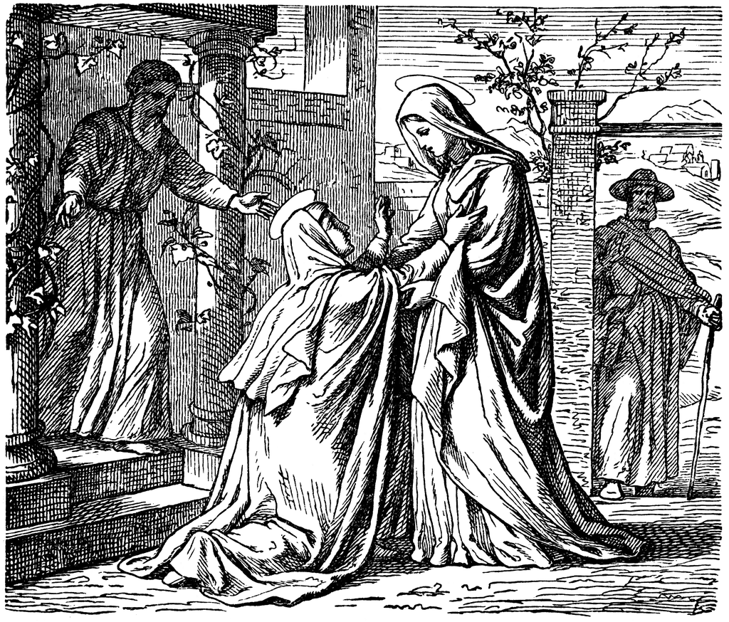
The Festival of the Visitation
July 2, 2017

Emmanuel Lutheran Church
4675 Bataan Memorial West
Las Cruces, New Mexico 88012
(575) 382-0220 (church office) / (575) 636-4988 (pastor cell)
www.GodWithUsLC.org

Sts. Peter & Paul Lutheran Mission
Silver City, New Mexico
www.peterandpaullutheran.org

Rev. Paul A. Rydecki, Pastor
member of the Evangelical Lutheran Diocese of North America (ELDoNA)

ANNOUNCEMENTS
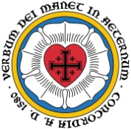
Welcome! Emmanuel is a liturgical, traditional, historical, evangelical, catholic, orthodox, confessional Lutheran congregation, in communion with the Evangelical Lutheran Diocese of North America (ELDoNA). We believe that the Bible is the very Word of God, inspired and without any errors. We confess the truth of Scripture according to the Lutheran Book of Concord of 1580, without exception or reservation. We observe the calendar of the traditional Church Year and follow the Historic Lectionary. We celebrate the Divine Service (also known as the Mass) every Sunday and on other festivals, and we welcome visitors.
With regard to Holy Communion, we ask our visitors to respect our practice of closed Communion, which means that only communicant members of our congregation or of other congregations in communion with us are invited to commune at the Lord’s Table here, after they have been examined and absolved. Classes are offered throughout the year by the pastor so that those who are interested in joining our Communion fellowship have the opportunity to learn about the Christian faith and our confession of it.
Today’s Service celebrates the account of the Virgin Mary’s Visitation to her relative Elizabeth after the Angel Gabriel announced to her that she would give birth to the Son of God. St. Luke tells us that Mary then went to visit Elizabeth, who was six months pregnant with the boy who would be named John (the Baptist). It was on this occasion that Mary spoke (or sang) the words that have come to be known as The Magnificat.
The Order of Service is The Order of Holy Communion (page 15) from The Lutheran Hymnal (TLH). The Scriptures are read from the New King James Version (NKJV). The Propers (the parts that change from week to week) are noted on the following page of this Service Folder.

EVENTS IN THE NEAR FUTURE…
Wed., July 5 - Vespers, 6:30 PM
Sun., July 9 - Bible class 9 AM (No Sunday School)
- Divine Service 10:15 AM (Trinity 4)
July 10 – 29 - Pastor on vacation / at ELDoNA family retreat

Weekly Small Catechism: Creed, First Article, Part 1

PROPERS The Visitation

HYMNS
OPENING HYMN TLH #75 - Ye Sons of Men, Oh, Hearken
HYMN (after the Creed) TLH #275 - My Soul Doth Magnify the Lord
HYMN (after General Prayer) TLH #272 - When All the World was Cursed
DISTRIBUTION HYMN TLH #58 - O Lord How Shall I Meet Thee

Epistle: Isaiah 11:1-5 Gospel: Luke 1:39-56

THE INTROIT (after general Absolution) Psalm 45:12, 14-15; Psalm 45:1
P (Antiphon) THE RICH among the people will seek your | favor. *
She shall be brought to the King in robes of ma- | ny colors;
The virgins, her companions who follow her, shall be brought | to You. *
With gladness and rejoicing they | shall be brought
C My heart is overflowing with a | good theme; *
I recite my composition concern- | ing the King.
GLORIA PATRI (p.16): Glory be to the Father, and to the Son, and to the Holy Ghost; as it was in the beginning, is now, and ever shall be, world without end. Amen.
P (Antiphon)
The service continues with The Kyrie, p. 17, followed immediately by The Gloria.
GRADUAL & HALLELUJAH (after the Epistle) Isaiah 11:1,10, 1; Luke 1:42,45
P There shall come forth a Rod from the stem of | Jesse, *
And a Branch shall grow out | of his roots.
C There shall be a Root of Jesse, who shall stand as a banner to the | people; *
For the Gentiles | shall seek Him.
P Alleluia! Alle- | luia! *
“Blessèd are you, O Mary, a- | mong women,
C And blessèd is the fruit of | your womb! *
Behold, there will be a fulfillment of those things which were told you from the Lord.” Al- | leluia!
The service continues with The Gospel, p. 21.
We believe, teach and confess…

from the Formula of Concord, Epitome: Article VIII
1. The divine and human natures in Christ are personally united. So there are not two Christs, one the Son of God and the other the Son of Man. But one and the same person is the Son of God and Son of Man (Luke 1:35; Romans 9:5).
2. We believe, teach, and confess that the divine and human natures are not mingled into one substance, nor is one changed into the other. Each keeps its own essential properties, which can never become the properties of the other nature.
3. The properties of the divine nature are these: to be almighty, eternal, infinite, and to be everywhere present (according to the property of its nature and its natural essence, of itself), to know everything, and so on. These never become properties of the human nature.
4. The properties of the human nature are to be a bodily creature, to be flesh and blood, to be finite and physically limited, to suffer, to die, to ascend and descend, to move from one place to another, to suffer hunger, thirst, cold, heat, and the like. These never become properties of the divine nature.
5. The two natures are united personally (i.e., in one person). Therefore, we believe, teach, and confess that this union is not the kind of joining together and connection that prevents either nature from having anything in common with the other personally (i.e., because of the personal union). It is not like when two boards are glued together, where neither gives anything to the other or takes anything from the other. But here is described the highest communion that God truly has with the man. From this personal union, the highest and indescribable communion results. There flows everything human that is said and believed about God, and everything divine that is said and believed about the man Christ. The ancient teachers of the Church explained this union and communion of the natures by the illustration of iron glowing with fire, and also by the union of body and soul in man.
6. We believe, teach, and confess that God is man and man is God. This could not be true if the divine and human natures had (in deed and truth) absolutely no communion with each other.
For how could the man, the Son of Mary, in truth be called or be God, or the Son of God the Most High, if His humanity were not personally united with the Son of God? How could He have no real communion (that is, in deed and truth) with the Most High, but only share God’s name?
7. So we believe, teach, and confess that Mary conceived and bore not merely a man and no more, but God’s true Son. Therefore, she also is rightly called and truly is “the mother of God.”

