Service Folder
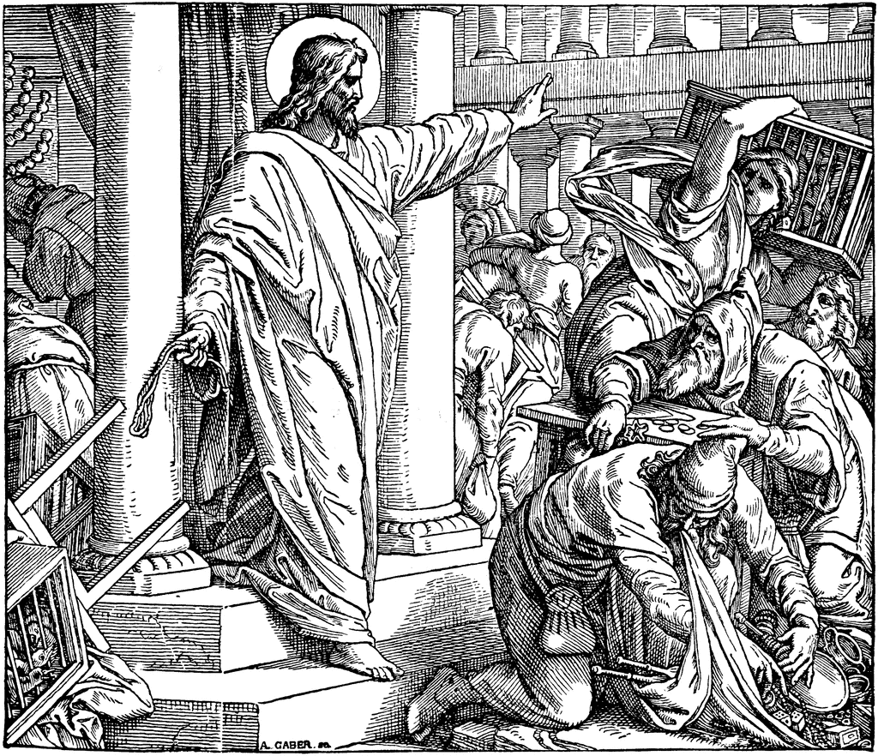
Tenth Sunday after Trinity
August 20, 2017

Emmanuel Lutheran Church
4675 Bataan Memorial West
Las Cruces, New Mexico 88012
(575) 382-0220 (church office) / (575) 636-4988 (pastor cell)
www.GodWithUsLC.org

Sts. Peter & Paul Lutheran Mission
Silver City, New Mexico
www.peterandpaullutheran.org

Rev. Paul A. Rydecki, Pastor
member of the Evangelical Lutheran Diocese of North America (ELDoNA)

ANNOUNCEMENTS
Welcome! Emmanuel is a liturgical, traditional, historical, evangelical, catholic, orthodox, confessional Lutheran congregation, in communion with the Evangelical Lutheran Diocese of North America (ELDoNA). We believe that the Bible is the very Word of God, inspired and without any errors. We confess the truth of Scripture according to the Lutheran Book of Concord of 1580, without exception or reservation. We observe the calendar of the traditional Church Year and follow the Historic Lectionary. We celebrate the Divine Service (also known as the Mass) every Sunday and on other festivals, and we welcome visitors to hear the Word of God with us.
With regard to Holy Communion, we ask our visitors to respect our practice of closed Communion, which means that only communicant members of our congregation or of other congregations in communion with us are invited to commune at the Lord’s Table here, after they have been examined and absolved. Classes are offered throughout the year by the pastor so that those who are interested in joining our Communion fellowship have the opportunity to learn about the Christian faith and our confession of it.
The Order of Service is The Order of Holy Communion (page 15) from The Lutheran Hymnal (TLH). The Scriptures are read from the New King James Version (NKJV). The Propers (the parts that change from week to week) are noted on the following page of this Service Folder.
A Reminder to our members that snacks for the Sunday School children would be appreciated—either the snacks themselves or a donation so that snack items can be purchased for them, since this is a non-budgeted expense.

EVENTS IN THE NEAR FUTURE…
Sun., Aug. 27 - Sunday School & Bible class 9 AM
- Divine Service 10:15 AM (Trinity 11)

PROPERS Trinity 10

HYMNS
OPENING HYMN TLH #290 - We Have a Sure Prophetic Word
HYMN (after the Creed) TLH #419 - O'er Jerusalem Thou Weepest
HYMN (after General Prayer) TLH #383 - Seek Where Ye May to Find a Way
DISTRIBUTION HYMNS TLH #315 - I Come, O Savior, to Thy Table

Epistle: 1 Corinthians 12:1-11 Gospel: Luke 19:41-48

THE INTROIT (after general Absolution) Psalm 55:16-22; Ps. 55:1
P (Antiphon) AS FOR me, I will call upon God, and He shall hear | my voice. *
He has redeemed my soul in peace from the battle that was | against me.
God will hear, and afflict them, even He who abides from | of old. *
Cast your burden on the Lord, and He shall | sustain you.
C Give ear to my prayer, | O God, *
And do not hide Yourself from my sup- | plication.
GLORIA PATRI (p.16): Glory be to the Father, and to the Son, and to the Holy Ghost; as it was in the beginning, is now, and ever shall be, world without end. Amen.
P (Antiphon)
The service continues with The Kyrie, p. 17.
THE GRADUAL & HALLELUJAH (after the Epistle) Psalm 17:8,2; 88:1
P Keep me, O Lord, as the apple of | Your eye; *
Hide me under the shadow | of Your wings.
C Let my vindication come from Your | presence; *
Let Your eyes look on the things that | are upright.
P Alle- | luia! *
Al- | leluia!
C O Lord, God of my sal- | vation, *
I have cried out day and night before You. Al- | leluia!
The service continues with The Gospel, p.21 in the hymnal.

God’s Word at Home

Bible Reading: Genesis 13-26

Small Catechism: Second Commandment
You shall not misuse the name of the Lord your God.
What does this mean?
We should fear and love God so that we do not curse, swear, practice witchcraft, lie, or deceive by His name, but call upon it in every trouble, pray, praise, and give thanks.

Bible Passages:
Genesis 3:15 And I will put enmity Between you and the woman, And between your seed and her Seed; He shall bruise your head, And you shall bruise His heel.”
Genesis 6:5 Then the Lord saw that the wickedness of man was great in the earth, and that every intent of the thoughts of his heart was only evil continually.
Genesis 15:6 And Abraham believed in the Lord, and He accounted it to him for righteousness.

