Service Folder
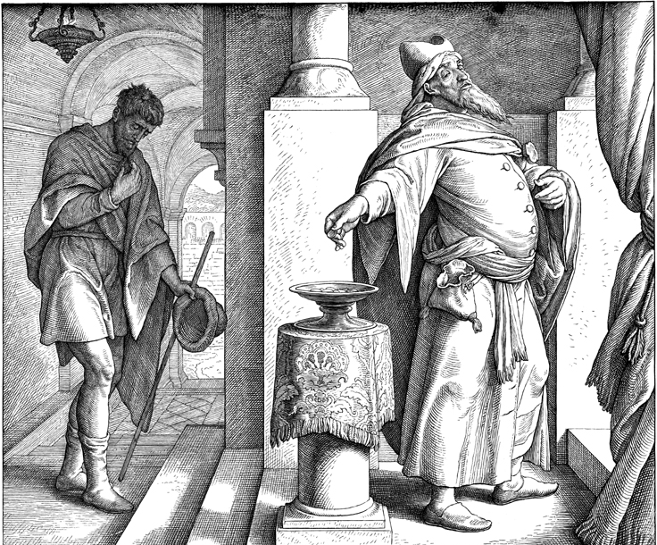
Eleventh Sunday after Trinity
August 27, 2017

Emmanuel Lutheran Church
4675 Bataan Memorial West
Las Cruces, New Mexico 88012
(575) 382-0220 (church office) / (575) 636-4988 (pastor cell)
www.GodWithUsLC.org

Sts. Peter & Paul Lutheran Mission
Silver City, New Mexico
www.peterandpaullutheran.org

Rev. Paul A. Rydecki, Pastor
member of the Evangelical Lutheran Diocese of North America (ELDoNA)

ANNOUNCEMENTS
Welcome! Emmanuel is a liturgical, traditional, historical, evangelical, catholic, orthodox, confessional Lutheran congregation, in communion with the Evangelical Lutheran Diocese of North America (ELDoNA). We believe that the Bible is the very Word of God, inspired and without any errors. We confess the truth of Scripture according to the Lutheran Book of Concord of 1580, without exception or reservation. We observe the calendar of the traditional Church Year and follow the Historic Lectionary. We celebrate the Divine Service (also known as the Mass) every Sunday and on other festivals, and we welcome visitors to hear the Word of God with us.
With regard to Holy Communion, we ask our visitors to respect our practice of closed Communion, which means that only communicant members of our congregation or of other congregations in communion with us are invited to commune at the Lord’s Table here, after they have been examined and absolved. Classes are offered throughout the year by the pastor so that those who are interested in joining our Communion fellowship have the opportunity to learn about the Christian faith and our confession of it.
The Order of Service is The Order of Holy Communion (page 15) from The Lutheran Hymnal (TLH). The Scriptures are read from the New King James Version (NKJV). The Propers (the parts that change from week to week) are noted on the following page of this Service Folder.

EVENTS IN THE NEAR FUTURE…
Sun., Sept. 3 - Sunday School & Bible class 9 AM
- Divine Service 10:15 AM (Trinity 12)

PROPERS Trinity 11

HYMNS
OPENING HYMN TLH #380 - Thy Works, Not Mine, O Christ
HYMN (after the Creed) TLH #318 - Before Thee God Who Knowest All
HYMN (after General Prayer) TLH #375 - If Thy Beloved Son O God
DISTRIBUTION HYMN TLH #305 - Soul Adorn Thyself with Gladness

Epistle: 1 Corinthians 15:1-10 Gospel: Luke 18:9-14

The Order of Holy Communion begins on p. 15 of The Lutheran Hymnal.
THE INTROIT (after general Absolution) Ps. 68:5b, 6a, 35b; Ps. 68:1
P (Antiphon) God is in His holy habi- | tation. *
God sets the solitary in | families.
The God of Israel is He who | gives strength *
And power to | His people.
C Let God arise, Let His enemies be | scattered; *
Let those also who hate Him flee | before Him.
GLORIA PATRI (p.16): Glory be to the Father, and to the Son, and to the Holy Ghost; as it was in the beginning, is now, and ever shall be, world without end. Amen.
P (Antiphon)
The service continues with The Kyrie, p. 17.
THE GRADUAL & HALLELUJAH (after the Epistle) Ps. 28:7b, 1b, 2a; 90:1
P My heart trusted in God, and I | am helped; *
Therefore my heart greatly rejoices; And with my song I | will praise Him.
C To You I will cry, O Lord, | my Rock; *
Do not be silent to me, hear the voice of my sup- | plications.
P Alle- | luia! * Al- | leluia!
C Lord, You have been our dwelling place in all gener- | ations. *
Al- | leluia!
The service continues with The Gospel, p.21 in the hymnal.
God’s Word at Home

Bible Reading: Genesis 27-39

Small Catechism: Third Commandment
You shall sanctify the Sabbath day.
What does this mean?
We should fear and love God so that we do not despise preaching and His Word, but hold it sacred and gladly hear and learn it.

Bible Passages:
Exodus 20:11 For in six days the Lord made the heavens and the earth, the sea, and all that is in them, and rested the seventh day. Therefore the Lord blessed the Sabbath day and hallowed it.
Leviticus 19:2 You shall be holy, for I the Lord your God am holy.
Deuteronomy 6:4 Hear, O Israel: The Lord our God, the Lord is one!

