Service Folder
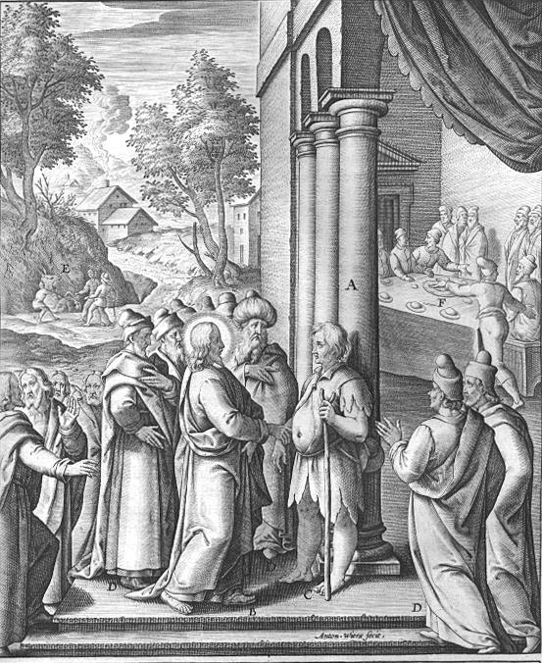
Seventeenth Sunday after Trinity
October 8, 2017
Emmanuel Lutheran Church
4675 Bataan Memorial West
Las Cruces, New Mexico 88012
(575) 382-0220 (church office) / (575) 636-4988 (pastor cell)
www.GodWithUsLC.org

Sts. Peter & Paul Lutheran Mission
Silver City, New Mexico
www.peterandpaullutheran.org

Rev. Paul A. Rydecki, Pastor
member of the Evangelical Lutheran Diocese of North America (ELDoNA)

ANNOUNCEMENTS
Welcome! Emmanuel is a liturgical, traditional, historical, evangelical, catholic, orthodox, confessional Lutheran congregation, in communion with the Evangelical Lutheran Diocese of North America (ELDoNA). We believe that the Bible is the very Word of God, inspired and without any errors. We confess the truth of Scripture according to the Lutheran Book of Concord of 1580, without exception or reservation. We observe the calendar of the traditional Church Year and follow the Historic Lectionary. We celebrate the Divine Service (also known as the Mass) every Sunday and on other festivals, and we welcome visitors to hear the Word of God with us.
With regard to Holy Communion, we ask our visitors to respect our practice of closed Communion, which means that only communicant members of our congregation or of other congregations in communion with us are invited to commune at the Lord’s Table here, after they have been examined and absolved. Classes are offered throughout the year by the pastor so that those who are interested in joining our Communion fellowship have the opportunity to learn about the Christian faith and our confession of it.
The Order of Service is The Order of Holy Communion (page 15) from The Lutheran Hymnal (TLH). The Scriptures are read from the New King James Version (NKJV). The Propers (the parts that change from week to week) are noted on the following page of this Service Folder.

EVENTS IN THE NEAR FUTURE…
Sun., Oct. 15 - Sunday School & Bible Class, 9 AM
- Divine Service, 10:15 AM (Trinity 18)
Wed., Oct. 18 - Divine Service, 6:30 PM (St. Luke, Evangelist)
Sun., Oct. 22 - Sunday School & Bible Class, 9 AM
- Divine Service, 10:15 AM (Trinity 19)
Sun., Oct. 29 - Sunday School & Bible Class, 9 AM
- Divine Service, 10:15 AM (Reformation, transferred)
- Reformation Party @ Sagecrest Park, 12:30-3:30 PM (actual reservation of park is from 12:00 – 4:00 pm)

PROPERS Trinity 17

HYMNS
OPENING HYMN TLH #465 - Christ Is Our Cornerstone
HYMN (after the Creed) TLH #329 - From Depths of Woe I Cry to Thee
HYMN (after General Prayer) TLH #330 - I Come to Thee O Blessed Lord
DISTRIBUTION HYMNS TLH #324 - Jesus Sinners Doth Receive
TLH #321 - O Faithful God Thanks Be to Thee

Epistle: Ephesians 4:1-6 Gospel: Luke 14:1-11

The Order of Holy Communion begins on p. 15 of The Lutheran Hymnal.
THE INTROIT (after general Absolution) Psalm 119:137, 124a; Psalm 119:1
P (Antiphon) RIGHTEOUS are You, | O Lord, *
And upright | are Your judgments.
Deal with Your | servant * According | to Your mercy.
C Blessèd are the undefiled in | the way, *
Who walk in the | Law of the Lord!
GLORIA PATRI (p.16): Glory be to the Father, and to the Son, and to the Holy Ghost; as it was in the beginning, is now, and ever shall be, world without end. Amen.
P (Antiphon)
The service continues with The Kyrie, p. 17.
THE GRADUAL & HALLELUJAH (after the Epistle) Psalm 33:12, 6; 118:16
P Blessèd is the nation whose God is | the Lord, *
The people He has chosen as His own | inheritance.
C By the word of the Lord the heavens | were made, *
And all the host of them by the | breath of His mouth.
P Alle- | luia. * Al- | — le-lu-ia.
C The right hand of the Lord is ex- | alted; *
The right hand of the Lord does valiantly. | Alleluia!
The service continues with The Gospel, p.21 in the hymnal.
God’s Word at Home

Bible Reading: Leviticus 16 – Numbers 1

Small Catechism: Ninth Commandment
You shall not covet your neighbor's house.
What does this mean?
We should fear and love God so that we do not plot to get our neighbor’s inheritance or house, or get it in a way that outwardly appears to be lawful, but help and be of service to him in keeping it.

Bible Passages:
Psalm 50:15 Call upon Me in the day of trouble; I will deliver you, and you shall glorify Me.”
Psalm 51:5 Behold, I was brought forth in iniquity, And in sin my mother conceived me.
Psalm 90:1-2 Lord, You have been our dwelling place in all generations. Before the mountains were brought forth, Or ever You had formed the earth and the world, Even from everlasting to everlasting, You are God.

