Service Folder
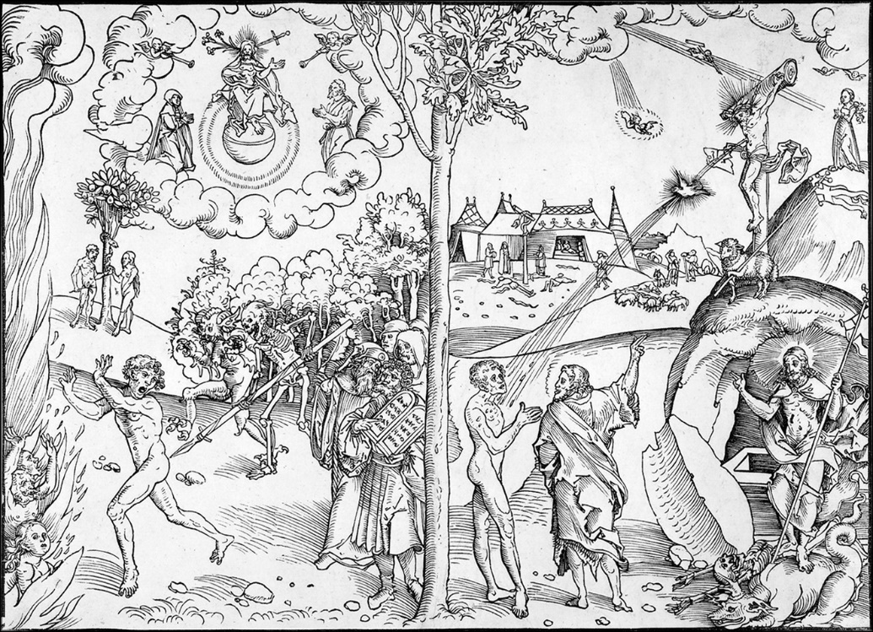
Eighteenth Sunday after Trinity
October 15, 2017

Emmanuel Lutheran Church
4675 Bataan Memorial West
Las Cruces, New Mexico 88012
(575) 382-0220 (church office) / (575) 636-4988 (pastor cell)
www.GodWithUsLC.org

Sts. Peter & Paul Lutheran Mission
Silver City, New Mexico
www.peterandpaullutheran.org

Rev. Paul A. Rydecki, Pastor
member of the Evangelical Lutheran Diocese of North America (ELDoNA)

ANNOUNCEMENTS
Welcome! Emmanuel is a liturgical, traditional, historical, evangelical, catholic, orthodox, confessional Lutheran congregation, in communion with the Evangelical Lutheran Diocese of North America (ELDoNA). We believe that the Bible is the very Word of God, inspired and without any errors. We confess the truth of Scripture according to the Lutheran Book of Concord of 1580, without exception or reservation. We observe the calendar of the traditional Church Year and follow the Historic Lectionary. We celebrate the Divine Service (also known as the Mass) every Sunday and on other festivals, and we welcome visitors to hear the Word of God with us.
With regard to Holy Communion, we ask our visitors to respect our practice of closed Communion, which means that only communicant members of our congregation or of other congregations in communion with us are invited to commune at the Lord’s Table here, after they have been examined and absolved. Classes are offered throughout the year by the pastor so that those who are interested in joining our Communion fellowship have the opportunity to learn about the Christian faith and our confession of it.
The Order of Service is The Order of Holy Communion (page 15) from The Lutheran Hymnal (TLH). The Scriptures are read from the New King James Version (NKJV). The Propers (the parts that change from week to week) are noted on the following page of this Service Folder.

EVENTS IN THE NEAR FUTURE…
Wed., Oct. 18 - Divine Service, 6:30 PM (St. Luke, Evangelist)
Sun., Oct. 22 - Sunday School & Bible Class, 9 AM
- Divine Service, 10:15 AM (Trinity 19)
Sun., Oct. 29 - Sunday School & Bible Class, 9 AM
- Divine Service, 10:15 AM (Reformation, observed)
- Reformation Party @ Sagecrest Park, 12:30-3:30 PM (actual reservation of park is from 12:00 – 4:00 pm)

PROPERS Trinity 18

HYMNS
OPENING HYMN TLH #293 - O Holy Spirit, Grant Us Grace
HYMN (after the Creed) TLH #143 - O Dearest Jesus (st. 1-7)
HYMN (after General Prayer) TLH #349 - Jesus, Thy Boundless Love (st. 1-4)
DISTRIBUTION HYMNS TLH #313 - O Lord We Praise Thee
TLH #316 - O Living Bread from Heaven

Epistle: 1 Corinthians 1:4-9 Gospel: Matthew 22:34-46

The Order of Holy Communion begins on p. 15 of The Lutheran Hymnal.
THE INTROIT (after general Absolution) Ecclesiasticus 36:16-17; Psalm 122:1
P (Antiphon) REWARD, O Lord, those who wait | for You: *
And let Your prophets | be found faithful.
Hear the prayer of Your | servants, *
And of Your peo- | ple Israel.
C I was glad when they said | to me, *
“Let us go into the | house of the Lord.”
GLORIA PATRI (p.16): Glory be to the Father, and to the Son, and to the Holy Ghost; as it was in the beginning, is now, and ever shall be, world without end. Amen.
P (Antiphon)
The service continues with The Kyrie, p. 17.
THE GRADUAL & HALLELUJAH (after the Epistle) Ps. 122:1,7; Ps. 117:1
P I was glad when they said | to me, *
“Let us go into the | house of the Lord.”
C “Peace be within | your walls, *
Prosperity within | your palaces.”
P Alle- | luia. * Al- | — le-lu-ia.
C Praise the Lord, all you | Gentiles! *
Laud Him, all you peoples! | Alleluia!
The service continues with The Gospel, p.21 in the hymnal.
God’s Word at Home

Bible Reading: Number 2-14

Small Catechism: Tenth Commandment
You shall not covet your neighbor’s wife, servant, maid, cattle, or anything that is his.
What does this mean?
We should fear and love God, that we do not alienate or tear away from our neighbor his wife, servants or cattle, nor cause them to desert him; but urge them to stay and do their duty.

Bible Passages:
Psalm 91:10-12 No evil shall befall you, Nor shall any plague come near your dwelling; For He shall give His angels charge over you, To keep you in all your ways. In their hands they shall bear you up, Lest you dash your foot against a stone.
Psalm 119:105 Your word is a lamp to my feet And a light to my path.

