Service Folder
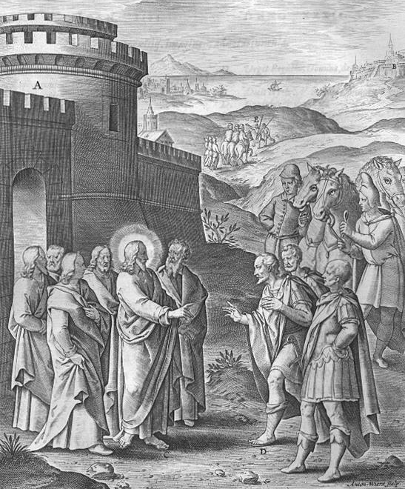
Twenty-first Sunday after Trinity
November 5, 2017
Emmanuel Lutheran Church
4675 Bataan Memorial West
Las Cruces, New Mexico 88012
(575) 382-0220 (church office) / (575) 636-4988 (pastor cell)
www.GodWithUsLC.org

Sts. Peter & Paul Lutheran Mission
Silver City, New Mexico
www.peterandpaullutheran.org

Rev. Paul A. Rydecki, Pastor
member of the Evangelical Lutheran Diocese of North America (ELDoNA)

ANNOUNCEMENTS
Welcome! Emmanuel is a liturgical, traditional, historical, evangelical, catholic, orthodox, confessional Lutheran congregation, in communion with the Evangelical Lutheran Diocese of North America (ELDoNA). We believe that the Bible is the very Word of God, inspired and without any errors. We confess the truth of Scripture according to the Lutheran Book of Concord of 1580, without exception or reservation. We observe the calendar of the traditional Church Year and follow the Historic Lectionary. We celebrate the Divine Service (also known as the Mass) every Sunday and on other festivals, and we welcome visitors to hear God’s Word with us.
With regard to Holy Communion, we ask our visitors to respect our practice of closed Communion, which means that only communicant members of our congregation or of other congregations in communion with us are invited to commune at the Lord’s Table here, after they have been examined and absolved. Classes are offered throughout the year by the pastor so that those who are interested in joining our Communion fellowship have the opportunity to learn about the Christian faith and our confession of it.
The Order of Service is The Order of Holy Communion (page 15) from The Lutheran Hymnal (TLH). The Scriptures are read from the New King James Version (NKJV). The Propers (the parts that change from week to week) are noted on the following page of this Service Folder.

EVENTS IN THE NEAR FUTURE…
Sun., Nov. 12 - Bible Class/Sunday School, 9 AM
- Divine Service, 10:15 AM (Trinity 25 – Third to Last)

PROPERS Trinity 21

HYMNS
OPENING HYMN TLH #293 - O Holy Spirit, Grant Us Grace
HYMN (after the Creed) TLH #524 - In Thee Lord Have I Put My Trust
HYMN (after General Prayer) TLH #381 - I Know My Faith Is Founded
DISTRIBUTION HYMN TLH #385 - Now I Have Found the Firm Foundation

Epistle: Ephesians 6:10-17 Gospel: John 4:46-54

The Order of Holy Communion begins on p. 15 of The Lutheran Hymnal.
THE INTROIT (after general Absolution) Apocryphal Esther 13:9,10,11; Ps. 119:1
P (Antiphon) The whole world is in Your power; O Lord, | King Almighty, *
No one | can gainsay — You.
For You have made heaven and earth, and all the wondrous things un- | der the heaven. *
You | are Lord of — all!
C Blessèd are the unde- | filed in the way, *
Who walk in the | law of the — Lord!
GLORIA PATRI (p.16): Glory be to the Father, and to the Son, and to the Holy Ghost; as it was in the beginning, is now, and ever shall be, world without end. Amen.
P (Antiphon)
The service continues with The Kyrie, p. 17.
THE GRADUAL & HALLELUJAH (after the Epistle) Ps. 90:1-2; Ps. 125:1
P Lord, You have been | our dwelling place *
In all | genera- -tions.
C Before the mountains were brought forth, before You ever had formed the | earth and the world, *
Even from everlasting to everlast- | ing, You are — God.
P Al- | - leluia. * Al- | - lelu- -ia.
C Those who trust in the Lord are | like Mount Zion, *
Which cannot be moved, but abides forever. | Allelu- -ia.
The service continues with The Gospel, p.21 in the hymnal.
God’s Word at Home

Bible Reading: Deuteronomy 5-18

Small Catechism: Creed, First Article, Part 1
I believe in God, the Father Almighty, Creator of heaven and earth.
What does this mean?
I believe that God has made me and all created things; that He has given me my body and soul, eyes, ears, and all my members, my reason and all my senses, and still preserves them;

Bible Passages:
Psalm 143:2 Do not enter into judgment with Your servant, For in Your sight no one living is righteous.
Psalm 145:9 The Lord is good to all, And His tender mercies are over all His works.
Proverbs 3:5-6 Trust in the Lord with all your heart, And lean not on your own understanding; In all your ways acknowledge Him, And He shall direct your paths.

