Service Folder
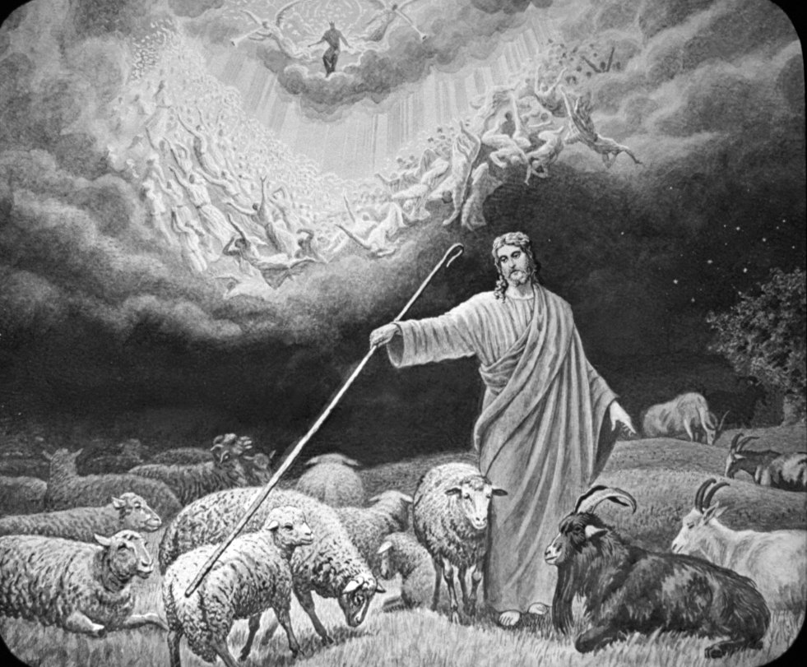
Second-to-Last Sunday after Trinity
November 19, 2017

Emmanuel Lutheran Church
4675 Bataan Memorial West
Las Cruces, New Mexico 88012
(575) 382-0220 (church office) / (575) 636-4988 (pastor cell)
www.GodWithUsLC.org

Sts. Peter & Paul Lutheran Mission
Silver City, New Mexico
www.peterandpaullutheran.org

Rev. Paul A. Rydecki, Pastor
member of the Evangelical Lutheran Diocese of North America (ELDoNA)

ANNOUNCEMENTS
Welcome! Emmanuel is a liturgical, traditional, historical, evangelical, catholic, orthodox, confessional Lutheran congregation, in communion with the Evangelical Lutheran Diocese of North America (ELDoNA). We believe that the Bible is the very Word of God, inspired and without any errors. We confess the truth of Scripture according to the Lutheran Book of Concord of 1580, without exception or reservation. We observe the calendar of the traditional Church Year and follow the Historic Lectionary. We celebrate the Divine Service (also known as the Mass) every Sunday and on other festivals, and we welcome visitors to hear God’s Word with us.
With regard to Holy Communion, we ask our visitors to respect our practice of closed Communion, which means that only communicant members of our congregation or of other congregations in communion with us are invited to commune at the Lord’s Table here, after they have been examined and absolved. Classes are offered throughout the year by the pastor so that those who are interested in joining our Communion fellowship have the opportunity to learn about the Christian faith and our confession of it.
The Order of Service is The Order of Holy Communion (page 15) from The Lutheran Hymnal (TLH). The Scriptures are read from the New King James Version (NKJV). The Propers (the parts that change from week to week) are noted on the following page of this Service Folder.

EVENTS IN THE NEAR FUTURE…
Wed., Nov. 22 - 6PM Thanksgiving Vespers, followed by dessert
Sun., Nov. 26 - Bible Class/Sunday School, 9AM
- Divine Service, 10:15 AM (Trinity 27)

PROPERS Trinity 26

HYMNS
OPENING HYMN TLH #605 - The World Is Very Evil
HYMN (after the Creed) TLH #611 - The Day Is Surely Drawing Near
HYMN (after General Prayer) TLH #610 - And Will the Judge Descend
DISTRIBUTION HYMN TLH #607 - Day of Wrath Oh Day of Mourning

Epistle: 2 Peter 3:3-14 Gospel: Matthew 25:31-46

The Order of Holy Communion begins on p. 15 of The Lutheran Hymnal.
THE INTROIT (after general Absolution) Psalm 54:1–2; Psalm 54:3
P (Antiphon) SAVE ME, O | God, by Your name, *
And vindicate | me by Your strength. —
Hear | my prayer, O God; *
Give ear to the | words of my mouth. —
C For strangers have risen | up against me; *
They have not set | God before them. —
GLORIA PATRI (p.16): Glory be to the Father, and to the Son, and to the Holy Ghost; as it was in the beginning, is now, and ever shall be, world without end. Amen.
P (Antiphon)
THE GRADUAL & HALLELUJAH (after the Epistle) Psalm 50:4,6; Is. 35:10
P He shall call to the heav- | ens from above, *
And to the earth, that He may | judge His people. —
C Let the heavens declare | His righteousness, *
For God | Himself is Judge. —
P Alleluia. Alleluia. The ransomed of the | Lord shall return, *
and come to Zion with singing, with everlasting | joy on their heads. —
C They shall obtain | joy and gladness, *
and sorrow and sighing shall flee away. | Alleluia. —
The service continues with The Triple Hallelujah and Gospel, p.20 in the hymnal.

God’s Word at Home

Bible Reading: Deuteronomy 33 – Joshua 10

Small Catechism: Creed, First Article, Part 3
He also richly and daily provides me with clothing and shoes, food and drink, house and yard, wife and children, land, cattle, and all that I have—with all the needs and necessities of this body and life; He shields me against all danger and guards and protects me from all evil;

Bible Passages:
Isaiah 49:6 Indeed He says, "It is too small a thing that You should be My Servant To raise up the tribes of Jacob, And to restore the preserved ones of Israel; I will also give You as a light to the Gentiles, That You should be My salvation to the ends of the earth."
Isaiah 53:5-6 But He was wounded for our transgressions, He was bruised for our iniquities; The chastisement for our peace was upon Him, And by His stripes we are healed. All we like sheep have gone astray; We have turned, every one, to his own way; And the Lord has laid on Him the iniquity of us all.

