Service Folder
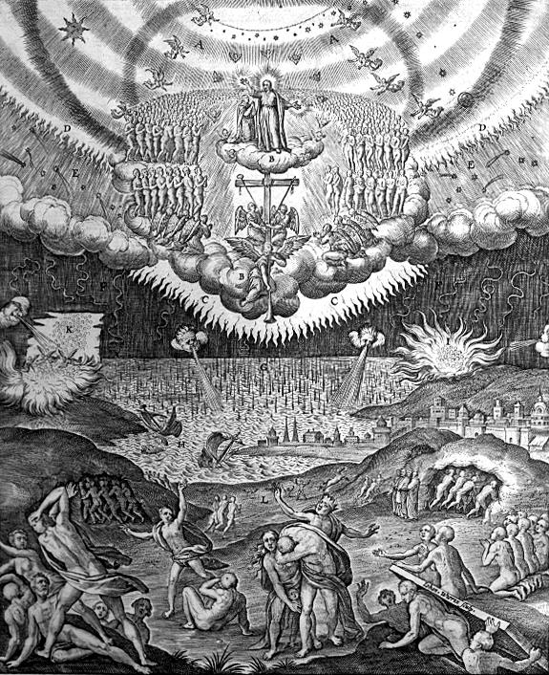
The Second Sunday in Advent
Populus Sion – “Daughter of Zion, behold!”
December 10, 2017

Emmanuel Lutheran Church
4675 Bataan Memorial West
Las Cruces, New Mexico 88012
(575) 382-0220 (church office) / (575) 636-4988 (pastor cell)
www.GodWithUsLC.org

Sts. Peter & Paul Lutheran Mission
Silver City, New Mexico
www.peterandpaullutheran.org

Rev. Paul A. Rydecki, Pastor
member of the Evangelical Lutheran Diocese of North America (ELDoNA)

ANNOUNCEMENTS
Welcome! Emmanuel is a liturgical, traditional, historical, evangelical, catholic, orthodox, confessional Lutheran congregation, in communion with the Evangelical Lutheran Diocese of North America (ELDoNA). We believe that the Bible is the very Word of God, inspired and without any errors. We confess the truth of Scripture according to the Lutheran Book of Concord of 1580, without exception or reservation. We observe the calendar of the traditional Church Year and follow the Historic Lectionary. We celebrate the Divine Service (also known as the Mass) every Sunday and on other festivals, and we welcome visitors to hear the Word of God with us.
With regard to Holy Communion, we ask our visitors to respect our practice of closed Communion, which means that only communicant members of our congregation or of other congregations in communion with us are invited to commune at the Lord’s Table here, after they have been examined and absolved. Classes are offered throughout the year by the pastor so that those who are interested in joining our Communion fellowship have the opportunity to learn about the Christian faith and our confession of it.
The Order of Service is The Order of Holy Communion (page 15) from The Lutheran Hymnal (TLH). The Scriptures are read from the New King James Version (NKJV). The Propers (the parts that change from week to week) are noted on the following page of this Service Folder.
Note: The Gloria in Excelsis is omitted during the Advent season.
EVENTS IN THE NEAR FUTURE…
TODAY - Church Christmas Party at the Rydecki’s, after the service
Wed., Dec. 13 - Supper, 5:45 PM; Advent Vespers, 6:30 PM
Sun., Dec. 17 - Sunday School & Bible Class, 9 AM
- Divine Service, 10:15 AM (Advent 3)
Wed., Dec. 20 - Supper, 5:45 PM; Advent Vespers, 6:30 PM
- Caroling at one or two houses, after Vespers
Sun., Dec. 24 - Sunday School & Bible Class, 9 AM
- Divine Service, 10:15 AM (Advent 4)
- Christmas Eve Vespers, 6:30 PM
Mon., Dec. 25 - Christmas Day Divine Service, 10 AM
Sun., Dec. 31 - No Sunday School or Bible Class
- Divine Service, 10:15 AM (Sunday after Christmas)
Sat., Jan. 6 - Matins, 10 AM (The Epiphany of Our Lord)
Sun., Jan. 7 - No Sunday School. (Bible Class TBD)
- Divine Service, 10:15 AM (Epiphany 1)

PROPERS Advent 2

HYMNS
OPENING HYMN TLH #612 - That Day of Wrath, That Dreadful Day
HYMN (after the Creed) TLH #69 - Arise Sons of the Kingdom
HYMN (after General Prayer) TLH #613 - Jerusalem the Golden
DISTRIBUTION HYMN TLH #306 - Lord Jesus Christ Thou Hast Prepared

Epistle: Romans 15:4-13 Gospel: Luke 21:25-36

The Order of Holy Communion begins on p. 15 of The Lutheran Hymnal.
INTROIT (after The Confession of Sins) Is. 30:29-30, 62:11; Ps. 80:1,3,14,17
After the Refrain is introduced one time (1x) by the organ/guitar, all join to sing it three times (3x). The Psalm verses and Gloria Patri are spoken while the music plays softly in the background. Then the Refrain is sung by all twice (2x) more.
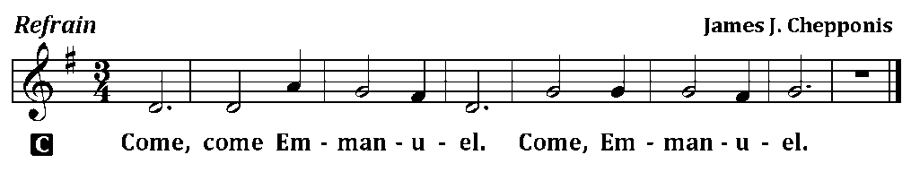
C (Sing Refrain 3x while the Pastor sings the first line of the Psalm: O Daughter of Zion, Behold!)
P Daughter of Zion, Behold,
C Surely your salvation is coming.
P The Lord will cause His glorious voice to be heard,
C And you shall have gladness of heart.
P Give ear, O Shepherd of Israel, You who lead Jacob like a flock.
C Restore us, O God; cause Your face to shine, and we shall be saved!
P Return, we beseech You, O God of Hosts,
C Look down from heaven and see.
P Let Your hand be upon the Man of Your right hand,
C Upon the Son of Man whom You made strong for Yourself.
C Glory be to the Father and to the Son and to the Holy Ghost; as it was in the beginning, is now, and ever shall be, world without end. Amen.
C (Sing Refrain 2x)
The service continues with The Kyrie on p.17, followed by the Salutation & Collect.
After the Epistle follows the Gradual & Hallelujah (next page).

THE GRADUAL & HALLELUJAH (after the Epistle) Ps. 50:2-3,5; Lk. 21:26c-27
P Out of Zion, the perfec- | tion of beauty,
God will shine forth: | Our God shall come. __
Gather My saints toge- | ther unto Me,
Those who have made a covenant with Me | by sacrifice. __
C Alleluia. Alleluia. The powers of heaven | will be shaken.
Then they will see the Son of Man coming in a cloud with power and great glory. | Alleluia. __
The service continues with The Triple Hallelujah and The Gospel, p. 20-21.

God’s Word at Home

Bible Reading: Judges 14 – 1 Samuel 1

Small Catechism: Creed, Third Article, Part 1
I believe in the Holy Spirit; the holy Christian Church, the communion of saints; the forgiveness of sins, the resurrection of the body; and the life everlasting. Amen.
What does this mean?
I believe that I cannot by my own reason or strength believe in Jesus Christ, my Lord, or come to Him; but the Holy Spirit has called me by the Gospel, enlightened me with His gifts, sanctified and preserved me in the true faith; just as He calls, gathers, enlightens and sanctifies the whole Christian Church on earth, and preserves it with Jesus Christ in the one true faith.

Bible Passages:
Ezekiel 33:11 "As I live," says the Lord God, "I have no pleasure in the death of the wicked, but that the wicked turn from his way and live. Turn, turn from your evil ways! For why should you die, O house of Israel?"
Malachi 3:6 For I am the Lord, I do not change; Therefore you are not consumed, O sons of Jacob.
Matthew 3:2 Repent, for the kingdom of heaven is at hand!

