Service Folder
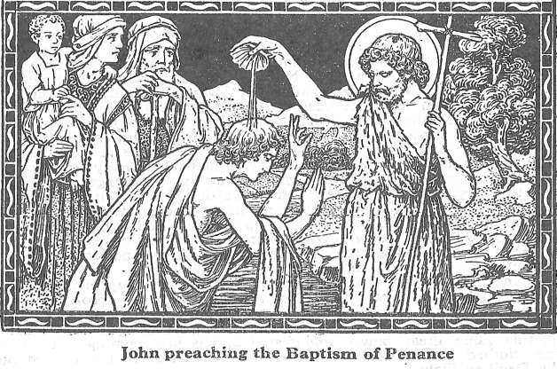
The Fourth Sunday in Advent
Rorate Coeli – “Rain down, O heavens, from above!”
December 24, 2017

Emmanuel Lutheran Church
4675 Bataan Memorial West
Las Cruces, New Mexico 88012
(575) 382-0220 (church office) / (575) 636-4988 (pastor cell)
www.GodWithUsLC.org

Sts. Peter & Paul Lutheran Mission
Silver City, New Mexico
www.peterandpaullutheran.org

Rev. Paul A. Rydecki, Pastor
member of the Evangelical Lutheran Diocese of North America (ELDoNA)

ANNOUNCEMENTS
Welcome! Emmanuel is a liturgical, traditional, historical, evangelical, catholic, orthodox, confessional Lutheran congregation, in communion with the Evangelical Lutheran Diocese of North America (ELDoNA). We believe that the Bible is the very Word of God, inspired and without any errors. We confess the truth of Scripture according to the Lutheran Book of Concord of 1580, without exception or reservation. We observe the calendar of the traditional Church Year and follow the Historic Lectionary. We celebrate the Divine Service (also known as the Mass) every Sunday and on other festivals, and we welcome visitors to hear God’s Word with us.
With regard to Holy Communion, we ask our visitors to respect our practice of closed Communion, which means that only communicant members of our congregation or of other congregations in communion with us are invited to commune at the Lord’s Table here, after they have been examined and absolved. Classes are offered throughout the year by the pastor so that those who are interested in joining our Communion fellowship have the opportunity to learn about the Christian faith and our confession of it.
The Order of Service is The Order of Holy Communion (page 15) from The Lutheran Hymnal (TLH). The Scriptures are read from the New King James Version (NKJV). The Propers (the parts that change from week to week) are noted on the following page of this Service Folder.
Note: The Gloria in Excelsis is omitted during the Advent season.

There will be no Sunday School for the next two Sundays.
There will be no Bible Class next Sunday, but there will be class on Jan. 7.
EVENTS IN THE NEAR FUTURE…
TODAY - Sunday School & Bible Class, 9 AM
- Divine Service, 10:15 AM (Advent 4)
- Christmas Eve Vespers, 6:30 PM
Mon., Dec. 25 - Christmas Day Divine Service, 10 AM
Sun., Dec. 31 - (No Sunday School or Bible Class)
- Divine Service, 10:15 AM (Sunday after Christmas)

PROPERS Advent 4

HYMNS
OPENING HYMN TLH #95 - Savior of the Nations, Come
HYMN (after the Creed) TLH #61 - Comfort, Comfort Ye My People
HYMN (after General Prayer) TLH #60 - Hark! A Thrilling Voice is Sounding
DISTRIBUTION HYMNS TLH #74 - Once He Came in Blessing
TLH #314 - Lord Jesus Christ, We Humbly Pray

Epistle: Philippians 4:4-7 Gospel: John 1:19-28

The Order of Holy Communion begins on p. 15 of The Lutheran Hymnal.
INTROIT Isaiah 45:8; Psalm 19:1, 4-6
After the Refrain is introduced one time (1x) by the organ/guitar, all join to sing it three times (3x). The Psalm verses and Gloria Patri are spoken while the music plays softly in the background. Then the Refrain is sung by all twice (2x) more.
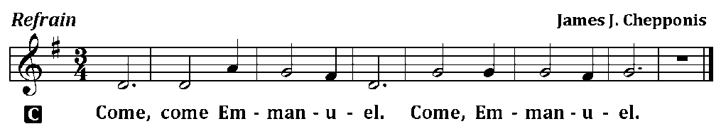
C (Sing Refrain 3x while the Pastor sings the first line of the Psalm: Rain down, O heav’ns, from above!)
P Rain down, you heavens, from above, *
C And let the skies pour down righteousness;
P Let the earth open her womb, *
C And bring forth salvation.
P The heavens declare the glory of God; *
C And the firmament shows His handiwork.
P Their line is gone out into all the earth, *
C And their words to the end of the world.
P In the heavens He has set a tabernacle for the sun, *
C Which is like a bridegroom coming out of his chamber.
P Its rising is from one end of the heaven, *
C And its circuit to the other end.
C Glory be to the Father and to the Son and to the Holy Ghost;
as it was in the beginning, is now, and ever shall be, world without end. Amen.
C (Sing Refrain 2x)
The service continues with The Kyrie on p.17, followed by the Salutation & Collect.
After the Epistle follows the Gradual & Hallelujah (next page).
THE GRADUAL & HALLELUJAH (after the Epistle) Ps. 145:18, 21; 40:17
P The Lord is near to all who | call upon Him,
To all who call up- | on Him in truth. __
My mouth shall speak the | praise of the Lord,
And all flesh shall bless | His holy name. __
C Alleluia. Alleluia. You are my help and my | deliverer;
Do not delay, O my God. | Alleluia. __
The service continues with The Triple Hallelujah and The Gospel, p. 20-21.

God’s Word at Home

Bible Reading: 1 Samuel 15-28

Small Catechism: Lord’s Prayer, Our Father
Our Father, who art in Heaven.
What does this mean?
With these words, God would invite us to believe that He is our true Father, and that we are His true children, so that with all boldness and confidence we should ask Him, as dear children ask their dear father.

Bible Passages:
Matthew 6:33 But seek first the kingdom of God and His righteousness, and all these things shall be added to you.
Matthew 7:7 Ask, and it will be given to you; seek, and you will find; knock, and it will be opened to you.
Matthew 7:15 Beware of false prophets, who come to you in sheep’s clothing, but inwardly they are ravenous wolves.

