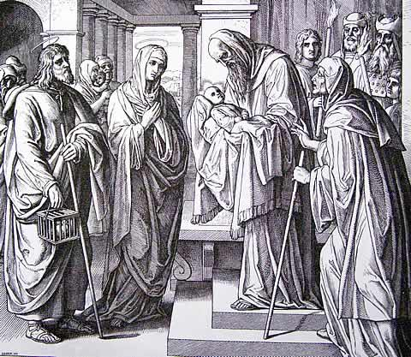
Service Folder
The Sunday after Christmas
December 31, 2017

Emmanuel Lutheran Church
4675 Bataan Memorial West
Las Cruces, New Mexico 88012
(575) 382-0220 (church office) / (575) 636-4988 (pastor cell)
www.GodWithUsLC.org

Sts. Peter & Paul Lutheran Mission
Silver City, New Mexico
www.peterandpaullutheran.org

Rev. Paul A. Rydecki, Pastor
member of the Evangelical Lutheran Diocese of North America (ELDoNA)

ANNOUNCEMENTS
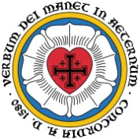
Welcome! Emmanuel is a liturgical, traditional, historical, evangelical, catholic, orthodox, confessional Lutheran congregation, in communion with the Evangelical Lutheran Diocese of North America (ELDoNA). We believe that the Bible is the very Word of God, inspired and without any errors. We confess the truth of Scripture according to the Lutheran Book of Concord of 1580, without exception or reservation. We observe the calendar of the traditional Church Year and follow the Historic Lectionary. We celebrate the Divine Service (also known as the Mass) every Sunday and on other festivals, and we welcome visitors to hear God’s Word with us.
With regard to Holy Communion, we ask our visitors to respect our practice of closed Communion, which means that only communicant members of our congregation or of other congregations in communion with us are invited to commune at the Lord’s Table here, after they have been examined and absolved. Classes are offered throughout the year by the pastor so that those who are interested in joining our Communion fellowship have the opportunity to learn about the Christian faith and our confession of it.
The Order of Service is The Order of Holy Communion (page 15) from The Lutheran Hymnal (TLH). The Scriptures are read from the New King James Version (NKJV). The Propers (the parts that change from week to week) are noted on the following page of this Service Folder.

EVENTS IN THE NEAR FUTURE…
Sat., Jan. 6 - Matins, 10 AM (The Epiphany of Our Lord)
Sun., Jan. 7 - No Sunday School or Bible Class
- Divine Service, 10:15 AM (Epiphany 1)

God’s Word at Home:
Bible Reading: 1 Samuel 29 – 2 Samuel 11
Small Catechism: Lord’s Prayer, First Petition, Part 1
Bible Passages: Matthew 10:32, Matthew 11:28-30

PROPERS Sunday after Christmas

HYMNS
OPENING HYMN TLH #90 - Come, Your Hearts and Voices Raising
HYMN (after the Creed) TLH #138 - Thou Light of Gentile Nations
HYMN (after General Prayer) TLH #137 - In Peace and Joy I Now Depart
DISTRIBUTION HYMNS TLH #91 - Let the Earth Now Praise the Lord
TLH #99 - Now Are the Days Fulfilled
CLOSING HYMN TLH #92 – Now Sing We, Now Rejoice

Epistle: Galatians 4:1-7 Gospel: Luke 2:33-40

The Order of Holy Communion begins on p. 15 of The Lutheran Hymnal (TLH).
THE INTROIT (after the general Absolution) Psalm 93:5,2; Psalm 93:1
P (Antiphon) YOUR TESTimonies are ve- | ry sure; *
Holiness adorns Your house, O | Lord, forever.
Your throne is established from | of old; *
You are from | everlasting
C The Lord reigns, He is clothed with ma- | jesty; *
The Lord is clothed, He has girded | Himself with strength.
GLORIA PATRI (p.16): Glory be to the Father, and to the Son, and to the Holy Ghost; as it was in the beginning, is now, and ever shall be, world without end. Amen.
P (Antiphon)
The service continues with the Kyrie and the Gloria in Excelsis, TLH p.17.
THE GRADUAL & HALLELUJAH (after the Epistle) Psalm 45:2a,1; Psalm 93:1
P You are fairer than the sons | of men; *
Grace is poured | upon Your lips.
C My heart is overflowing with a good theme; I recite my composition concerning | the King; *
My tongue is the pen of a | ready writer.
P Alleluia. Alleluia. The | Lord reigns, *
He is clothed | with majesty;
C The Lord | is clothed; *
He has girded Himself with strength. | Alleluia.
The service continues with The Triple Hallelujah and Gospel, TLH p.20.

We believe, teach and confess…
from the Formula of Concord: Solid Declaration, VIII
We believe, teach, and confess that God’s Son from eternity has been a particular, distinct, entire, divine person. Yet He is true, essential, perfect God with the Father and the Holy Spirit. In the fullness of time He received also the human nature into the unity of His person. He did not do this in such a way that there are now two persons or two Christs. Christ Jesus is now in one person at the same time true, eternal God, born of the Father from eternity, and a true man, born of the most blessed Virgin Mary. This is written in Romans 9:5, “from their race, according to the flesh, is the Christ who is God over all, blessed forever.”
We believe, teach, and confess that now, in this one undivided person of Christ, there are two distinct natures: the divine, which is from eternity, and the human, which in time was received into the unity of the person of God’s Son. These two natures in the person of Christ are never either separated from or mingled with each other. Nor are they changed into each other. Each one abides in its nature and essence in the person of Christ to all eternity.
We believe, teach, and confess also that both natures mentioned remain unmingled and undestroyed in their nature and essence. Each keeps its natural, essential properties to all eternity and does not lay them aside. Neither do the essential properties of the one nature ever become the essential properties of the other nature.
We believe, teach, and confess that it is the property of the divine nature to be almighty, eternal, infinite, everywhere present at the same time, and all-knowing. In other words, it agrees with the properties of [the divine] nature and its natural essence. These are essential attributes of the divine nature. Never in eternity do they become essential properties of the human nature.
On the other hand, these are properties of the human nature: being a bodily creation or creature, flesh and blood, finite and located in one place; it suffers, dies, ascends, and descends; it moves from one place to another, suffers hunger, thirst, cold, heat, and the like. These properties never become properties of the divine nature.
We believe, teach, and confess that now, since the incarnation, each nature in Christ does not exist by itself so that each is, or makes up, a separate person. These two natures are so united that they make up one single person, in which the divine and the received human nature are and exist at the same time. So now, since the incarnation, there belongs to the entire person of Christ personally not only His divine nature, but also His received human nature. So without His divinity, and also without His humanity, the person of Christ or the incarnate Son of God is not complete. We mean the Son of God who has received flesh and become man. Therefore, Christ is not two distinct persons, but one single person, even though two distinct natures are found in Him, unconfused in their natural essence and properties.

