Service Folder
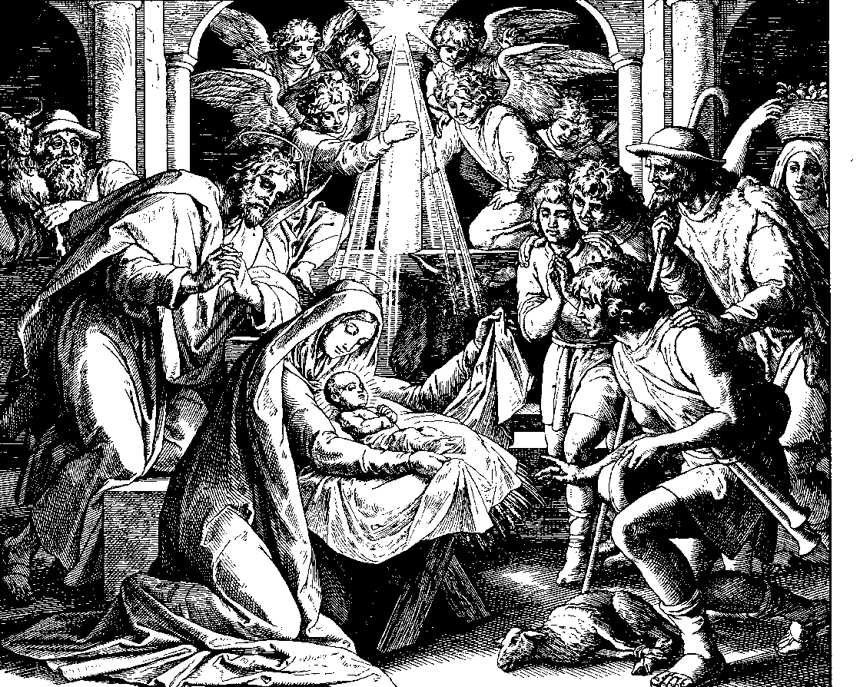
The Feast of the Nativity of Our Lord
December 25, 2017

Emmanuel Lutheran Church
4675 Bataan Memorial West
Las Cruces, New Mexico 88012
(575) 382-0220 (church office) / (575) 636-4988 (pastor cell)
www.GodWithUsLC.org

Sts. Peter & Paul Lutheran Mission
Silver City, New Mexico
www.peterandpaullutheran.org

Rev. Paul A. Rydecki, Pastor
member of the Evangelical Lutheran Diocese of North America (ELDoNA)

ANNOUNCEMENTS
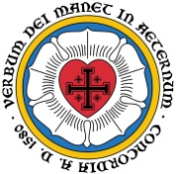
Welcome! Emmanuel is a liturgical, traditional, historical, evangelical, catholic, orthodox, confessional Lutheran congregation, in communion with the Evangelical Lutheran Diocese of North America (ELDoNA). We believe that the Bible is the very Word of God, inspired and without any errors. We confess the truth of Scripture according to the Lutheran Book of Concord of 1580, without exception or reservation. We observe the calendar of the traditional Church Year and follow the Historic Lectionary. We celebrate the Divine Service (also known as the Mass) every Sunday and on other festivals, and we welcome visitors to hear God’s Word with us.
With regard to Holy Communion, we ask our visitors to respect our practice of closed Communion, which means that only communicant members of our congregation or of other congregations in communion with us are invited to commune at the Lord’s Table here, after they have been examined and absolved. Classes are offered throughout the year by the pastor so that those who are interested in joining our Communion fellowship have the opportunity to learn about the Christian faith and our confession of it.
The Order of Service is The Order of Holy Communion (page 15) from The Lutheran Hymnal (TLH), which is outlined on the next page. The Scriptures are read from the New King James Version (NKJV).
Please note that hymns replace the Gradual and Hallelujah in this morning’s service.

After the first hymn is sung, the service begins on p. 15 in the hymnal. As soon as the General Absolution is pronounced, open to hymn #87, which will be sung immediately after the Introit.

EVENTS IN THE NEAR FUTURE…
Sun., Dec. 31 - No Sunday School or Bible Class
- Divine Service, 10:15 AM (Sunday after Christmas)
Sat., Jan. 6 - Matins, 10 AM (The Epiphany of Our Lord)
Sun., Jan. 7 - No Sunday School
- Divine Service, 10:15 AM (Epiphany 1)

The Order of Holy Communion for Christmas Day

Hymn TLH #102 – Oh, Come, All Ye Faithful
The Opening of the Service & The Confession of Sins p. 15
The Introit Isaiah 9:6
P (Antiphon) UNTO us a Child is born, unto us a Son is | given; *
And the government will be upon | His shoulder.
His name shall be called Wonder -ful, (+) Counselor, the Might- | y God, *
The Everlasting Father, the | Prince of Peace.
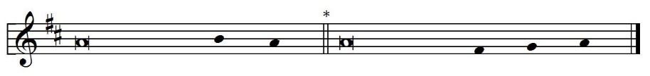
C (TLH #87 – Joy to the World, the Lord Is Come)
P (Antiphon)
The Kyrie & Gloria in Excelsis p. 17-19
The Salutation & The Collect p. 19
The Epistle Hebrews 1:1-12
Hymn TLH #105 - Praise God the Lord Ye Sons of Men
The Gospel John 1:1-14
The Creed p. 22
Hymn TLH #98 – Of the Father’s Love Begotten
The Sermon
The Offertory p. 22
The Offering
The General Prayer
Hymn TLH #107 - We Christians May Rejoice Today
The Preface p. 24-25
The Sanctus p. 26
The Lord’s Prayer p. 27
The Words of Institution & Pax Domini p. 27
The Agnus Dei p. 28
The Distribution
Hymn TLH #90 - Come, Your Hearts and Voices Raising
Hymn TLH #93 - O Lord We Welcome Thee
The Nunc Dimittis p. 29-30
The Thanksgiving, Benedicamus & Benediction p. 30-31
Hymn TLH #94 – Hark! The Herald Angels Sing
We believe, teach and confess…
from the Formula of Concord: Epitome, Art. VIII
1. The divine and human natures in Christ are personally united. So there are not two Christs, one the Son of God and the other the Son of Man. But one and the same person is the Son of God and Son of Man (Luke 1:35; Romans 9:5).
2. We believe, teach, and confess that the divine and human natures are not mingled into one substance, nor is one changed into the other. Each keeps its own essential properties, which can never become the properties of the other nature.
3. The properties of the divine nature are these: to be almighty, eternal, infinite, and to be everywhere present (according to the property of its nature and its natural essence, of itself), to know everything, and so on. These never become properties of the human nature.
4. The properties of the human nature are to be a bodily creature, to be flesh and blood, to be finite and physically limited, to suffer, to die, to ascend and descend, to move from one place to another, to suffer hunger, thirst, cold, heat, and the like. These never become properties of the divine nature.
5. The two natures are united personally (i.e., in one person). Therefore, we believe, teach, and confess that this union is not the kind of joining together and connection that prevents either nature from having anything in common with the other personally (i.e., because of the personal union). It is not like when two boards are glued together, where neither gives anything to the other or takes anything from the other. But here is described the highest communion that God truly has with the man. From this personal union, the highest and indescribable communion results. There flows everything human that is said and believed about God, and everything divine that is said and believed about the man Christ. The ancient teachers of the Church explained this union and communion of the natures by the illustration of iron glowing with fire, and also by the union of body and soul in man.
6. We believe, teach, and confess that God is man and man is God. This could not be true if the divine and human natures had (in deed and truth) absolutely no communion with each other.
For how could the man, the Son of Mary, in truth be called or be God, or the Son of God the Most High, if His humanity were not personally united with the Son of God? How could He have no real communion (that is, in deed and truth) with the Most High, but only share God’s name?
7. So we believe, teach, and confess that Mary conceived and bore not merely a man and no more, but God’s true Son. Therefore, she also is rightly called and truly is “the mother of God.”

