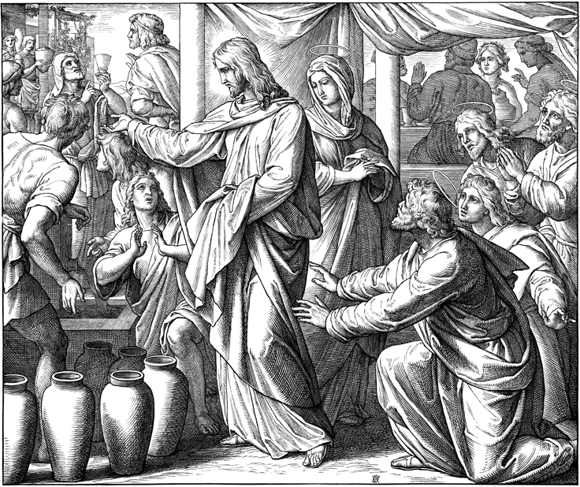
Service Folder
The Second Sunday after Epiphany
January 14, 2018

Emmanuel Lutheran Church
4675 Bataan Memorial West
Las Cruces, New Mexico 88012
(575) 382-0220 (church office) / (575) 636-4988 (pastor cell)
www.GodWithUsLC.org

Sts. Peter & Paul Lutheran Mission
Silver City, New Mexico
www.peterandpaullutheran.org

Rev. Paul A. Rydecki, Pastor
member of the Evangelical Lutheran Diocese of North America (ELDoNA)

ANNOUNCEMENTS
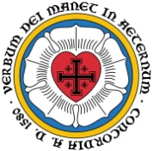
Welcome! Emmanuel is a liturgical, traditional, historical, evangelical, catholic, orthodox, confessional Lutheran congregation, in communion with the Evangelical Lutheran Diocese of North America (ELDoNA). We believe that the Bible is the very Word of God, inspired and without any errors. We confess the truth of Scripture according to the Lutheran Book of Concord of 1580, without exception or reservation. We observe the calendar of the traditional Church Year and follow the Historic Lectionary. We celebrate the Divine Service (also known as the Mass) every Sunday and on other festivals, and we welcome visitors to hear God’s Word with us.
With regard to Holy Communion, we ask our visitors to respect our practice of closed Communion, which means that only communicant members of our congregation or of other congregations in communion with us are invited to commune at the Lord’s Table here, after they have been examined and absolved. Classes are offered throughout the year by the pastor so that those who are interested in joining our Communion fellowship have the opportunity to learn about the Christian faith and our confession of it.
The Order of Service is The Order of Holy Communion (page 15) from The Lutheran Hymnal (TLH). The Scriptures are read from the New King James Version (NKJV). The Propers (the parts that change from week to week) are noted on the following page of this Service Folder.

EVENTS IN THE NEAR FUTURE…
Mon. – Wed. - Pastor at ELDoNA Colloquium in Fort Wayne, IN
Sun., Jan. 22 - Bible Class/Sunday School, 9AM
- Divine Service, 10:15 AM (Transfiguration of Our Lord)

God’s Word at Home:
Bible Reading: 1 Kings 1-13
Small Catechism: Lord’s Prayer, Second Petition
Bible Passages: Matthew 16:24-26, Matthew 18:3

PROPERS Epiphany 2

HYMNS
OPENING HYMN TLH #134 - Songs of Thankfulness and Praise
HYMN (after the Creed) TLH #343 – How Lovely Shines (st. 1-3)
HYMN (after General Prayer) TLH #343 – How Lovely Shines (st. 4-7)
DISTRIBUTION HYMN TLH #306 - Lord Jesus Christ Thou Hast Prepared

Epistle: Romans 12:6-16 Gospel: John 2:1-11

The Order of Holy Communion begins on p. 15 of The Lutheran Hymnal (TLH).
THE INTROIT (after the general Absolution) Psalm 66:4, 9:2 (paraphrase); Psalm 66:1
P (Antiphon) ALL THE earth | shall worship You, *
And sing praises | to You, O — God.
They will sing | praise to Your name; *
O | — Most — High.
C Make a joyful shout to | God, all the earth! *
Sing out the honor of His name; make | His praise glor- -ious.
GLORIA PATRI (p.16): Glory be to the Father, and to the Son, and to the Holy Ghost; as it was in the beginning, is now, and ever shall be, world without end. Amen.
P (Antiphon)
The service continues with the Kyrie and the Gloria in Excelsis, TLH p.17.
THE GRADUAL & HALLELUJAH (after the Epistle) Ps. 107:20-21; Ps. 148:2
P The Lord sent His | word and healed them, *
And delivered them from | their destruc- -tions.
C Oh, that men would give thanks to the Lord | for His goodness, *
And for His wonderful works to the | children of — men!
P Al- | — leluia. *
Al- | — lelu- -ia.
C Praise Him, | all His angels; *
Praise Him, all His hosts! | Allelu- -ia.
The service continues with The Triple Hallelujah and Gospel, TLH p.20.

We believe, teach and confess…
from the Formula of Concord: Solid Declaration: Art. VIII
On account of this personal union and communion of the natures, Mary, the most blessed Virgin, bore not a mere man, but, as the angel Gabriel testifies, such a man as is truly the Son of the most high God, who showed His divine majesty even in His mother’s womb, inasmuch as He was born of a virgin, with her virginity inviolate. Therefore she is truly the mother of God, and nevertheless remained a virgin.
Christ did all His miracles by the power of this personal union. He showed His divine majesty, according to His pleasure, when and as He willed. He did this not just after His resurrection and ascension, but also in His state of humiliation. For example:
(a) At the wedding at Cana of Galilee.
(b) When He was twelve years old, among the learned.
(c) In the garden, when with a word He cast His enemies to the ground.
(d) In death, when He died not simply as any other man, but in and with His death conquered sin, death, devil, hell, and eternal damnation.
The human nature alone would not have been able to do these miracles if it had not been personally united and had communion with the divine nature.
The human nature, after the resurrection from the dead, is exalted above all creatures in heaven and on earth. This is nothing other than that He entirely laid aside the form of a servant [Philippians 2:7–11]. He did not lay aside His human nature, but retains it to eternity. He has the full possession and use of the divine majesty according to His received human nature. However, He had this majesty immediately at His conception, even in His mother’s womb. As the apostle testifies [Philippians 2:7], He laid it aside. As Dr. Luther explains, He kept it concealed in the state of His humiliation and did not always use it, but only when He wanted to use it.

