Service Folder
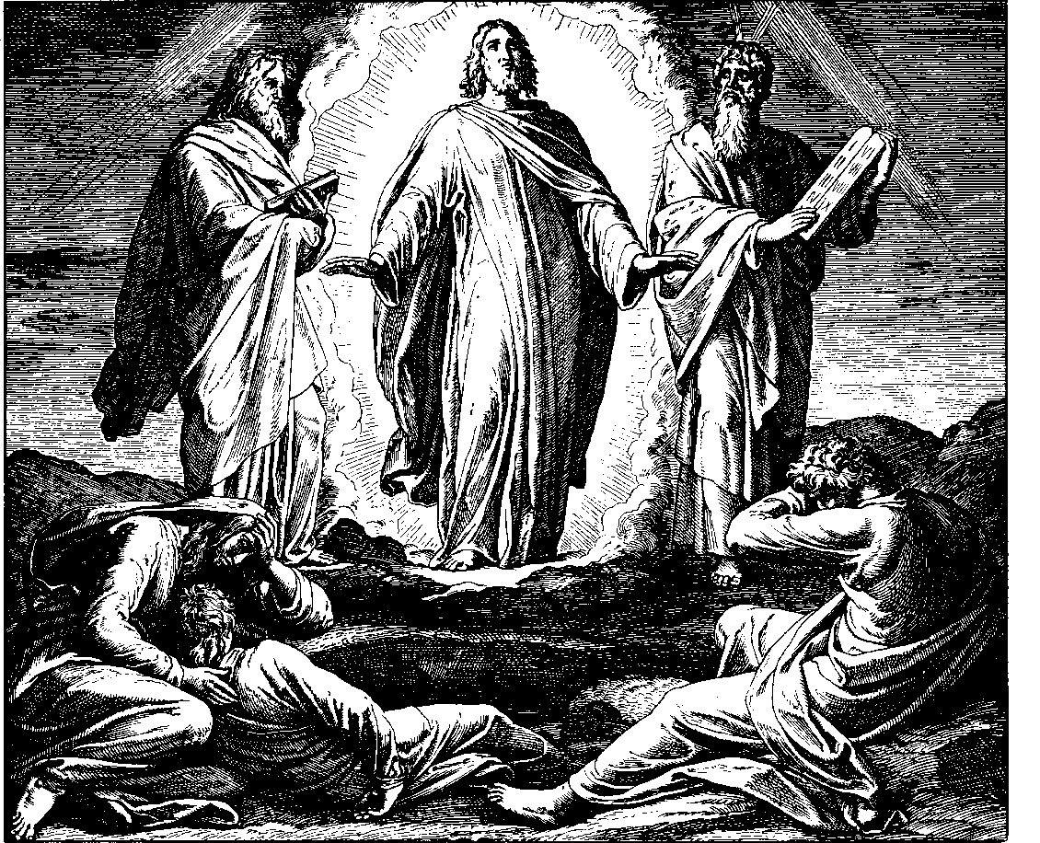

The Transfiguration of Our Lord
January 21, 2018

Emmanuel Lutheran Church
4675 Bataan Memorial West
Las Cruces, New Mexico 88012
(575) 382-0220 (church office) / (575) 636-4988 (pastor cell)
www.GodWithUsLC.org

Sts. Peter & Paul Lutheran Mission
Silver City, New Mexico
www.peterandpaullutheran.org

Rev. Paul A. Rydecki, Pastor
member of the Evangelical Lutheran Diocese of North America (ELDoNA)

ANNOUNCEMENTS
Welcome! Emmanuel is a liturgical, traditional, historical, evangelical, catholic, orthodox, confessional Lutheran congregation, in communion with the Evangelical Lutheran Diocese of North America (ELDoNA). We believe that the Bible is the very Word of God, inspired and without any errors. We confess the truth of Scripture according to the Lutheran Book of Concord of 1580, without exception or reservation. We observe the calendar of the traditional Church Year and follow the Historic Lectionary. We celebrate the Divine Service (also known as the Mass) every Sunday and on other festivals, and we welcome visitors to hear God’s Word with us.
With regard to Holy Communion, we ask our visitors to respect our practice of closed Communion, which means that only communicant members of our congregation or of other congregations in communion with us are invited to commune at the Lord’s Table here, after they have been examined and absolved. Classes are offered throughout the year by the pastor so that those who are interested in joining our Communion fellowship have the opportunity to learn about the Christian faith and our confession of it.
The Order of Service is The Order of Holy Communion (page 15) from The Lutheran Hymnal (TLH). The Scriptures are read from the New King James Version (NKJV). The Propers (the parts that change from week to week) are noted on the following page of this Service Folder.

EVENTS IN THE NEAR FUTURE…
Wed., Jan. 24 - Vespers for St. Timothy, 6:30PM
Sun., Jan. 28 - Bible Class/Sunday School, 9AM
- Divine Service, 10:15 AM (Septuagesima)
Sun., Feb. 4 - Bible Class/Sunday School, 9AM
- Divine Service, 10:15 AM (Sexagesima)
- Congregational / Voters’ Meeting, after the service

God’s Word at Home:
Bible Reading: 1 Kings 14 – 2 Kings 4
Small Catechism: Lord’s Prayer, Third Petition, Part 1
Bible Passages: Matthew 18:11, Matthew 18:18

PROPERS Transfiguration

HYMNS
OPENING HYMN TLH #130 - O Jesus King of Glory
HYMN (after the Creed) TLH #409 – Let Us Ever Walk with Jesus
HYMN (after General Prayer) TLH #408 – Jesus Christ My Pride and Glory
DISTRIBUTION HYMNS TLH #135 - 'Tis Good, Lord, to Be Here
TLH #304 - An Awe-full Mystery Is Here

Epistle: 2 Peter 1:16-21 Gospel: Matthew 17:1-9

The Order of Holy Communion begins on p. 15 of The Lutheran Hymnal (TLH).
THE INTROIT (after the general Absolution) Psalm 77:18b; Psalm 84:1-2a
P (Antiphon) THE LIGHTnings | lit up the world; *
The earth | trembled and — shook.
C How lovely is Your tabernacle, | O Lord of hosts! *
My soul longs, yes, even faints for the | courts of the — Lord.
GLORIA PATRI (p.16): Glory be to the Father, and to the Son, and to the Holy Ghost; as it was in the beginning, is now, and ever shall be, world without end. Amen.
P (Antiphon)
The service continues with the Kyrie and the Gloria in Excelsis, TLH p.17.
THE GRADUAL & HALLELUJAH (after the Epistle) Ps. 45:2a, 110:1; 96:2-3
P You are fairer than | the sons of men; *
Grace is poured | upon Your — lips.
C The Lord said to my Lord, “Sit | at My right hand, *
Till I make Your ene- | mies Your foot- -stool.”
P Alleluia. | Alleluia. *
Sing to the | Lord, bless His — name;
C Proclaim the good news of His salvation | from day to day. *
Declare His glory among the nations. | Allelu- -ia.
The service continues with The Triple Hallelujah and Gospel, TLH p.20.

We believe, teach and confess…

from the Formula of Concord: Solid Declaration: Art. II
The eternal Father calls down from heaven about His dear Son and about all who preach repentance and forgiveness of sins in His name, “Listen to Him” (Matthew 17:5).
All who want to be saved ought to listen to this preaching. For the preaching and hearing of God’s Word are the Holy Spirit’s instruments. By, with, and through these instruments the Spirit desires to work effectively, to convert people to God, and to work in them both to will and to do.
A person can hear and read this Word outwardly, even though he is not yet converted to God and regenerate. As said above, a person even since the fall has a free will to a certain extent in these outward things. So he can go to church and listen or not listen to the sermon.
God works through this means (i.e., the preaching and hearing of His Word). He breaks our hearts and draws us to Him. Through the preaching of the Law, a person comes to know his sins and God’s wrath. He experiences in his heart true terrors, contrition, and sorrow. Through the preaching of, and reflection on, the Holy Gospel about the gracious forgiveness of sins in Christ, a spark of faith is kindled in him. This faith accepts the forgiveness of sins for Christ’s sake and comforts itself with the Gospel promise. So the Holy Spirit (who does all this) is sent into the heart.
The preacher’s planting and watering and the hearer’s running and hearing would both be in vain and no conversion would follow it if the power and effectiveness of the Holy Spirit were not added. The Spirit enlightens and converts hearts through the Word preached and heard. So people believe this Word and agree with it. Neither preacher nor hearer is to doubt this grace and effectiveness of the Holy Spirit. They should be certain that when God’s Word is preached purely and truly, according to God’s command and will, and people listen attentively and seriously and meditate on it, God is certainly present with His grace. He grants, as has been said, what otherwise a person can neither accept nor give by his own powers. For we should not and cannot always judge from feeling about the presence, work, and gifts of the Holy Spirit, as to how and when they are experienced in the heart. They are often covered and happen in great weakness. Therefore, we should be certain about and agree with the promise that God’s Word preached and heard is ‹truly› an office and work of the Holy Spirit. He is certainly effective and works in our hearts by them (2 Corinthians 2:14–17; 3:5–6).

