Service Folder
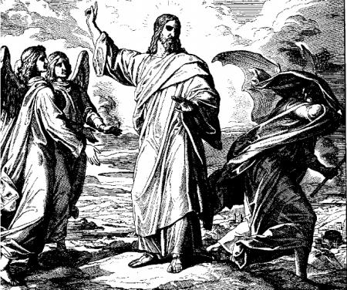
Invocavit – First Sunday in Lent
“He shall call upon Me, and I will answer Him”
February 18, 2018

Welcome! Emmanuel is a liturgical, traditional, historical, evangelical, catholic, orthodox, confessional Lutheran congregation, in communion with the Evangelical Lutheran Diocese of North America (ELDoNA).
With regard to Holy Communion, we ask our visitors to respect our practice of closed Communion, which means that only communicant members of our congregation or of other congregations in communion with us are invited to commune at the Lord’s Table here, after they have been examined and absolved. Classes are offered throughout the year by the pastor so that those who are interested in joining our Communion fellowship have the opportunity to learn about the Christian faith and our confession of it.
EVENTS IN THE NEAR FUTURE…
Wed., Feb. 21 - Supper at church, 5:45 PM
- Vespers, 6:30 PM
Sun., Feb. 25 - Bible class & Sunday School 9 AM
- Divine Service 10:15 AM (Reminiscere – Lent 2)
Please turn to page 15 in the front of The Lutheran Hymnal (TLH) at the beginning of the service, and refer to the back of this service folder for the Introit, Gradual and Tract.

PROPERS Lent 1 - Invocavit

HYMNS
OPENING HYMN TLH #410 - Jesus, Lead Thou On
HYMN (after the Creed) Through Adam’s Fall (service folder)
HYMN (after General Prayer) TLH #262 – A Mighty Fortress Is Our God
DISTRIBUTION HYMNS TLH #311 - Jesus Christ, Our Blessed Savior TLH #309 - O Jesus, Blessed Lord, to Thee

Genesis 3:1-24 + 2 Corinthians 6:1-10 + Matthew 4:1-11

The service begins on page 15 in The Lutheran Hymnal (TLH).
THE INTROIT (after the general Absolution) Psalm 91:15-16; Psalm 91:1
P (Antiphon) HE SHALL call upon Me, and I | will answer him; *
I will deliver him | and honor him. __
With long life I will | satisfy him, *
And show him | My salvation. __
C He who dwells in the secret place | of the Most High *
Shall abide under the shadow of | the Almighty. __
GLORIA PATRI (p.16): Glory be to the Father, and to the Son, and to the Holy Ghost; as it was in the beginning, is now, and ever shall be, world without end. Amen.
P (Antiphon)
The service continues with The Kyrie, p. 17, followed immediately by the Collect (the Gloria in Excelsis is omitted during the Lenten season).
THE GRADUAL (after First Lesson) & TRACT (after Epistle) Ps. 91:11-12; 1-2, 4a
P For He shall give His angels | charge over you, *
To keep you | in all your ways. __
C In their hands they | shall bear you up, *
Lest you dash your foot | against a stone.__
P He who dwells in the secret place | of the Most High *
Shall abide under the shadow of | the Almighty.__
C I will say of the Lord, “He is my refuge and my | fortress; My God, *
In | Him I will trust.” __
He shall cover you | with His feathers, *
And under His wings you | shall take refuge.__
The service continues with the Gospel, TLH p. 21.
Note: Following the Sanctus, the Lord’s Prayer will be chanted by the Pastor. The Congregation will sing the doxology at the end.

