Vigil of Easter

The Third Service of the
Triduum of Christ’s Passover
March 31, 2018

Emmanuel Lutheran Church
4675 Bataan Memorial West
Las Cruces, New Mexico 88012
(575) 382-0220 (church office) / (575) 636-4988 (pastor cell)
www.GodWithUsLC.org pastor@GodWithUsLC.org

Sts. Peter & Paul Lutheran Mission
Silver City, New Mexico
www.peterandpaullutheran.org

Rev. Paul A. Rydecki, Pastor
member of the Evangelical Lutheran Diocese of North America (ELDoNA)

ANNOUNCEMENTS
Welcome! Emmanuel is a liturgical, traditional, historical, evangelical, catholic, orthodox, confessional Lutheran congregation, in fellowship with the Evangelical Lutheran Diocese of North America (ELDoNA). We believe that the Bible is the very Word of God, inspired and without any errors. We confess the truth of Scripture according to the Lutheran Book of Concord of 1580, without exception or reservation. We observe the calendar of the traditional Church Year and follow the Historic Lectionary. We celebrate the Divine Service (also known as the Mass) every Sunday and on other festivals, and we welcome visitors to hear God’s Word with us.

Easter Vigil explanation: In some places throughout the early centuries of the Church’s life, the people of God would hold vigil through the night in expectation of Christ’s return. A vigil in expectation of Christ’s return at Easter became a common feature in the Church of the celebration of His crucifixion and resurrection.

As a service of watching that ushers in the resurrection, the Vigil of Easter is comprised of five parts:

- the Service of Light
- the Service of Lessons
- the Service of Holy Baptism
- the Service of Prayer
- the Service of the Word
- the Service of the Sacrament

SERVICE OF LIGHT
All gather at the church door. Candles are given to all, later to be lighted from the paschal candle.
P In the name of the Father and of the Son T and of the Holy Ghost.
C Amen.
The pastor addresses the congregation and says the prayer. The congregation answers:
C Amen.
The candle bearer, holding the paschal candle, steps forward. The pastor traces the cross on the candle while saying:
P Christ Jesus, the same yesterday, today, and forever, the beginning and the ending,
and then traces Greek letters Α and Ω (Alpha and Omega) on the candle while saying:
the Alpha and the Omega.
The pastor traces the year on the candle, saying:
P His are time and eternity; His are the glory and dominion, now and forever.
The pastor puts the five nails into the candle, saying:
P By His wounds we have healing both now and forever. Amen.
Then, lighting the paschal candle, he says:
P May the light of Christ, who is risen in glory from the dead, scatter all the darkness of our hearts and minds.
Let us pray.
After the prayer, the congregation answers:
C Amen.
All light their candles from the paschal candle and then follow the candle bearer in procession into the church.
At the entrance, the candle bearer stops and raises the paschal candle. The pastor chants:
P The light of Christ.
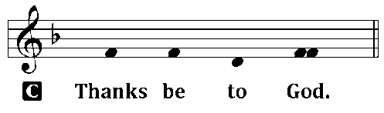
Halfway to the altar, the candle bearer stops. The pastor chants for the second time:
P The light of Christ.
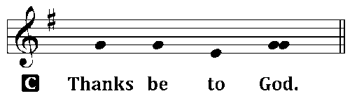
When the candle bearer arrives at the candle stand, he faces the congregation and lifts the candle high. The pastor chants the third time:
P The light of Christ.
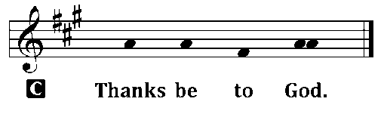
After the candle bearer places the paschal candle in its stand, the pastor chants the Easter Proclamation (Exsultet).
EXSULTET
P Rejoice now, all you heavenly choirs of angels; rejoice now, all creation; sound forth, trumpet of salvation, and proclaim the triumph of our King.
Rejoice, too, all the earth, in the radiance of the light now poured upon you and made brilliant by the brightness of the everlasting King; know that the ancient darkness has been forever banished.
Rejoice, O Church of Christ, clothed in the brightness of this light; let all this house of God ring out with rejoicing, with the praises of all God's faithful people.
P The Lord be with you. 2 Timothy 4:22
P Lift up your hearts. [Colossians 3:1]
P Let us give thanks unto the Lord, our God. [Psalm 136]
P It is truly meet, right, and salutary that we should at all times and in all places, with all our heart and mind and voice, praise you, O Lord, Holy Father, almighty everlasting God, and Your only-begotten Son, Jesus Christ.
For he is the very Paschal Lamb who offered Himself for the sin of the world, who has cleansed us by the shedding of His precious blood.
This is the night when you brought our fathers, the children of Israel, out of bondage in Egypt and led them through the Red Sea on dry ground.
This is the night when all who believe in Christ are delivered from bondage to sin and are restored to life and immortality.
This is the night when Christ, the Life, arose from the dead. The seal of the grave is broken and the morning of the new creation breaks forth out of night.
Oh, how wonderful and beyond all telling is Your mercy toward us, O God, that to redeem a slave You gave Your Son.
How holy is this night when all wickedness is put to flight and sin is washed away.
How holy is this night when innocence is restored to the fallen and joy is given to those downcast.
How blessed is this night when man is reconciled to God in Christ.
Holy Father, accept now the evening sacrifices of our thanksgiving and praise.
Let Christ, the true Light and Morning Star, shine in our hearts, He who gives light to all creation, who lives and reigns with You and the Holy Spirit, one God, now and forever.
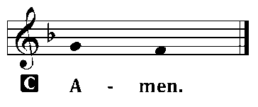
All may extinguish their candles at this time.
Sit

SERVICE OF LESSONS
The pastor exhorts the congregation, and then reads the following portions of Holy Scripture.
The Creation Genesis 1:1 – 2:3
After this and each subsequent reading:
P The Word of the Lord.
C Thanks be to God.
P Let us pray.
The pastor says the prayer.
C Amen.
The Flood Genesis 7:1-5, 11-18; 8:6-18; 9:8-13
Israel’s Deliverance at the Red Sea Exodus 14:10-15:1
Job Confesses the Redeemer Job 19:20-27
The Fiery Furnace Daniel 3:1-30

CANTICLE ALL YOU WORKS OF THE LORD (Benedicite, Omnia Opera)
The pastor chants the verses of the canticle, and the whole congregation joins in the Refrain.
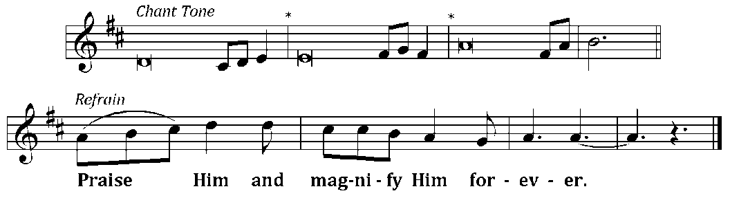
¹All you works of the Lord, | bless the Lord—*  praise Him and magnify Him for- | ever.*  You angels of the Lord, | bless the Lord: Refrain  ²You heavens, | bless the Lord;*  all you waters above the heavens, | bless the Lord;*  all you powers of the Lord, | bless the Lord: Refrain  ³You sun and moon, | bless the Lord;*  you stars of heaven, | bless the Lord;*  all you showers and dew, | bless the Lord— Refrain  ⁴All you winds of God, | bless the Lord;*  you fire and heat, | bless the Lord;*  you winter and summer, | bless the Lord— Refrain  ⁵You dews and frost, | bless the Lord;*  you frost and cold, | bless the Lord;*  you ice and snow, | bless the Lord— Refrain  ⁶You nights and days, | bless the Lord;*  you light and darkness, | bless the Lord;*  you lightning and clouds, | bless the Lord— Refrain | ⁷Let the earth | bless the Lord:*  you mountains and hills, | bless the Lord;*  all you green things that grow on the earth, | bless the Lord— Refrain  ⁸You wells and springs, | bless the Lord;*  you rivers and seas, | bless the Lord;*  you whales and all who move in the waters, | bless the Lord— Refrain  ⁹All you birds of the air, | bless the Lord;*  all you beasts and cattle, | bless the Lord;*  all you children of men, | bless the Lord— Refrain  ¹⁰O Israel, | bless the Lord;*  you priests of the Lord, | bless the Lord;*  you servants of the Lord, | bless the Lord— Refrain  ¹¹You spirits and souls of the righteous, | bless the Lord;*  you pure and humble of heart, | bless the Lord;*  let us bless the Father and the Son and the Holy | Spirit— Refrain

SERVICE OF HOLY BAPTISM
The pastor addresses the congregation and prays Luther’s Flood Prayer:
P Almighty and eternal God, according to Your strict judgment You condemned the unbelieving world through the flood, yet according to Your great mercy You preserved believing Noah and his family, eight souls in all. You drowned hard-hearted Pharaoh and all his host in the Red Sea, yet led Your people Israel through the water on dry ground, foreshadowing this washing of Your Holy Baptism. Through the Baptism in the Jordan of Your beloved Son, our Lord Jesus Christ, You sanctified and instituted all waters to be a blessed flood and a lavish washing away of sin. We pray that You would behold us all according to Your boundless mercy and bless us with true faith by the Holy Spirit, that through this saving flood all sin in us, which has been inherited from Adam and which we ourselves have committed since, would be drowned and die. Grant that we be kept safe and secure in the holy ark of the Christian Church, being separated from the multitude of unbelievers and serving Your name at all times with a fervent spirit and a joyful hope, so that, with all believers in Your promise, we would be declared worthy of eternal life; through Jesus Christ, our Lord.
C Amen.
P Do you renounce the devil?
C Yes, I renounce him.
P Do you renounce all his works?
C Yes, I renounce them.
P Do you renounce all his ways?
C Yes, I renounce them.
P Do you believe in God, the Father Almighty?
C Yes, I believe in God, the Father Almighty, maker of heaven and earth.
P Do you believe in Jesus Christ, His only Son?
C Yes, I believe in Jesus Christ, His only Son, our Lord, who was conceived by the Holy Spirit, born of the virgin Mary, suffered under Pontius Pilate, was crucified, died and was buried. He descended into hell. The third day he rose again from the dead. He ascended into heaven and is seated at the right hand of God the Father Almighty. From there he will come to judge the living and the dead.
P Do believe in the Holy Spirit?
C Yes, I believe in the Holy Spirit, the holy Christian Church, the communion of saints, the forgiveness of sins, the resurrection of the body, and the life everlasting. Amen.

HYMN TLH #301 – He That Believes and Is Baptized
P The Almighty God, the Father of our Lord Jesus Christ, who has given you the new birth of water and of the Spirit and has forgiven you all your sins, strengthen you with His grace to life T everlasting.
C Amen.
P Peace T be with you.
C Amen.

SERVICE OF PRAYER
LITANY OF THE RESURRECTION
P O Lord, C have mercy.
P O Christ, C have mercy.
P O Lord, C have mercy.
P Lord Jesus Christ, Son of God, C hear us.
P Paschal Lamb, who was offered for us and has taken away the sin of the world,
C have mercy on us.

P Who was crucified for our transgressions and raised for our justification,
C have mercy on us.
P Who foretold Your passion saying, “The Son of Man must be crucified and on the third day rise again,”
C have mercy on us.
P Who destroyed death by dying, and by rising to life again brought life and immortality to light,
C have mercy on us.
P Whose resurrection was first announced by an angel to the women,
C have mercy on us.
P Who appeared to Mary Magdalene and was worshiped by her,
C have mercy on us.
P Who revealed Yourself to the two disciples on the Emmaus road and made Yourself known to them in the Scriptures and in the breaking of the bread,
C have mercy on us.
P Who appeared to the disciples, bestowing on them Your peace and Your Spirit,
C have mercy on us.
P Who showed Your wounded hands and side to the apostle Thomas that he too might believe,
C have mercy on us.
P Who appeared to seven disciples on the Sea of Tiberias, bringing a miraculous catch of fish,
C have mercy on us.
P Who appeared to Peter and to the Eleven, to over 500 disciples, to James and to all the apostles, and to Paul on the Damascus road,
C have mercy on us.
P Who commissioned Your Church to make disciples of all nations by baptizing and teaching them,
C have mercy on us.
P By Your glorious resurrection from the dead,
C good Lord, deliver us.
P By Your victory over sin and death,
C good Lord, deliver us.
P By the majesty of Your risen body,
C good Lord, deliver us.
P We poor sinners implore You
C to hear us, Lord Jesus.
P That we may daily die and rise with You in our Baptism and walk in the freedom of Your forgiveness,
C grant us, good Lord.
P That we may set our minds on things above and not on earthly things, serving others as we have been served by You,
C grant us, good Lord.
P That we may dwell with You forever in the new creation as citizens of the heavenly Jerusalem, together with all the saints,
C grant us, good Lord.
P Christ, the Lamb of God, who takes away the sin of the world,
C have mercy on us.
P Christ, the Lamb of God, who takes away the sin of the world,
C have mercy on us.
P Christ, the Lamb of God, who takes away the sin of the world,
C grant us your peace.
P O Lord, C have mercy.
P O Christ, C have mercy.
P O Lord, C have mercy. Amen.

SERVICE OF THE WORD
EASTER ACCLAMATION
P Alleluia! Christ is risen!
C He is risen indeed! Alleluia!
The altar candles and other candles in the church are now lit from the paschal candle. The lights of the church are fully lit and the bells are rung.
HYMN OF PRAISE TLH #187 – Christ is Arisen
Stand
SALUTATION and COLLECT OF THE DAY
P The Lord be with you.
C And with thy spirit.
P Let us pray.
The pastor says the COLLECT of the Day.
C Amen.
GOSPEL John 20:1-18
P The Holy Gospel according to St. John, chapter 20.
C Glory be to Thee, O Lord.
After the reading of the Gospel, the pastor says:
P This is the Gospel of the Lord.
C Praise be to Thee, O Christ.
A brief sermon may follow.
Stand
SERVICE OF THE SACRAMENT
THE PREFACE
P The Lord be with you. 2 Timothy 4:22
P Lift up your hearts. [Colossians 3:1]
P Let us give thanks unto the Lord, our God. [Psalm 136]
Minister: It is truly meet, right, and salutary…
Therefore with angels and archangels and with all the company of heaven we laud and magnify Thy glorious name, evermore praising Thee and saying:
THE SANCTUS Is. 6:3; Matt.21:9
THE LORD’S PRAYER Matt. 6:9-13
Our Father, who art in heaven, Hallowed be thy name. Thy kingdom come. Thy will be done on earth as it is in heaven. Give us this day our daily bread. And forgive us our trespasses, as we forgive those who trespass against us. And lead us not into temptation, But deliver us from evil. For thine is the kingdom, and the power, and the glory, forever and ever. Amen.
THE WORDS OF INSTITUTION
The pastor shall consecrate the elements for Holy Communion, proclaiming the Words of our Lord Jesus Christ by which He instituted the Sacrament of the Altar.
THE PAX DOMINI John 20:19
P The peace of the Lord be with you alway!
THE AGNUS DEI John 1:29
Sit
THE DISTRIBUTION
The communicant members of this congregation are invited to the Lord’s Table. After all communicants have communed, the service concludes with:
THE CONCLUDING COLLECT AND BLESSING
Stand
P Let us pray.
The pastor chants the Collect, and the congregation answers:
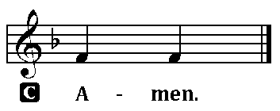
P Bless we the Lord.
P The almighty and merciful Lord, the Father, the T Son, and the Holy Ghost, bless and preserve you.
________________________________________________________________

