Service Folder
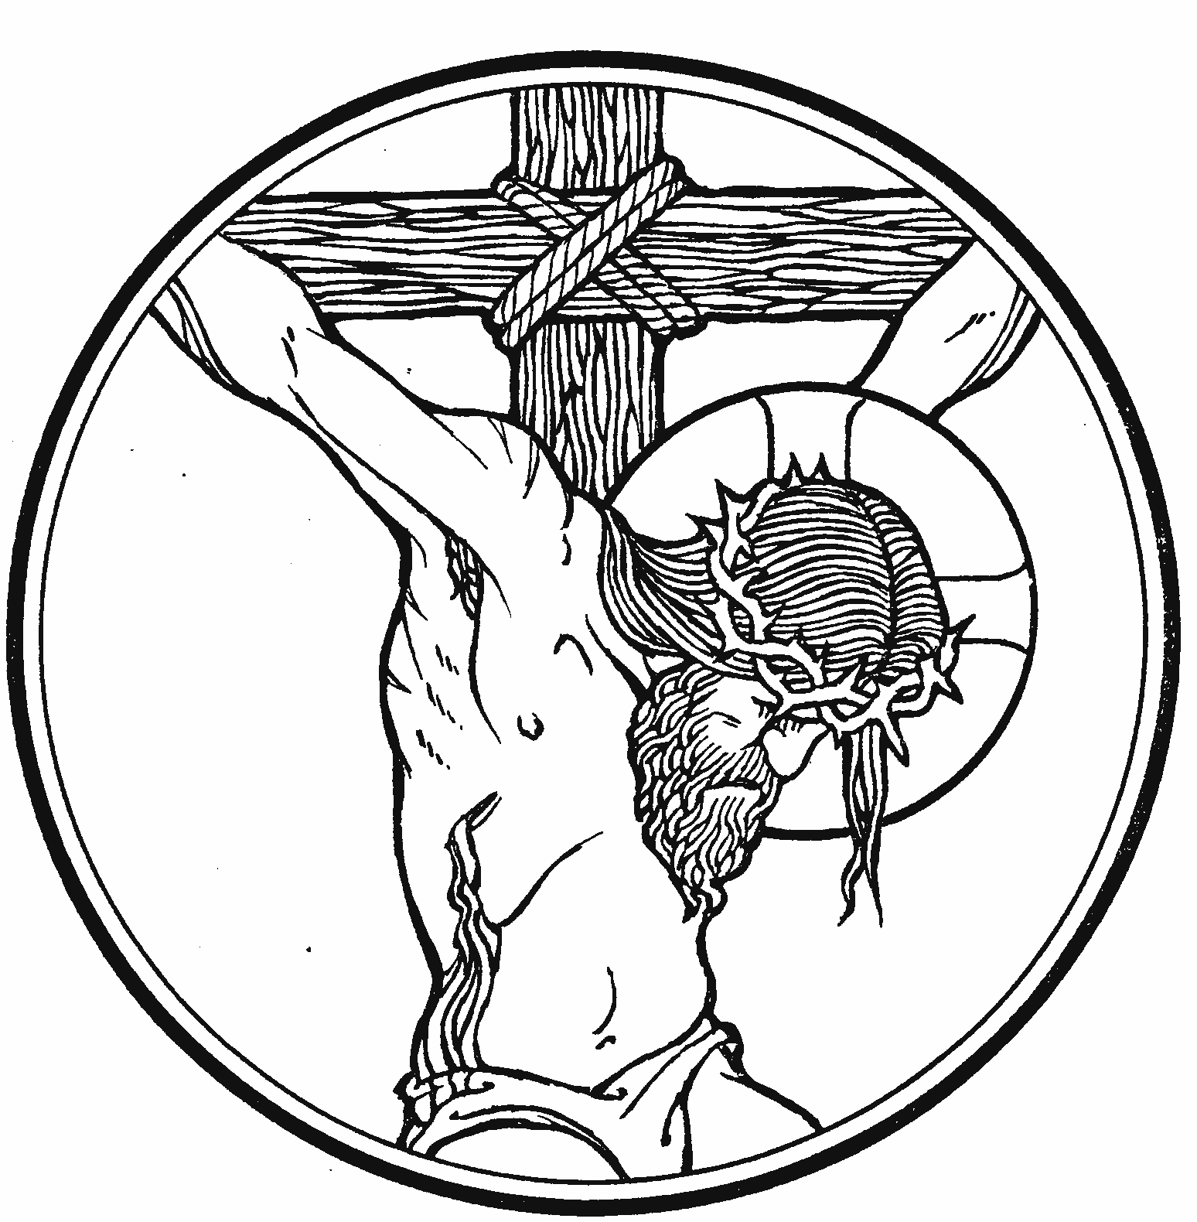
Good Friday
The Second Service of the Triduum
of Christ’s Passover
March 30, 2018

Emmanuel Lutheran Church
4675 Bataan Memorial West
Las Cruces, New Mexico 88012
(575) 382-0220 (church office) / (575) 636-4988 (pastor cell)
www.GodWithUsLC.org pastor@GodWithUsLC.org

Sts. Peter & Paul Lutheran Mission
Silver City, New Mexico
www.peterandpaullutheran.org

Rev. Paul A. Rydecki, Pastor
member of the Evangelical Lutheran Diocese of North America (ELDoNA)

ANNOUNCEMENTS
Welcome! Emmanuel is a liturgical, traditional, historical, evangelical, catholic, orthodox, confessional Lutheran congregation, in fellowship with the Evangelical Lutheran Diocese of North America (ELDoNA). We believe that the Bible is the very Word of God, inspired and without any errors. We confess the truth of Scripture according to the Lutheran Book of Concord of 1580, without exception or reservation. We observe the calendar of the traditional Church Year and follow the Historic Lectionary. We celebrate the Divine Service (also known as the Mass) every Sunday and on other festivals, and we welcome visitors to hear God’s Word with us.
Good Friday Chief Service: The First Day of the Triduum, which began yesterday at sunset, draws to a close. The hours of the cross began at 9 AM and last until about 3 PM, with sunset marking the end of the First Day. The entire Passion history will be read during the service from the Gospel of John. This service observes the true Day of Atonement on which satisfaction was made for the sins of the world through the blood of Christ, the true Passover Lamb and the fulfillment of all the Old Testament sacrifices.
The service will begin when the pastor enters the chancel. The Bidding Prayer is an ancient element of the service. In it, the people of God pray for the needs of the world, since the world’s sins have been borne by Christ on the cross. What’s more, it is faith in the cross of Christ that makes our prayers acceptable to God.
No offering will be gathered during the service. A collection plate will be available at the door for those who wish to give an offering today. The Sacrament will be offered to those who have previously announced their desire to commune. The Passion reading and preaching on the death of Christ will serve as the preparation for Communion in place of the regular liturgy of the Mass.
Easter Vigil: This is the Third Service of the Triduum, held on Saturday evening after sunset, which is already the beginning of Easter Sunday, according to Hebrew reckoning. The Paschal Candle is used prominently in the service, which consists of The Service of Light, Service of Lessons, Service of Holy Baptism, Service of Prayer, Service of the Word, and Service of Holy Communion.

Word, Prayer, and Sacrament for Good Friday
Stand
INTROIT Isaiah 53:4–6; Psalm 102:1-2, 13
P (Antiphon) SURE- LY - || He has borne our griefs and car- | ried | our | sor- - | rows; *
He was wounded for our transgressions, He was bruised for our | in- - | i- - | qui- | ties.
All we like sheep | have | gone | a- - | stray; *
And the Lord has laid on Him the iniqui- | ty - | of - | us | all.
C (spoken) Hear my prayer, O Lord, And let my cry come to You.
Do not hide Your face from me In the day of my trouble;
Incline Your ear to me; In the day that I call, answer me speedily.
But You, O Lord, shall endure forever, And the remembrance of Your name to all generations.
P (Antiphon)
COLLECTS
The Pastor speaks three collects, concluding each, “…ever one God, world without end.”
C Amen.
Sit
LESSON Isaiah 52:13 – 53:12
TRACT Psalm 69:20; Lamentations 1:12; Isaiah 53:5
P Reproach has broken my heart, and I am full of heaviness; *
C I looked for someone to take pity, but there was none; And for comforters, but I found none.
P Is it nothing to you, all you who pass by? *
C Behold and see if there is any sorrow like my sorrow, which has been brought on me, which the Lord has inflicted in the day of His fierce anger.
P But He was wounded for our transgressions, He was bruised for our iniquities; *
C The chastisement for our peace was upon Him, and by His stripes we are healed.
HYMN TLH #171 – Upon the Cross Extended
THE PASSION OF OUR LORD JESUS CHRIST John 18:1-27
HYMN TLH #172 – O Sacred Head, Now Wounded (st. 1-5)
THE PASSION OF OUR LORD JESUS CHRIST John 18:28 – 19:16a
HYMN TLH #172 – O Sacred Head, Now Wounded (st. 6-10)
Stand
THE PASSION OF OUR LORD JESUS CHRIST John 19:16b-42
ADORAMUS TE, CHRISTE
P We adore Thee, O Christ, | and we bless Thee; *
C For by Thy holy cross Thou hast redeemed | the world.
Sit
HYMN TLH #167 - Oh Darkest Woe
SERMON
Stand
THE BIDDING PRAYER
The Pastor bids the faithful to pray for various needs, and then leads them in prayer, concluding each petition, “…through (Jesus) Christ our Lord.” The congregation responds, “Amen.” After all the petitions have been prayed, the Pastor bids the congregation to pray:
THE LORD’S PRAYER spoken by all
THE WORDS OF INSTITUTION AND DISTRIBUTION OF THE SACRAMENT
The Pastor shall consecrate the elements for Holy Communion, proclaiming the Words of our Lord Jesus Christ by which He instituted the Sacrament of the Altar.
THE PAX DOMINI AND AGNUS DEI
The congregation then sits, and the communicants are invited to approach the altar and receive the Lord’s body and blood.
Stand
COLLECT
P Hear us, we beseech Thee, O Lord, that Thy abundant blessing may be upon Thy people who have held the passion and death of Thy Son in devout remembrance, that we may receive Thy pardon and the gift of Thy comfort, and may increase in faith and take hold of eternal salvation; through the same Jesus Christ, Thy Son, our Lord, who liveth and reigneth with Thee and the Holy Ghost, ever one God, world without end.
C Amen.
HYMN TLH #168 – The Royal Banners Forward Go
The pastor exits the chancel during the singing of the final stanza. The congregation may depart as the post-service music begins to play.

