Service Folder
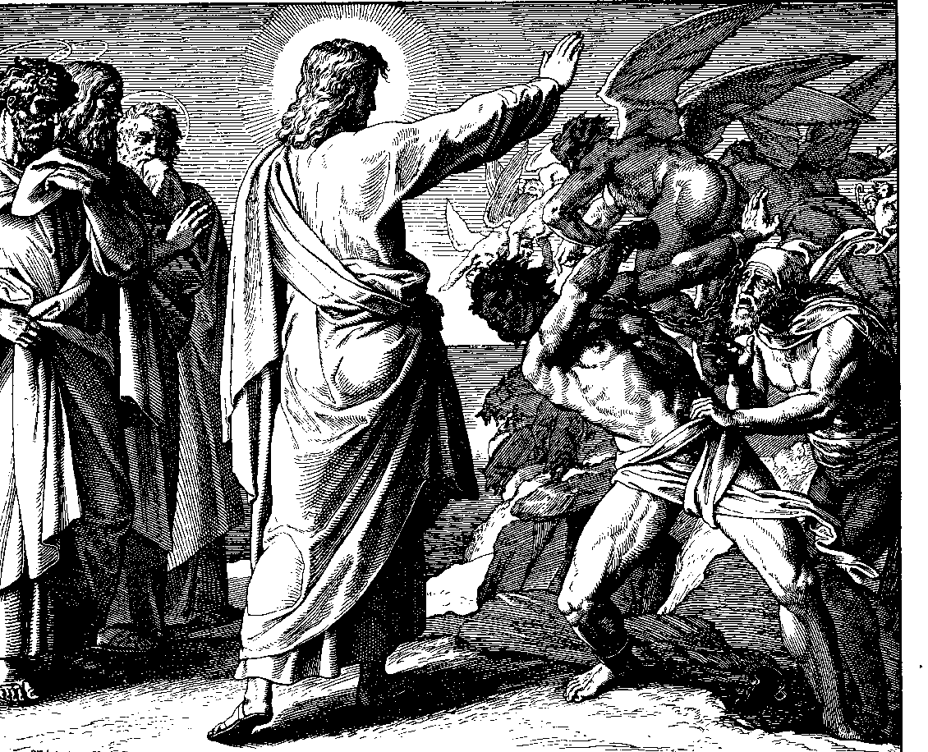
Oculi – Third Sunday in Lent
“My eyes are ever toward the Lord”
March 4, 2018

Emmanuel Lutheran Church
4675 Bataan Memorial West
Las Cruces, New Mexico 88012
(575) 382-0220 (church office) / (575) 636-4988 (pastor cell)
www.GodWithUsLC.org

Sts. Peter & Paul Lutheran Mission
Silver City, New Mexico
www.peterandpaullutheran.org

Rev. Paul A. Rydecki, Pastor
member of the Evangelical Lutheran Diocese of North America (ELDoNA)

ANNOUNCEMENTS
Welcome! Emmanuel is a liturgical, traditional, historical, evangelical, catholic, orthodox, confessional Lutheran congregation, in communion with the Evangelical Lutheran Diocese of North America (ELDoNA). We believe that the Bible is the very Word of God, inspired and without any errors. We confess the truth of Scripture according to the Lutheran Book of Concord of 1580, without exception or reservation. We observe the calendar of the traditional Church Year and follow the Historic Lectionary. We celebrate the Divine Service (also known as the Mass) every Sunday and on other festivals, and we welcome visitors to hear God’s Word with us.
With regard to Holy Communion, we ask our visitors to respect our practice of closed Communion, which means that only communicant members of our congregation or of other congregations in communion with us are invited to commune at the Lord’s Table here, after they have been examined and absolved. Classes are offered throughout the year by the pastor so that those who are interested in joining our Communion fellowship have the opportunity to learn about the Christian faith and our confession of it.
The Order of Service is The Order of Holy Communion (page 15) from The Lutheran Hymnal (TLH). Those who are unfamiliar with the service may wish to use the Service Booklet.) The Scriptures are read from the New King James Version (NKJV). The Propers (the parts that change from week to week) are noted on the following page of this Service Folder.
Service notes: All Hallelujah’s are omitted from the service from Septuagesima until the Vigil of Easter. The Gloria in Excelsis is omitted throughout the Lenten season. The Lord’s Prayer will be chanted by the Pastor, and the Congregation will sing the doxology at the end.
EVENTS IN THE NEAR FUTURE…
Wed., Mar. 7 - Supper at church, 5:45 PM
- Vespers, 6:30 PM
Sat., Mar. 10 - Daylight Savings begins at midnight. Spring clocks forward!
Sun., Mar. 11 - Bible class & Sunday School 9 AM
- Divine Service 10:15 AM (Laetare – Lent 4)
God’s Word at Home:
Bible Reading: 2 Chronicles 17-30
Small Catechism: Lord’s Prayer, Seventh Petition
Bible Passages: John 1:14, John 1:17-18

PROPERS Lent 3 - Oculi

HYMNS
OPENING HYMN TLH #263 - O Little Flock, Fear Not the Foe
HYMN (after the Creed) TLH #444 - Rise! To Arms! With Prayer Employ You
HYMN (after General Prayer) TLH #446 – Rise, My Soul, to Watch and Pray
DISTRIBUTION HYMNS TLH #325 - O Thou that Hear'st
TLH #301 – He that Believes and Is Baptized

2 Samuel 22:1-7 + Ephesians 5:1-9 + Luke 11:14-28

THE INTROIT (after the general Absolution) Psalm 25:15-16; Psalm 25:1
P (Antiphon) MY EYES are ev- | er toward the Lord, *
For He shall pluck my feet | out of the net.
Turn Yourself to me, and have | mercy on me, *
For I am desolate | and afflicted.
C To You, O Lord, I | lift up my soul. *
O my God, I trust in You; let me | not be ashamed;
GLORIA PATRI (p.16): Glory be to the Father, and to the Son, and to the Holy Ghost; as it was in the beginning, is now, and ever shall be, world without end. Amen.
P (Antiphon)
The service continues with The Kyrie, p. 17, followed immediately by the Collect.
THE GRADUAL (after First Lesson) & TRACT (after Epistle) Ps. 9:19, 3; 123:1, 3a
P Arise, O Lord, do not | let man prevail; *
Let the nations be | judged in Your sight.
C When my en- | emies turn back, *
They shall fall and perish | at Your presence.
P Unto You I | lift up my eyes, *
O You who dwell | in the heavens.
C Have mercy | on us, O Lord, *
have | mercy on us!

The service continues on p. 21 with the reading of the Gospel.
We believe, teach and confess…

from the Small Catechism: Lord’s Prayer: Second Petition
Thy Kingdom come.
What does this mean?
The kingdom of God certainly comes by itself without our prayer, but we pray in this petition that it may come to us also.

from the Large Catechism: The Lord’s Prayer, Second Petition
“But what is God’s kingdom?”
Answer, “Nothing other than what we learned in the Creed: God sent His Son, Jesus Christ, our Lord, into the world to redeem and deliver us from the devil’s power. He sent Him to bring us to Himself and to govern us as a King of righteousness, life, and salvation against sin, death, and an evil conscience. For this reason He has also given His Holy Spirit, who is to bring these things home to us by His holy Word and to illumine and strengthen us in the faith by His power.”
We pray here in the first place that this may happen with us. We pray that His name may be so praised through God’s holy Word and a Christian life that we who have accepted it may abide and daily grow in it, and that it may gain approval and acceptance among other people. We pray that it may go forth with power throughout the world. We pray that many may find entrance into the kingdom of grace, be made partakers of redemption, and be led to it by the Holy Spirit, so that we may all together remain forever in the one kingdom now begun.
For the coming of God’s kingdom to us happens in two ways: (a) here in time through the Word and faith; and (b) in eternity forever through revelation. Now we pray for both these things. We pray that the kingdom may come to those who are not yet in it, and, by daily growth that it may come to us who have received it, both now and hereafter in eternal life. All this is nothing other than saying, “Dear Father, we pray, give us first Your Word, so that the Gospel may be preached properly throughout the world. Second, may the Gospel be received in faith and work and live in us, so that through the Word and the Holy Spirit’s power, Your kingdom may triumph among us. And we pray that the devil’s kingdom be put down, so that he may have no right or power over us, until at last his power may be utterly destroyed. So sin, death, and hell shall be exterminated. Then we may live forever in perfect righteousness and blessedness.”

