Service Folder
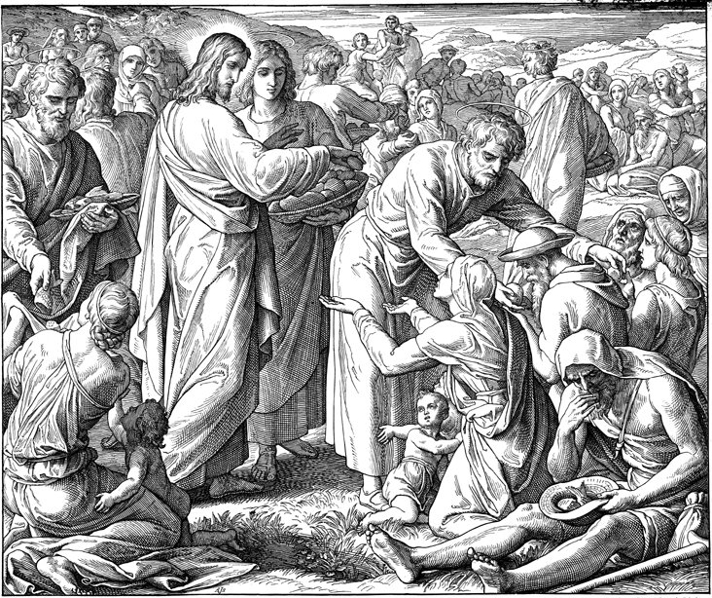
Laetare – Fourth Sunday in Lent
“Rejoice, O Jerusalem!”
March 11, 2018

Emmanuel Lutheran Church
4675 Bataan Memorial West
Las Cruces, New Mexico 88012
(575) 382-0220 (church office) / (575) 636-4988 (pastor cell)
www.GodWithUsLC.org

Sts. Peter & Paul Lutheran Mission
Silver City, New Mexico
www.peterandpaullutheran.org

Rev. Paul A. Rydecki, Pastor
member of the Evangelical Lutheran Diocese of North America (ELDoNA)

ANNOUNCEMENTS
Welcome! Emmanuel is a liturgical, traditional, historical, evangelical, catholic, orthodox, confessional Lutheran congregation, in communion with the Evangelical Lutheran Diocese of North America (ELDoNA). We believe that the Bible is the very Word of God, inspired and without any errors. We confess the truth of Scripture according to the Lutheran Book of Concord of 1580, without exception or reservation. We observe the calendar of the traditional Church Year and follow the Historic Lectionary. We celebrate the Divine Service (also known as the Mass) every Sunday and on other festivals, and we welcome visitors to hear God’s Word with us.
With regard to Holy Communion, we ask our visitors to respect our practice of closed Communion, which means that only communicant members of our congregation or of other congregations in communion with us are invited to commune at the Lord’s Table here, after they have been examined and absolved. Classes are offered throughout the year by the pastor so that those who are interested in joining our Communion fellowship have the opportunity to learn about the Christian faith and our confession of it.
The Order of Service is The Order of Holy Communion (page 15) from The Lutheran Hymnal (TLH). Those who are unfamiliar with the service may wish to use the Service Booklet.) The Scriptures are read from the New King James Version (NKJV). The Propers (the parts that change from week to week) are noted on the following page of this Service Folder.
Service notes: All Hallelujah’s are omitted from the service from Septuagesima until the Vigil of Easter. The Gloria in Excelsis is omitted throughout the Lenten season. The Lord’s Prayer will be chanted by the Pastor, and the Congregation will sing the doxology at the end.
EVENTS IN THE NEAR FUTURE…
Wed., Mar. 14 - Supper at church, 5:45 PM
- Vespers, 6:30 PM
Sun., Mar. 18 - Bible class & Sunday School 9 AM
- Divine Service 10:15 AM (Judica – Lent 5)

God’s Word at Home:
Bible Reading: 2 Chronicles 31 – Ezra 7
Small Catechism: Lord’s Prayer, Amen
Bible Passages: John 1:29, John 3:5-7

PROPERS Lent 4 - Laetare

HYMNS
OPENING HYMN TLH #348 – Jesus, Jesus, Only Jesus
HYMN (after the Creed) TLH #319 - In Thee Alone O Christ My Lord
HYMN (after General Prayer) TLH #430 – What Is the World to Me
DISTRIBUTION HYMNS TLH #375 - If Thy Beloved Son, O God
TLH #304 – An Awefull Mystery Is Here

Isaiah 49:8-13 + Galatians 4:21-31 + John 6:1-15

The service begins on page 15 or The Lutheran Hymnal (TLH).
THE INTROIT (after the general Absolution) Isaiah 66:10; Psalm 122:1
P (Antiphon) Rejoice with Jerusalem, and be glad with her, All| you who love her; *
Rejoice for joy with her, All you | who mourn for her.
C I was glad when | they said to me, *
“Let us go into the | house of the Lord.”
GLORIA PATRI (p.16): Glory be to the Father, and to the Son, and to the Holy Ghost; as it was in the beginning, is now, and ever shall be, world without end. Amen.
P (Antiphon)
The service continues with The Kyrie, p. 17, followed immediately by the Salutation.
THE GRADUAL (after First Lesson) & TRACT (after Epistle) Ps. 122:1, 7; 125:12
P I was glad when | they said to me, *
“Let us go into the | house of the Lord.”
C Peace be | within your walls, *
Prosperity within | your palaces.
P Those who trust in the Lord are | like Mount Zion, *
Which cannot be moved, but | abides forever.
C As the mountains surround | Jerusalem, *
So the Lord surrounds His people from this time forth | and forever.

The service continues on p. 21 with the reading of the Gospel.
We believe, teach and confess…

from the Apology of the Augsburg Confession: Article XXIV
The Sacraments are signs of God’s will toward us and not merely signs of people among one another. Those who define Sacraments in the New Testament as signs of grace are correct. There are two things in a Sacrament: a sign and the Word. In the New Testament, the Word is the promise of grace added. The promise of the New Testament is the promise of the forgiveness of sins, “This is My body, which is given for you. This is My blood of the new testament, which is shed for you for the forgiveness of sins.” So the Word offers the forgiveness of sins. A ceremony is a sort of picture, or seal, as Paul (Romans 4:11) calls it, the Word making known the promise. Therefore, just as the promise is useless unless it is received through faith, so a ceremony is useless unless faith, which is truly confident that the forgiveness of sins is here offered, is added. This faith encourages penitent minds. Just as the Word has been given to excite this faith, so the Sacrament has been set up so that what meets the eyes might move the heart to believe. The Holy Spirit works through these: Word and Sacrament.
Such a use of the Sacrament, in which faith enlivens terrified hearts, is a service of the New Testament. That is because the New Testament requires spiritual inclinations, making dead and alive. Christ instituted the Sacrament for this use, since He commanded the disciples to do this in remembrance of Him. Remembering Christ is not the useless celebration of a show. It is not something set up for the sake of example, as the memory of Hercules or Ulysses is celebrated in tragedies. Rather, it is remembering Christ’s benefits and receiving them through faith, to be enlivened by them. So Psalm 111:4–5 says, “He has caused His wondrous works to be remembered; the LORD is gracious and merciful. He provides food for those who fear Him.” The Sacrament illustrates that God’s will and mercy should be discerned in the ceremony. Faith that grasps mercy enlivens. This is the chief use of the Sacrament. It is clear who are fit for the Sacrament (namely, terrified consciences) and how they should use it.

