Service Folder
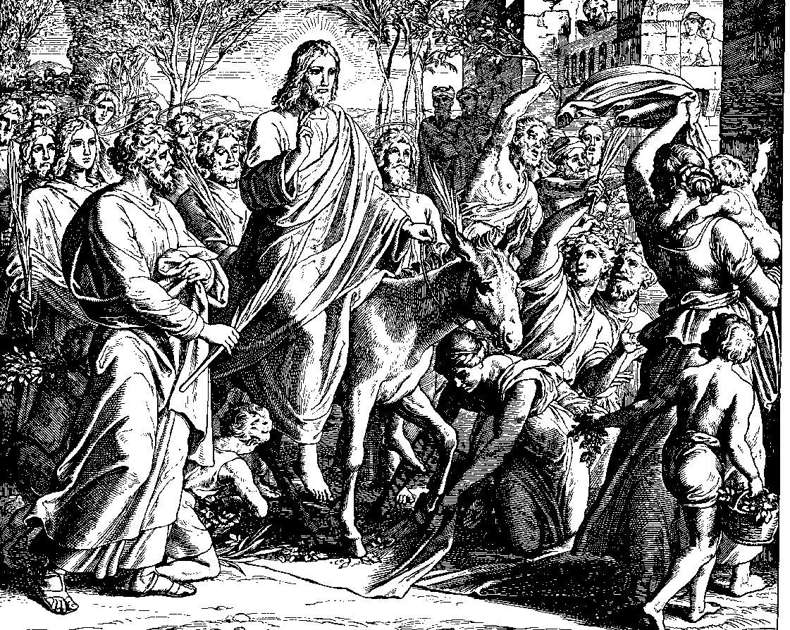
Palmarum – Palm Sunday
March 25, 2018

Emmanuel Lutheran Church
4675 Bataan Memorial West
Las Cruces, New Mexico 88012
(575) 382-0220 (church office) / (575) 636-4988 (pastor cell)
www.GodWithUsLC.org

Sts. Peter & Paul Lutheran Mission
Silver City, New Mexico
www.peterandpaullutheran.org

Rev. Paul A. Rydecki, Pastor
member of the Evangelical Lutheran Diocese of North America (ELDoNA)

ANNOUNCEMENTS
Welcome! Emmanuel is a liturgical, traditional, historical, evangelical, catholic, orthodox, confessional Lutheran congregation, in communion with the Evangelical Lutheran Diocese of North America (ELDoNA). We believe that the Bible is the very Word of God, inspired and without any errors. We confess the truth of Scripture according to the Lutheran Book of Concord of 1580, without exception or reservation. We observe the calendar of the traditional Church Year and follow the Historic Lectionary. We celebrate the Divine Service (also known as the Mass) every Sunday and on other festivals, and we welcome visitors to hear God’s Word with us.
With regard to Holy Communion, we ask our visitors to respect our practice of closed Communion, which means that only communicant members of our congregation or of other congregations in communion with us are invited to commune at the Lord’s Table here, after they have been examined and absolved. Classes are offered throughout the year by the pastor so that those who are interested in joining our Communion fellowship have the opportunity to learn about the Christian faith and our confession of it.
The Order of Service for Palm Sunday begins with a procession starting from the patio outside the front doors of the church where the Palm Sunday Gospel will be read from Matthew 21. (Those who do not wish to walk in the procession may remain seated in the sanctuary.) The congregation follows the pastor around the sanctuary, singing the processional hymn. After walking around the sanctuary once, the procession proceeds up the center aisle, at which time all return to their seats.
In place of the regular Gospel and the Sermon, the entire Passion History of the Suffering & Death of our Lord Jesus Christ will be read according to St. Matthew’s Gospel. The Passion History will be read tomorrow from St. Mark, on Tuesday from St. Luke, and on Good Friday from St. John.

EVENTS IN THE NEAR FUTURE…
Mon., Mar. 26 - Passion History according to St. Mark, 6:30 PM
Tues., Mar. 27 - Passion History according to St. Luke, 6:30 PM
Thur., Mar. 29 - Maundy Thursday Divine Service, 6:30 PM
Fri., Mar. 30 - Good Friday Divine Service, 1 PM
Sat., Mar. 31 - Easter Vigil, 8 PM
Sun., Apr. 1 - Easter breakfast, 8:30 AM
- Divine Service for the Feast of the Resurrection, 10:15 AM

PROCESSION OF PALMS
Those who wish to participate in the procession gather on the outside patio.
P The grace of our Lord T Jesus Christ and the love of God and the communion of the Holy Ghost be with you all.
C Amen.
P Blessed is He who comes in the name of the Lord.
C Hosanna to the Son of David!
P Let us pray. … one God, now and forever.
C Amen.
P The Holy Gospel according to St. Matthew, chapter 21.
C (spoken) Glory be to Thee, O Lord.
After the reading of the Gospel:
P This is the Gospel of the Lord.
C (spoken) Praise be to Thee, O Christ.
P Let us go forth in peace,
C in the name of the Lord.
Those who are seated in the sanctuary STAND as the hymn begins. As the procession proceeds up the center aisle, all take their places and remain standing.
PROCESSIONAL HYMN TLH #160
1. All glory, laud, and honor To Thee, Redeemer, King,
To whom the lips of children Made sweet hosannas ring.
Thou art the King of Israel And David’s royal Son,
Who in the Lord’s name comest, The King and Blessed One.
2. All glory, laud, and honor To Thee, Redeemer, King,
To whom the lips of children Made sweet hosannas ring.
The company of angels Are praising Thee on high,
And mortal men and all things Created make reply.
3. All glory, laud, and honor To Thee, Redeemer, King,
To whom the lips of children Made sweet hosannas ring.
The people of the Hebrews With palms before Thee went;
Our praise and prayer and anthems Before Thee we present.
4. All glory, laud, and honor To Thee, Redeemer, King,
To whom the lips of children Made sweet hosannas ring.
To Thee before Thy Passion They sang their hymns of praise;
To Thee, now high exalted, Our melody we raise.
5. All glory, laud, and honor To Thee, Redeemer, King,
To whom the lips of children Made sweet hosannas ring.
Thou didst accept their praises, Accept the prayers we bring,
Who in all good delightest, Thou good and gracious King.
After the final stanza is sung and all are standing in place in the sanctuary:
P Blessed is He who comes in the name of the Lord.
C Hosanna in the highest!
P (sung) The Lord be with you.
C (sung) And with thy spirit.
The Pastor speaks the collect. The congregation sings “Amen” and then sits.
THE EPISTLE Philippians 2:5-11
HYMN TLH #140 – Jesus, I Will Ponder Now (st. 1-2)
THE HOLY GOSPEL, Part 1
P The Holy Gospel of the Passion History of our Lord Jesus Christ from the Gospel according to St. Matthew, chapters 26 and 27.
C (sung) Glory be to Thee, O Lord.
HYMN TLH #140 – Jesus, I Will Ponder Now (st. 3-4)
THE HOLY GOSPEL, Part 2
HYMN TLH #140 – Jesus, I Will Ponder Now (st. 5-6)
THE HOLY GOSPEL, Part 3
HYMN TLH #142 – A Lamb Goes Uncomplaining (st. 1-3)
Stand
THE HOLY GOSPEL, Part 4
After the Gospel:
P This is the Gospel of our Lord.
C (sung) Praise be to Thee, O Christ.
THE NICENE CREED TLH, p. 22
Sit
HYMN TLH #142 – A Lamb Goes Uncomplaining (st. 4-6)
BRIEF SERMON
THE OFFERING
Stand
THE GENERAL PRAYER
The service continues with The Preface, TLH p. 24.

DISTRIBUTION HYMNS TLH #161 - Hosanna, Loud Hosanna
TLH #162 – Ride On, Ride On in Majesty

