Service Insert
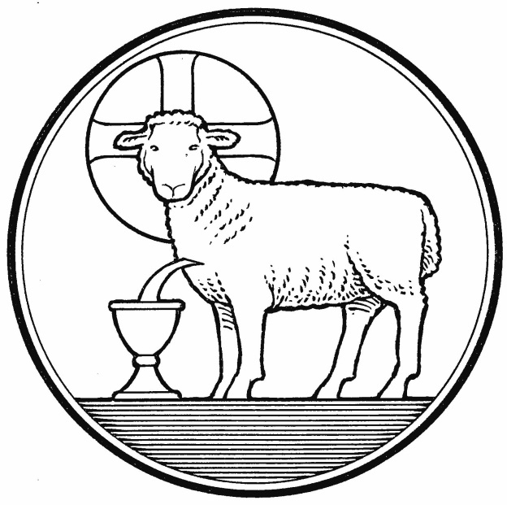
Maundy Thursday
March 29, 2018

Emmanuel Lutheran Church
4675 Bataan Memorial West
Las Cruces, New Mexico 88012
(575) 382-0220 (church office) / (575) 636-4988 (pastor cell)
www.GodWithUsLC.org pastor@GodWithUsLC.org

Sts. Peter & Paul Lutheran Mission
Silver City, New Mexico
www.peterandpaullutheran.org

Rev. Paul A. Rydecki, Pastor
member of the Evangelical Lutheran Diocese of North America (ELDoNA)

ANNOUNCEMENTS
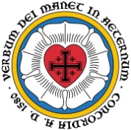
Welcome! Emmanuel is a liturgical, traditional, historical, evangelical, catholic, orthodox, confessional Lutheran congregation, in fellowship with the Evangelical Lutheran Diocese of North America (ELDoNA). We believe that the Bible is the very Word of God, inspired and without any errors. We confess the truth of Scripture according to the Lutheran Book of Concord of 1580, without exception or reservation. We observe the calendar of the traditional Church Year and follow the Historic Lectionary. We celebrate the Divine Service (also known as the Mass) every Sunday and on other festivals, and we welcome visitors to hear God’s Word with us.
With regard to Holy Communion, we ask our visitors to respect our practice of closed Communion, which means that only communicant members of our congregation or of other congregations in communion with us are invited to commune at the Lord’s Table here, after they have been examined and absolved. Classes are offered throughout the year by the pastor so that those who are interested in joining our Communion fellowship have the opportunity to learn about the Christian faith and our confession of it.
Holy (Maundy) Thursday, occurring on the eve of our Lord’s crucifixion, begins the celebration of the holy Three Days of Christ’s Passover (Pascha), commonly known as the Triduum. Each service of the Triduum flows into the next, all of them being treated as a single unit, not as three separate services. The Service for Maundy Thursday consists of three parts:
- The Confessional Service
- The Service of the Holy Communion
- The Stripping of the Altar
Good Friday Chief Service: This is the Second Service of the Triduum. During this service, which is held during the hours of darkness (12 – 3PM), the Passion History will be read from the Gospel of John.
Easter Vigil: This is the Third Service of the Triduum, held on Saturday evening after sunset, which is already the beginning of Easter Sunday, according to Hebrew reckoning. The Paschal Candle is used prominently in the service, which consists of The Service of Light, Service of Lessons, Service of Holy Baptism, Service of Prayer, Service of the Word, and Service of Holy Communion.

The Order of the Confessional Service
The Lutheran Hymnal, p.46
Remain seated
Versicles and Responses p.46
The Psalm Psalm 88
The Scripture Lesson Exodus 12:1-14
The Exhortation p.47
Stand
The Examination and Absolution p.48 (bottom half)
The Order of the Holy Communion
The Lutheran Hymnal, beginning on p.19
The Kyrie & Gloria in Excelsis p.17-19
The Salutation and Collect for the Day p.19
Sit
The Epistle 1 Corinthians 11:23-32
The Gradual and Tract Philippians 2:8, 9 paraphrase
P Christ humbled Himself and became obedient to | the point of death, *
Even the death of | the cross.
C Therefore God also has highly | exalted Him *
And given Him the name which is above ev- | ery name.
Stand
The Gospel John 13:1-15
The Nicene Creed p.22
Sit
Hymn TLH #163 - The Death of Jesus Christ, Our Lord
The Sermon
The Offering (no Offertory is sung)
Stand
The Litany p.110
Hymn TLH #311 – Jesus Christ, Our Blessed Savior
The Preface p. 24
The Service continues on p.24 through the Communion Distribution. No hymns will be sung during the Distribution. The Nunc Dimittis is omitted.
Post-Communion Collect
P Let us pray.
The collect is spoken.
C Amen.
Sit
Stripping of the Altar
HYMN TLH #150 – Lord Jesus, Thou Art Going Forth
The Congregation sings stanzas 1,3 & 5 – the words of The Soul.
The Pastor sings stanzas 2 & 4 – the words of Jesus.
During the hymn the Communion vessels are removed and the altar is solemnly stripped as a picture of the Lord’s abandonment by His disciples on Maundy Thursday.
The pastor exits the chancel, carrying the Paschal candle. The congregation may depart as the post-service music begins to play.

__________________________________________________

Holy Week Schedule
Holy Friday Service of Word and Sacrament, 1 PM
Holy Saturday Vigil of Easter, 8 PM
Easter Sunday Breakfast, 8:30 AM
Easter Sunday Divine Service, 10:15 AM

