Service Folder
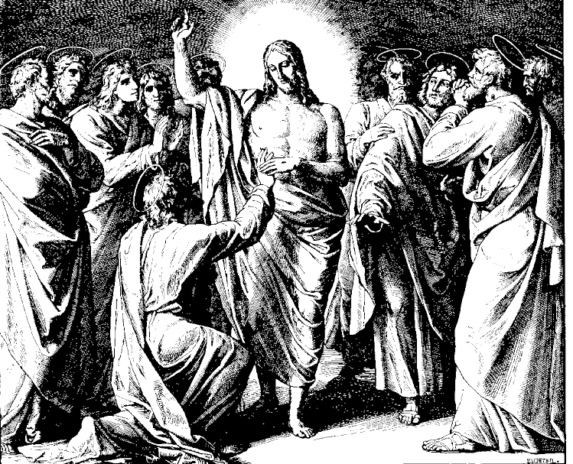
First Sunday after Easter
Quasimodogeniti
“As newborn babes…”
April 8, 2018

Emmanuel Lutheran Church
4675 Bataan Memorial West
Las Cruces, New Mexico 88012
(575) 382-0220 (church office) / (575) 636-4988 (pastor cell)
www.GodWithUsLC.org

Sts. Peter & Paul Lutheran Mission
Silver City, New Mexico
www.peterandpaullutheran.org

Rev. Paul A. Rydecki, Pastor
member of the Evangelical Lutheran Diocese of North America (ELDoNA)

ANNOUNCEMENTS
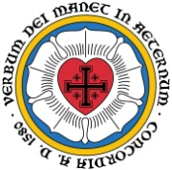
Welcome! Emmanuel is a liturgical, traditional, historical, evangelical, catholic, orthodox, confessional Lutheran congregation, in communion with the Evangelical Lutheran Diocese of North America (ELDoNA). We believe that the Bible is the very Word of God, inspired and without any errors. We confess the truth of Scripture according to the Lutheran Book of Concord of 1580, without exception or reservation. We observe the calendar of the traditional Church Year and follow the Historic Lectionary. We celebrate the Divine Service (also known as the Mass) every Sunday and on other festivals, and we welcome visitors to hear God’s Word with us.
With regard to Holy Communion, we ask our visitors to respect our practice of closed Communion, which means that only communicant members of our congregation or of other congregations in communion with us are invited to commune at the Lord’s Table here, after they have been examined and absolved. Classes are offered throughout the year by the pastor so that those who are interested in joining our Communion fellowship have the opportunity to learn about the Christian faith and our confession of it.
The Order of Service is The Order of Holy Communion (page 15) from The Lutheran Hymnal (TLH). The Scriptures are read from the New King James Version (NKJV). The Propers (the parts that change from week to week) are noted on the following page of this Service Folder.

EVENTS IN THE NEAR FUTURE…
Sun., Apr. 15 - Bible class & Sunday School 9 AM
- Divine Service 10:15 AM (Easter 2)

God’s Word at Home:
Bible Reading: Job 14-27
Small Catechism: Baptism, Third, Part 2
Bible Passages: John 8:58, 10:7, 10:11

PROPERS Easter 1

HYMNS
OPENING HYMN TLH #204 - Come Ye Faithful Raise the Strain
HYMN (after the Creed) TLH #208 - Ye Sons and Daughters of the King
HYMN (after General Prayer) TLH #331 - Yea as I Live Jehovah Saith
DISTRIBUTION HYMN TLH #206 – Jesus Christ, My Sure Defense

Epistle: 1 John 5:4-10 Gospel: John 20:19-31

THE INTROIT (after the general Absolution) 1 Pe. 2:2a; Ps. 81:8; Ps. 81:1, 7, 10, 16
P (Antiphon) As new- | born babes, *
Desire the pure | milk of the Word.
Hear, O My people, and I will admon- | ish you! *
O Israel, if you will | listen to Me!
C Sing aloud to God | our strength; *
Make a joyful shout to the | God of Jacob.
GLORIA PATRI (p.16): Glory be to the Father, and to the Son, and to the Holy Ghost; as it was in the beginning, is now, and ever shall be, world without end. Amen.
P (Antiphon)
The service continues with The Kyrie, p. 17, followed immediately by The Gloria.
THE GREATER HALLELUJAH (after the Epistle) 1 Cor. 5:7b; Matthew 28:2b
P Alle- | luia! *
Al- | — leluia!
C Christ our Passover was sacrificed | for us. *
Al- | — leluia!
The angel of the Lord descended from | heaven, *
And came and rolled back the stone from the door, and sat upon it. | Alleluia!
The service continues with The Gospel, p. 21.
We believe, teach and confess…

from the Augsburg Confession: Article XXVIII
Our teachers’ position is this: the authority of the Keys, or the authority of the bishops—according to the Gospel—is a power or commandment of God, to preach the Gospel, to forgive and retain sins, and to administer Sacraments. Christ sends out His apostles with this command, “As the Father has sent Me, even so I am sending you … Receive the Holy Spirit. If you forgive the sins of anyone, they are forgiven; if you withhold forgiveness from anyone, it is withheld” (John 20:21–22). And in Mark 16:15, Christ says, “Go … proclaim the Gospel to the whole creation.”
This authority is exercised only by teaching or preaching the Gospel and administering the Sacraments, either to many or to individuals, according to their calling. In this way are given not only bodily, but also eternal things: eternal righteousness, the Holy Spirit, and eternal life. These things cannot reach us except by the ministry of the Word and the Sacraments, as Paul says, “The Gospel … is the power of God for salvation to everyone that believes” (Romans 1:16). Therefore, the Church has the authority to grant eternal things and exercises this authority only by the ministry of the Word.
from the Apology of the Augsburg Confession: Article VI
But the Keys have the power of binding and loosing only upon earth [not in purgatory], according to Matthew 16:19, “Whatever you bind on earth shall be bound in heaven, and whatever you loose on earth shall be loosed in heaven.” As we have said before, the Keys do not have the power to impose penalties or to institute rites of worship, but only the command to forgive sins to those who are converted and to convict and excommunicate those who are unwilling to be converted. For just as to loose means to forgive sins, so to bind means not to forgive sins. Christ speaks of a spiritual kingdom, and God’s command is that ministers of the Gospel should absolve those who are converted, according to 2 Corinthians 10:8, “our authority, which the Lord gave for building you up.”

