Service Folder
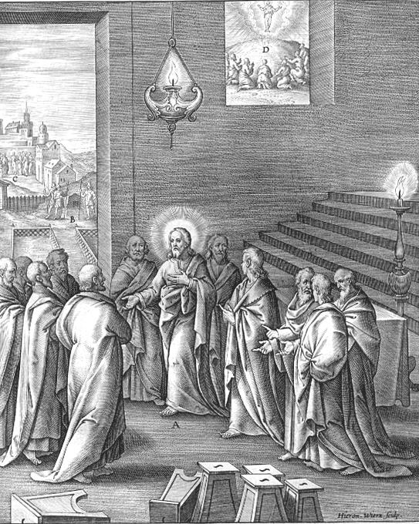
Third Sunday after Easter
Jubilate
“Make a joyful shout to God, all the earth!”
April 22, 2018

Emmanuel Lutheran Church
4675 Bataan Memorial West
Las Cruces, New Mexico 88012
(575) 382-0220 (church office) / (575) 636-4988 (pastor cell)
www.GodWithUsLC.org

Sts. Peter & Paul Lutheran Mission
Silver City, New Mexico
www.peterandpaullutheran.org

Rev. Paul A. Rydecki, Pastor
member of the Evangelical Lutheran Diocese of North America (ELDoNA)

ANNOUNCEMENTS
Welcome! Emmanuel is a liturgical, traditional, historical, evangelical, catholic, orthodox, confessional Lutheran congregation, in communion with the Evangelical Lutheran Diocese of North America (ELDoNA). We believe that the Bible is the very Word of God, inspired and without any errors. We confess the truth of Scripture according to the Lutheran Book of Concord of 1580, without exception or reservation. We observe the calendar of the traditional Church Year and follow the Historic Lectionary. We celebrate the Divine Service (also known as the Mass) every Sunday and on other festivals, and we welcome visitors to hear God’s Word with us.
With regard to Holy Communion, we ask our visitors to respect our practice of closed Communion, which means that only communicant members of our congregation or of other congregations in communion with us are invited to commune at the Lord’s Table here, after they have been examined and absolved. Classes are offered throughout the year by the pastor so that those who are interested in joining our Communion fellowship have the opportunity to learn about the Christian faith and our confession of it.
The Order of Service is The Order of Holy Communion (page 15) from The Lutheran Hymnal (TLH). The Scriptures are read from the New King James Version (NKJV). The Propers (the parts that change from week to week) are noted on the following page of this Service Folder.
EVENTS IN THE NEAR FUTURE…
Sun., April 29 - Bible class & Sunday School 9 AM
- Divine Service 10:15 AM (Easter 4)
- Congregational meeting, after the service
God’s Word at Home:
Bible Reading: Job 41 – Psalm 11
Small Catechism: Baptism, Fourth, Part 2
Bible Passages:
John 13:34 A new commandment I give to you, that you love one another; as I have loved you, that you also love one another.
John 14:1 Let not your heart be troubled; you believe in God, believe also in Me.
John 14:2-3 In My Father’s house are many mansions; if it were not so, I would have told you. I go to prepare a place for you. And if I go and prepare a place for you, I will come again and receive you to Myself; that where I am, there you may be also.

PROPERS Easter 3

HYMNS
OPENING HYMN TLH #207 - Like the Golden Sun Ascending
HYMN (after the Creed) TLH #535 - Rejoice, My Heart, Be Glad and Sing
HYMN (after General Prayer) TLH #353 - Lord Jesus Christ My Savior Blest
DISTRIBUTION HYMN TLH #192 – Awake, My Heart, with Gladness

Epistle: 1 Peter 2:11-20 Gospel: John 16:16-23a

THE INTROIT (after the general Absolution) Psalm 66:1-2; Psalm 66:3, 5, 8-9
P (Antiphon) MAKE A joyful shout to God, all the earth! Alle- | luia!
Sing out the honor of His name; | Alleluia!
Make His praise glorious. Alle- | luia!
Alleluia! | Alleluia!
C Say to God, “How awesome are | Your works! *
Through the greatness of Your power Your enemies shall submit | themselves to You.
GLORIA PATRI (p.16): Glory be to the Father, and to the Son, and to the Holy Ghost; as it was in the beginning, is now, and ever shall be, world without end. Amen.
P (Antiphon)
The service continues with The Kyrie, p. 17, followed immediately by The Gloria.
THE GREATER HALLELUJAH (after the Epistle) Ps. 111:9a; Luke 24:46b para.
P Alle- | luia! *
Al- | — leluia!
C The Lord has sent re- | demption *
To His people. | Alleluia!
It was necessary for the Christ to suffer and to rise from | the dead *
And to enter into His glory. | Alleluia!
The service continues with The Triple Hallelujah and the Gospel, p. 20.
We believe, teach and confess…

from the Apology of the Augsburg Confession: Article IV
How could the office of Christ and justification be declared more clearly? Paul says that the Law does not justify. Therefore, Christ was given, that we may believe that for His sake we are justified. He plainly denies justification by the Law. So for Christ’s sake we are accounted righteous when we believe that God, for His sake, has been reconciled to us.
This Jesus is the stone that was rejected by you, the builders, which has become the cornerstone. And there is salvation in no one else, for there is no other name under heaven given among men by which we must be saved. (Acts 4:11–12)
Christ’s name is received only by faith. Therefore, we are saved by confidence in Christ’s name, and not by confidence in our works. For “the name” here means the cause that is mentioned, because of which salvation is gained. To call upon Christ’s name is to trust in His name as the cause, or price, because of which we are saved. Acts 15:9 says, “cleansed their hearts by faith.” Therefore, the faith that the apostles speak about is not useless knowledge, but a reality. It receives the Holy Spirit and justifies us.
Habakkuk 2:4 says, “The righteous shall live by his faith.” Here he says, first, that people are just by faith. By faith they believe that God is favorable, and he adds that the same faith gives life because this faith produces peace and joy in the heart and eternal life.
from the Formula of Concord, Solid Declaration: Article IX
Even in the Ancient Christian teachers of the Church, as well as among some of our teachers, different explanations of the article about Christ’s descent to hell are found. Therefore, we abide in the simplicity of our Christian faith. Dr. Luther has pointed us to this in a sermon about Christ’s descent to hell, which he delivered in the castle at Torgau in the year 1533. In the Creed we confess, “I believe … in Jesus Christ, His only Son, our Lord, who … was crucified, died and was buried. He descended into hell.” In this Confession Christ’s burial and descent to hell are distinguished as different articles. We simply believe that the entire person (God and man) descended into hell after the burial, conquered the devil, destroyed hell’s power, and took from the devil all his might. We should not, however, trouble ourselves with high and difficult thoughts about how this happened. With our reason and our five senses this article can be understood as little as the preceding one about how Christ is placed at the right hand of God’s almighty power and majesty. We are simply to believe it and cling to the Word. So we hold to the substance and consolation that neither hell nor the devil can take captive or injure us and all who believe in Christ.

