Service Folder
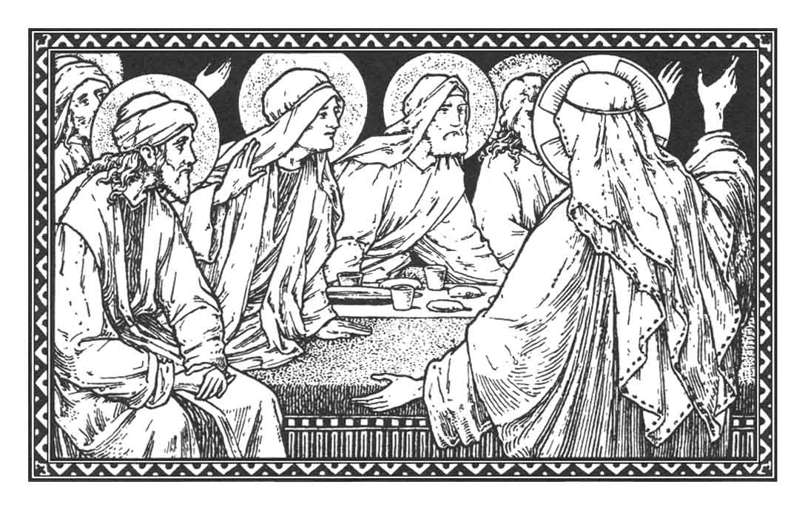
Fifth Sunday after Easter
Rogate
“Ask!”
May 6, 2018

Emmanuel Lutheran Church
4675 Bataan Memorial West
Las Cruces, New Mexico 88012
(575) 382-0220 (church office) / (575) 636-4988 (pastor cell)
www.GodWithUsLC.org

Sts. Peter & Paul Lutheran Mission
Silver City, New Mexico
www.peterandpaullutheran.org

Rev. Paul A. Rydecki, Pastor
member of the Evangelical Lutheran Diocese of North America (ELDoNA)

ANNOUNCEMENTS
Welcome! Emmanuel is a liturgical, traditional, historical, evangelical, catholic, orthodox, confessional Lutheran congregation, in communion with the Evangelical Lutheran Diocese of North America (ELDoNA). We believe that the Bible is the very Word of God, inspired and without any errors. We confess the truth of Scripture according to the Lutheran Book of Concord of 1580, without exception or reservation. We observe the calendar of the traditional Church Year and follow the Historic Lectionary. We celebrate the Divine Service (also known as the Mass) every Sunday and on other festivals, and we welcome visitors to hear God’s Word with us.
With regard to Holy Communion, we ask our visitors to respect our practice of closed Communion, which means that only communicant members of our congregation or of other congregations in communion with us are invited to commune at the Lord’s Table here, after they have been examined and absolved. Classes are offered throughout the year by the pastor so that those who are interested in joining our Communion fellowship have the opportunity to learn about the Christian faith and our confession of it.
The Order of Service is The Order of Holy Communion (page 15) from The Lutheran Hymnal (TLH). The Scriptures are read from the New King James Version (NKJV). The Propers (the parts that change from week to week) are noted on the following page of this Service Folder.
EVENTS IN THE NEAR FUTURE…
Thur., May 10 - Divine Service for Ascension, 6:30 PM
Sun., May 13 - Bible class & Sunday School 9 AM
- Divine Service 10:15 AM (Sunday after Ascension)
God’s Word at Home:
Bible Reading: Psalm 25-38
Small Catechism: Confession, Part 2
Bible Passages:
John 15:5 I am the vine, you are the branches. He who abides in Me, and I in him, bears much fruit; for without Me you can do nothing.
John 17:3 And this is eternal life, that they may know You, the only true God, and Jesus Christ whom You have sent.
John 17:17 Sanctify them by Your truth. Your word is truth.

PROPERS Easter 5

HYMNS
OPENING HYMN TLH #458 - Our Father Thou in Heaven (st. 1-3)
HYMN (after the Creed) TLH #458 - Our Father Thou in Heaven (st. 4-6)
HYMN (after General Prayer) TLH #458 - Our Father Thou in Heaven (st. 7-9)
DISTRIBUTION HYMNS TLH #308 - Invited, Lord, by Boundless Grace
TLH #307 - Draw Nigh and Take the Body of the Lord

Epistle: James 1:22-27 Gospel: John 16:23-30

THE INTROIT (after the general Absolution) Isaiah 48:20b; Psalm 66:1
P (Antiphon) With a voice of singing, declare, pro- | claim this, *
Utter it to the end of the earth. | Alleluia!
The Lord has redeemed His servant | Jacob! *
Alleluia! | Alleluia!
C Make a joyful shout to God, all | the earth! *
Sing out the honor of His name; Make His | praise glorious.
GLORIA PATRI (p.16): Glory be to the Father, and to the Son, and to the Holy Ghost; as it was in the beginning, is now, and ever shall be, world without end. Amen.
P (Antiphon)
The service continues with The Kyrie, p. 17, followed immediately by The Gloria.
THE GREATER HALLELUJAH Liturgical text based on Luke 24:46b; John 16:28
P Alle- | luia! *
Al- | — leluia!
C Christ who has redeemed us with | His blood, *
Is risen and has appeared unto us. | Alleluia!
I came forth from the Father and have come into | the world. *
Again, I leave the world and go to the Father. | Alleluia!
The service continues with the Triple Hallelujah and The Gospel, p. 20.
We believe, teach and confess…

from the Large Catechism: The Lord’s Prayer
We have now heard what we must do and believe, in what things the best and happiest life consists. Now follows the third part, how we ought to pray. For we are in a situation where no person can perfectly keep the Ten Commandments, even though he has begun to believe. The devil with all his power, together with the world and our own flesh, resists our efforts. Therefore, nothing is more necessary than that we should continually turn towards God’s ear, call upon Him, and pray to Him. We must pray that He would give, preserve, and increase faith in us and the fulfillment of the Ten Commandments. We pray that He would remove everything that is in our way and that opposes us in these matters. So that we might know what and how to pray, our Lord Christ has Himself taught us both the way and the words…
But before we explain the Lord’s Prayer part by part, it is most necessary first to encourage and stir people to prayer, as Christ and the apostles also have done. And the first thing to know is that it is our duty to pray because of God’s commandment. For that’s what we heard in the Second Commandment, “You shall not take the name of the LORD your God in vain.” We are required to praise that holy name and call upon it in every need, or to pray. To call upon God’s name is nothing other than to pray. Prayer is just as strictly and seriously commanded as all other commandments: to have no other God, not to kill, not to steal, and so on…
Now, from the fact that prayer is so solemnly commanded, you are to conclude and think that no one should in any way despise his prayer. Instead, he should count on prayer. He should always turn to an illustration from the other commandments. A child should in no way despise his obedience to father and mother, but should always think, “This work is a work of obedience. What I do I do for no other reason than that I may walk in the obedience and commandment of God. On this obedience I can settle and stand firm, and I can value it as a great thing, not because of my worthiness, but because of the commandment.” So here also, we should think about the words we pray and the things we pray for as things demanded by God and done in obedience to Him. We should think, “On my account this prayer would amount to nothing. But it shall succeed, because God has commanded it.”

