Service Folder
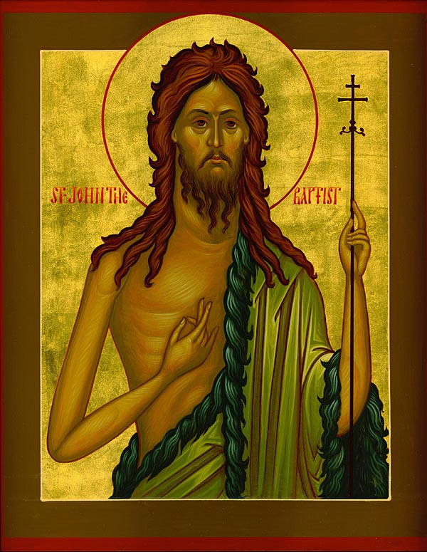
Feast of the Nativity of John the Baptist
June 24, 2018

Emmanuel Lutheran Church
4675 Bataan Memorial West
Las Cruces, New Mexico 88012
(575) 382-0220 (church office) / (575) 636-4988 (pastor cell)
www.GodWithUsLC.org

Sts. Peter & Paul Lutheran Mission
Silver City, New Mexico
www.peterandpaullutheran.org

Rev. Paul A. Rydecki, Pastor
member of the Evangelical Lutheran Diocese of North America (ELDoNA)

ANNOUNCEMENTS
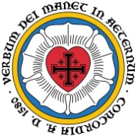
Welcome! Emmanuel is a liturgical, traditional, historical, evangelical, catholic, orthodox, confessional Lutheran congregation, in communion with the Evangelical Lutheran Diocese of North America (ELDoNA). We believe that the Bible is the very Word of God, inspired and without any errors. We confess the truth of Scripture according to the Lutheran Book of Concord of 1580, without exception or reservation. We observe the calendar of the traditional Church Year and follow the Historic Lectionary. We celebrate the Divine Service (also known as the Mass) every Sunday and on other festivals, and we welcome visitors to hear the Word of God with us.
With regard to Holy Communion, we ask our visitors to respect our practice of closed Communion, which means that only communicant members of our congregation or of other congregations in communion with us are invited to commune at the Lord’s Table here, after they have been examined and absolved. Classes are offered throughout the year by the pastor so that those who are interested in joining our Communion fellowship have the opportunity to learn about the Christian faith and our confession of it.
The Order of Service is The Order of Holy Communion (page 15) from The Lutheran Hymnal (TLH). The Scriptures are read from the New King James Version (NKJV). The Propers (the parts that change from week to week) are noted on the following page of this Service Folder.
The Day. Today we celebrate the birth of St. John the Baptist, the great forerunner of the Messiah prophesied by the Old Testament Prophets. John himself was the last Prophet of the Old Testament era. Today the Word of God surrounding John’s birth receives our focus, especially the Song of Zechariah (“Benedictus”), John’s father, in which the Holy Spirit tells of John’s future ministry of pointing to Christ for the forgiveness of sins.

EVENTS IN THE NEAR FUTURE…
Sun., July 1 - Bible Class, 9 AM
- Divine Service 10:15 AM (Trinity 5)

PROPERS Nativity of John the Baptist

HYMNS
OPENING HYMN TLH #6 - Kyrie! God, Father in Heaven Above
HYMN (after the Creed) TLH p.38-39 – The Benedictus
HYMN (after General Prayer) TLH #272 – When All the World was Cursed
DISTRIBUTION HYMN TLH #311 - Jesus Christ, Our Blessed Savior

First Lesson: Mal. 4:4-6 Epistle: Is. 40:1-5 Gospel: Luke 1:57-80

THE INTROIT (after general Absolution) Isaiah 40:3,5a; Psalm 92:1-2,4-5
P (Antiphon) THE VOICE of one crying in the wil- | derness: *
“Prepare the way of the Lord make straight in the desert a highway | for our God.
The glory of | the Lord * Shall | be revealed.
C It is good to give thanks to | the Lord, *
And to sing praises to Your name, | O Most High.
To declare Your lovingkindness in the | morning, *
And Your faithfulness | ev’ry night.
For You, Lord, have made me glad through | Your work; *
I will triumph in the works | of Your hands.
O Lord, how great are | Your works! *
Your thoughts are | very deep.
GLORIA PATRI (p.16): Glory be to the Father, and to the Son, and to the Holy Ghost; as it was in the beginning, is now, and ever shall be, world without end. Amen.
P (Antiphon)
The service continues with The Kyrie, p. 17.
GRADUAL (after First Lesson) & HALLELUJAH (after Epistle) Jer. 1:5,9; Is. 40:3
P Before I formed you in the womb I | knew you; *
Before you were born I sanc- | tified you.
C Then the Lord put forth His hand and touched | my mouth, *
And the Lord said to me: “Behold, I have put My words | in your mouth.
P Alle- | luia! * Al- | leluia!
C The voice of one | crying: *
“Prepare the way of the Lord.” Al- | leluia!
The service continues with The Triple Hallelujah and The Gospel, p. 20-21.

God’s Word at Home:
Bible Reading: Psalm 119-131
Small Catechism: First Commandment

The First Commandment
You shall have no other gods.
What does this mean?
We should fear, love and trust in God above all things.

Bible Passages:
Romans 4:5 But to him who does not work but believes on Him who justifies the ungodly, his faith is accounted for righteousness.
Romans 4:24-25 [Faith] shall be imputed to us who believe in Him who raised up Jesus our Lord from the dead, who was delivered up because of our offenses, and was raised because of our justification.
Romans 5:1 Therefore, having been justified by faith, we have peace with God through our Lord Jesus Christ.

