Service Folder
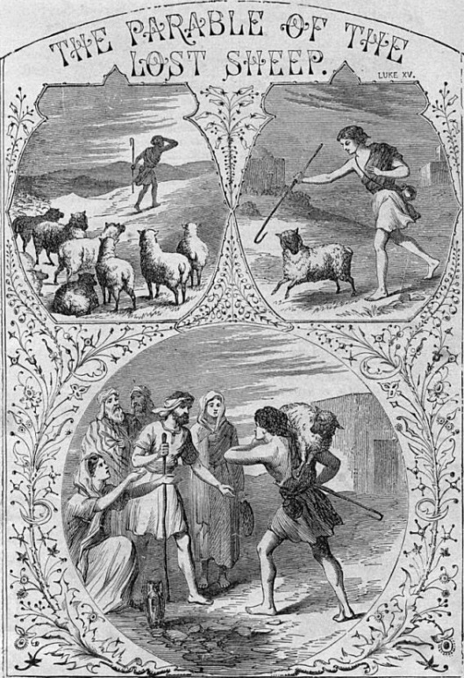
Third Sunday after Trinity
June 17, 2018

Emmanuel Lutheran Church
4675 Bataan Memorial West
Las Cruces, New Mexico 88012
(575) 382-0220 (church office) / (575) 636-4988 (pastor cell)
www.GodWithUsLC.org

Sts. Peter & Paul Lutheran Mission
Silver City, New Mexico
www.peterandpaullutheran.org

Rev. Paul A. Rydecki, Pastor
member of the Evangelical Lutheran Diocese of North America (ELDoNA)

ANNOUNCEMENTS
Welcome! Emmanuel is a liturgical, traditional, historical, evangelical, catholic, orthodox, confessional Lutheran congregation, in communion with the Evangelical Lutheran Diocese of North America (ELDoNA). We believe that the Bible is the very Word of God, inspired and without any errors. We confess the truth of Scripture according to the Lutheran Book of Concord of 1580, without exception or reservation. We observe the calendar of the traditional Church Year and follow the Historic Lectionary. We celebrate the Divine Service (also known as the Mass) every Sunday and on other festivals, and we welcome visitors to hear God’s Word with us.
With regard to Holy Communion, we ask our visitors to respect our practice of closed Communion, which means that only communicant members of our congregation or of other congregations in communion with us are invited to commune at the Lord’s Table here, after they have been examined and absolved. Classes are offered throughout the year by the pastor so that those who are interested in joining our Communion fellowship have the opportunity to learn about the Christian faith and our confession of it.
The Order of Service is The Order of Holy Communion (page 15) from The Lutheran Hymnal (TLH). The Scriptures are read from the New King James Version (NKJV). The Propers (the parts that change from week to week) are noted on the following page of this Service Folder.
EVENTS IN THE NEAR FUTURE…
TODAY - Father’s Day Potluck, after the service
Sun., June 24 - Bible Class, 9 AM; Divine Service, 10:15 AM (Trinity 4)

God’s Word at Home:
Bible Reading: Psalm 106-118
Small Catechism: Sacrament of the Altar, Part 5
Bible Passages:
Romans 3:23-25 For there is no difference; for all have sinned and fall short of the glory of God, being justified freely by His grace through the redemption that is in Christ Jesus, whom God set forth as a propitiation by His blood, through faith.
Romans 3:28 Therefore we conclude that a man is justified by faith apart from the deeds of the law.

PROPERS Trinity 3

HYMNS
OPENING HYMN TLH #321 - O Faithful God, Thanks Be to Thee
HYMN (after the Creed) TLH #324 - Jesus Sinners Doth Receive (st. 1-4)
HYMN (after General Prayer) TLH #324 - Jesus Sinners Doth Receive (st. 5-8)
DISTRIBUTION HYMN TLH #315 - I Come, O Savior, to Thy Table

Epistle: 1 Peter 5:6-11 Gospel: Luke 15:1-10

THE INTROIT (after general Absolution) Psalm 25:16, 18; Psalm 25:1
P (Antiphon) Turn Yourself to me, and have | mercy on me,
For I am desolate and af- | flicted.
Look on my afflict- | tion and my pain,
And forgive all | my sins.
C To You, O Lord, I | lift up my soul.
O my God, I trust in You; Let me not be | ashamed.
GLORIA PATRI (p.16): Glory be to the Father, and to the Son, and to the Holy Ghost; as it was in the beginning, is now, and ever shall be, world without end. Amen.
P (Antiphon)
The service continues with The Kyrie, p. 17, followed immediately by The Gloria.
GRADUAL & HALLELUJAH (after the Epistle) Ps. 55:22a, 16, 18a; Ps. 18:1–2a
P Cast your bur- | den on the Lord,
And He shall sus- | tain you;
C I will call upon God, and the | Lord shall save me.
He has redeemed my soul | in peace.
P Al- | — leluia!
Alle- | luia!
C I will love You, | O Lord, my strength.
The Lord is my rock and my fortress and my deliverer. Alle- | luia!
The service continues with The Triple Hallelujah and The Gospel, p.20- 21.
We believe, teach and confess…

from the Augsburg Confession: Article XI on Confession
Our churches teach that private Absolution should be retained in the churches, although listing all sins is not necessary for Confession. For, according to the Psalm, it is impossible. “Who can discern his errors?” (Psalm 19:12).

from the Augsburg Confession: Article XII on Repentance
Our churches teach that there is forgiveness of sins for those who have fallen after Baptism whenever they are converted. The Church ought to impart Absolution to those who return to repentance. Now, strictly speaking, repentance consists of two parts. One part is contrition, that is, terrors striking the conscience through the knowledge of sin. The other part is faith, which is born of the Gospel or the Absolution and believes that for Christ’s sake, sins are forgiven. It comforts the conscience and delivers it from terror. Then good works are bound to follow, which are the fruit of repentance.
Our churches condemn the Anabaptists, who deny that those who have once been justified can lose the Holy Spirit. They also condemn those who argue that some may reach such a state of perfection in this life that they cannot sin.
The Novatians also are condemned, who would not absolve those who had fallen after Baptism, though they returned to repentance.
Our churches also reject those who do not teach that forgiveness of sins comes through faith, but command us to merit grace through satisfactions of our own.
They also reject those who teach that it is necessary to perform works of satisfaction, commanded by Church law, in order to remit eternal punishment or the punishment of purgatory.

