Service Folder
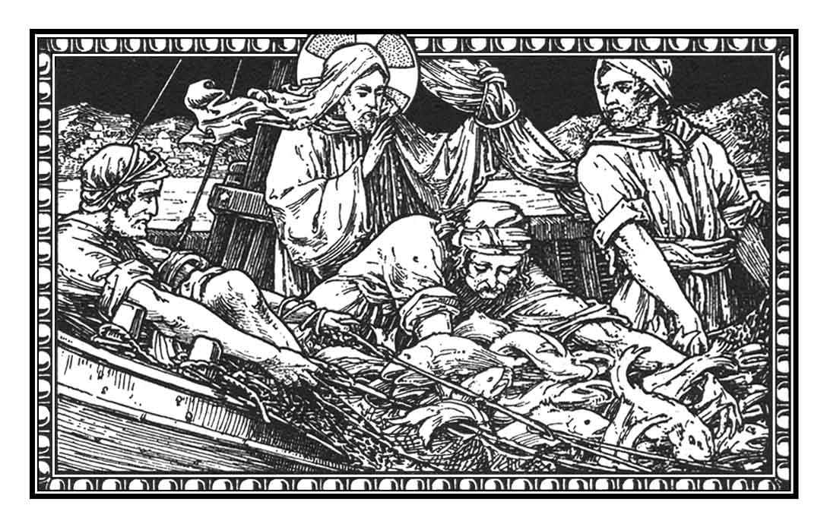
Fifth Sunday after Trinity
July 1, 2018

Emmanuel Lutheran Church
4675 Bataan Memorial West
Las Cruces, New Mexico 88012
(575) 382-0220 (church office) / (575) 636-4988 (pastor cell)
www.GodWithUsLC.org

Sts. Peter & Paul Lutheran Mission
Silver City, New Mexico
www.peterandpaullutheran.org

Rev. Paul A. Rydecki, Pastor
member of the Evangelical Lutheran Diocese of North America (ELDoNA)

ANNOUNCEMENTS
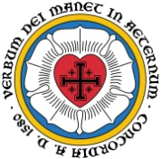
Welcome! Emmanuel is a liturgical, traditional, historical, evangelical, catholic, orthodox, confessional Lutheran congregation, in communion with the Evangelical Lutheran Diocese of North America (ELDoNA). We believe that the Bible is the very Word of God, inspired and without any errors. We confess the truth of Scripture according to the Lutheran Book of Concord of 1580, without exception or reservation. We observe the calendar of the traditional Church Year and follow the Historic Lectionary. We celebrate the Divine Service (also known as the Mass) every Sunday and on other festivals, and we welcome visitors to hear the Word of God with us.
With regard to Holy Communion, we ask our visitors to respect our practice of closed Communion, which means that only communicant members of our congregation or of other congregations in communion with us are invited to commune at the Lord’s Table here, after they have been examined and absolved. Classes are offered throughout the year by the pastor so that those who are interested in joining our Communion fellowship have the opportunity to learn about the Christian faith and our confession of it.
The Order of Service is The Order of Holy Communion (page 15) from The Lutheran Hymnal (TLH). The Scriptures are read from the New King James Version (NKJV). The Propers (the parts that change from week to week) are noted on the following page of this Service Folder.
EVENTS IN THE NEAR FUTURE…
Sun., July 8 - Bible Class, 9 AM (no Sunday School)
- Divine Service 10:15 AM (Trinity 6)
God’s Word at Home:
Bible Reading: Psalm 132-144
Small Catechism: Second Commandment
Bible Passages:
Romans 5:12 Therefore, just as through one man sin entered the world, and death through sin, and thus death spread to all men, because all sinned—
Romans 5:18-19 Therefore, as through one man’s offense judgment came to all men, resulting in condemnation, even so through one Man’s righteous act the free gift came to all men, resulting in justification of life. For as by one man’s disobedience many were made sinners, so also by one Man’s obedience many will be made righteous.

PROPERS Trinity 5

HYMNS
OPENING HYMN TLH #540 - With the Lord Begin Thy Task
HYMN (after the Creed) TLH #494 - Awake Thou Spirit Who Didst Fire
HYMN (after General Prayer) TLH #282 - Christians Come in Sweetest Measures
DISTRIBUTION HYMN TLH #315 - I Come, O Savior, to Thy Table

First: Jer. 16:14-21 Epistle: 1 Peter 3:8-15 Gospel: Luke 5:1-11

THE INTROIT (after general Absolution) Ps. 27:7,9b; Ps. 27:1a
P (Antiphon) Hear, O LORD, when I cry with | my voice! *
Have mercy also upon me, and | answer me.
You have been | my help; *
Do not leave me nor forsake me, O God of my | salvation.
C The LORD is my light and my sal- | vation; *
Whom | shall I fear?
GLORIA PATRI (p.16): Glory be to the Father, and to the Son, and to the Holy Ghost; as it was in the beginning, is now, and ever shall be, world without end. Amen.
P (Antiphon)
The service continues with The Kyrie, p. 17.
THE GRADUAL (after the First Lesson) Ps. 84:9
P O God, behold | our shield, *
And look upon the face of Your | anointed.
C O LORD God of hosts, hear | my prayer; *
Give ear, O God | of Jacob!
THE HALLELUJAH (after the Epistle) Ps. 21:18
P Alle- | luia! *
Al- | leluia!
C The king shall have joy in Your strength, | O LORD; *
And in Your salvation how greatly shall he rejoice! Al- | leluia.
The service continues with The Triple Hallelujah and The Gospel, p. 20-21.

We believe, teach and confess…

from the Augsburg Confession: Art. V
So that we may obtain this faith, the ministry of teaching the Gospel and administering the Sacraments was instituted. Through the Word and Sacraments, as through instruments, the Holy Spirit is given. He works faith, when and where it pleases God, in those who hear the good news that God justifies those who believe that they are received into grace for Christ’s sake. This happens not through our own merits, but for Christ’s sake.
Our churches condemn the Anabaptists and others who think that through their own preparations and works the Holy Spirit comes to them without the external Word.
from the Formula of Concord: Solid Declaration, Art. XI
Furthermore, the declaration in John 6:44 is right and true, “No one can come to Me unless the Father who sent Me draws him.” However, the Father will not do this without means, but has ordained His Word and Sacraments for this purpose as ordinary means and instruments. It is not the will of the Father or of the Son that a person should not hear or should despise the preaching of His Word and wait for the drawing of the Father without the Word and Sacraments. For the Father draws indeed by the power of His Holy Spirit. However, He works according to His usual way. He works by the hearing of His holy, divine Word, as with a net, by which the elect are plucked from the devil’s jaws. Every poor sinner should therefore attend to the Word, hear it attentively, and not doubt the Father’s drawing. For the Holy Spirit will be with His Word in His power, and will work by it. That is the Father’s drawing.
The reason why not all who hear the Word believe, and some are therefore deeply condemned, is not because God had begrudged them their salvation. It is their own fault. They have heard the Word in such a way as not to learn, but only to despise, blaspheme, and disgrace it. They have resisted the Holy Spirit, who through the Word wanted to work in them, as was the case at the time of Christ with the Pharisees and their followers.

