Service Folder
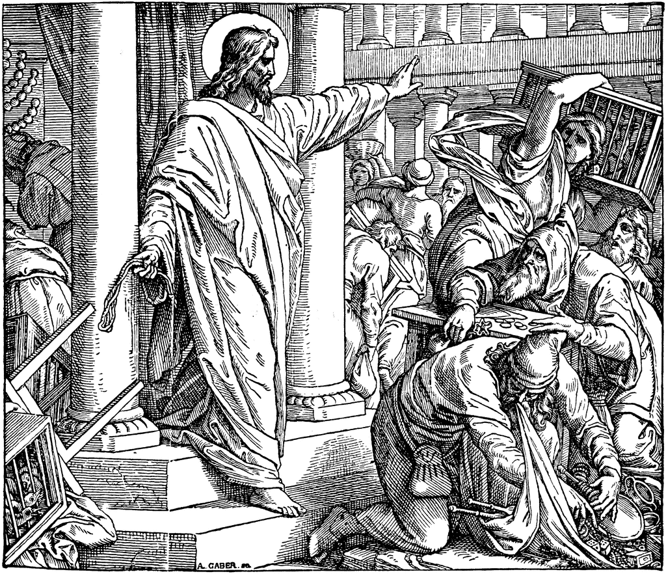
Tenth Sunday after Trinity
August 5, 2018

Emmanuel Lutheran Church
4675 Bataan Memorial West
Las Cruces, New Mexico 88012
(575) 382-0220 (church office) / (575) 636-4988 (pastor cell)
www.GodWithUsLC.org

Sts. Peter & Paul Lutheran Mission
Silver City, New Mexico
www.peterandpaullutheran.org

Rev. Paul A. Rydecki, Pastor
member of the Evangelical Lutheran Diocese of North America (ELDoNA)

ANNOUNCEMENTS
Welcome! Emmanuel is a liturgical, traditional, historical, evangelical, catholic, orthodox, confessional Lutheran congregation, in communion with the Evangelical Lutheran Diocese of North America (ELDoNA). We believe that the Bible is the very Word of God, inspired and without any errors. We confess the truth of Scripture according to the Lutheran Book of Concord of 1580, without exception or reservation. We observe the calendar of the traditional Church Year and follow the Historic Lectionary. We celebrate the Divine Service (also known as the Mass) every Sunday and on other festivals, and we welcome visitors to hear the Word of God with us.
With regard to Holy Communion, we ask our visitors to respect our practice of closed Communion, which means that only communicant members of our congregation or of other congregations in communion with us are invited to commune at the Lord’s Table here, after they have been examined and absolved. Classes are offered throughout the year by the pastor so that those who are interested in joining our Communion fellowship have the opportunity to learn about the Christian faith and our confession of it.
The Order of Service is The Order of Holy Communion (page 15) from The Lutheran Hymnal (TLH). The Scriptures are read from the New King James Version (NKJV). The Propers (the parts that change from week to week) are noted on the following page of this Service Folder.
EVENTS IN THE NEAR FUTURE…
Sun., Aug. 12 - Sunday School & Bible class, 9 AM
- Divine Service 10:15 AM (Trinity 11)
God’s Word at Home:
Bible Reading: Song of Solomon 5 – Isaiah 9
Small Catechism: Seventh Commandment
Bible Passages:
Romans 13:1 Let every soul be subject to the governing authorities. For there is no authority except from God, and the authorities that exist are appointed by God.
Romans 16:17 Now I urge you, brethren, note those who cause divisions and offenses, contrary to the doctrine which you learned, and avoid them.
1 Corinthians 3:16 Do you not know that you are the temple of God and that the Spirit of God dwells in you?

PROPERS Trinity 10

HYMNS
OPENING HYMN TLH #290 - We Have a Sure Prophetic Word
HYMN (after the Creed) TLH #419 - O'er Jerusalem Thou Weepest
HYMN (after General Prayer) TLH #383 - Seek Where Ye May to Find a Way
DISTRIBUTION HYMNS TLH #315 - I Come, O Savior, to Thy Table

First: Jer. 7:1-7 Epistle: 1 Cor. 12:1-11 Gospel: Luke 19:41-48

The service begins on p. 15 of The Lutheran Hymnal (TLH)
THE INTROIT (after general Absolution) Psalm 55:16-22; Ps. 55:1
P (Antiphon) AS FOR me, I will call upon God, and He shall hear | my voice. *
He has redeemed my soul in peace from the battle that was | against me.
God will hear, and afflict them, even He who abides from | of old. *
Cast your burden on the Lord, and He shall | sustain you.
C Give ear to my prayer, | O God, *
And do not hide Yourself from my sup- | plication.
GLORIA PATRI (p.16): Glory be to the Father, and to the Son, and to the Holy Ghost; as it was in the beginning, is now, and ever shall be, world without end. Amen.
P (Antiphon)
The service continues with The Kyrie, p. 17.
THE GRADUAL & HALLELUJAH (after the Epistle) Psalm 17:8,2; 88:1
P Keep me, O Lord, as the apple of | Your eye; *
Hide me under the shadow | of Your wings.
C Let my vindication come from Your | presence; *
Let Your eyes look on the things that | are upright.
P Alle- | luia! *
Al- | leluia!
C O Lord, God of my sal- | vation, *
I have cried out day and night before You. Al- | leluia!
The service continues with The Triple Hallelujah and The Gospel, p.21-22.
We believe, teach and confess…

from the Large Catechism: Close of the Commandments
For I the LORD your God am a jealous God, visiting the iniquity of the fathers on the children to the third and the fourth generation of those who hate Me, but showing steadfast love to thousands of those who love Me and keep My commandments.
Now, there is included in these words (as said before) both an angry, threatening word and a friendly promise. These are to terrify and warn us. They are also to lead and encourage us to receive and highly value His Word as a matter of divine sincerity. For God Himself declares how much He is concerned about it and how rigidly He will enforce it: He will horribly and terribly punish all who despise and transgress His commandments. Also, He declares how richly He will reward, bless, and do all good to those who hold them in high value and gladly do and live according to them. So God demands that all our works proceed from a heart that fears and regards God alone. From such fear the heart avoids everything that is contrary to His will, lest it should move Him to wrath. And, on the other hand, the heart also trusts in Him alone and from love for Him does all He wants. For He speaks to us as friendly as a father and offers us all grace and every good.
This is exactly the meaning and true interpretation of the first and chief commandment, from which all the others must flow and proceed. So this word, “You shall have no other gods before Me”, in its simplest meaning states nothing other than this demand: You shall fear, love, and trust in Me as your only true God. For where there is a heart set in this way before God, that heart has fulfilled this commandment and all the other commandments. On the other hand, whoever fears and loves anything else in heaven and upon earth will keep neither this nor any of the commandments. So then all the Scriptures have everywhere preached and taught this commandment, aiming always at these two things: fear of God and trust in Him. The prophet David especially does this throughout the Psalms, as when he says “the LORD takes pleasure in those who fear Him, in those who hope in His steadfast love”. He writes as if the entire commandment were explained by one verse, as if to say, “The Lord takes pleasure in those who have no other gods.”
So the First Commandment is to shine and give its splendor to all the others. Therefore, you must let this declaration run through all the commandments. It is like a hoop in a wreath, joining the end to the beginning and holding them all together. Let it be continually repeated and not forgotten, as the Second Commandment says, so that we fear God and do not take His name in vain for cursing, lying, deceiving, and other ways of leading men astray, or trickery. But we make proper and good use of His name by calling upon Him in prayer, praise, and thanksgiving, derived from love and trust according to the First Commandment. In the same way such fear, love, and trust is to drive and force us not to despise His Word, but gladly to learn it, hear it, value it holy, and honor it.

