Service Folder
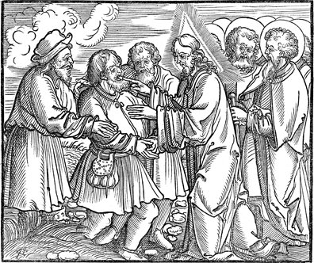
Twelfth Sunday after Trinity
August 19, 2018

Emmanuel Lutheran Church
4675 Bataan Memorial West
Las Cruces, New Mexico 88012
(575) 382-0220 (church office) / (575) 636-4988 (pastor cell)
www.GodWithUsLC.org

Sts. Peter & Paul Lutheran Mission
Silver City, New Mexico
www.peterandpaullutheran.org

Rev. Paul A. Rydecki, Pastor
member of the Evangelical Lutheran Diocese of North America (ELDoNA)

ANNOUNCEMENTS
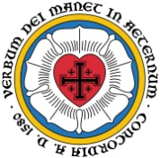
Welcome! Emmanuel is a liturgical, traditional, historical, evangelical, catholic, orthodox, confessional Lutheran congregation, in communion with the Evangelical Lutheran Diocese of North America (ELDoNA). We believe that the Bible is the very Word of God, inspired and without any errors. We confess the truth of Scripture according to the Lutheran Book of Concord of 1580, without exception or reservation. We observe the calendar of the traditional Church Year and follow the Historic Lectionary. We celebrate the Divine Service (also known as the Mass) every Sunday and on other festivals, and we welcome visitors to hear the Word of God with us.
With regard to Holy Communion, we ask our visitors to respect our practice of closed Communion, which means that only communicant members of our congregation or of other congregations in communion with us are invited to commune at the Lord’s Table here, after they have been examined and absolved. Classes are offered throughout the year by the pastor so that those who are interested in joining our Communion fellowship have the opportunity to learn about the Christian faith and our confession of it.
The Order of Service is The Order of Holy Communion (page 15) from The Lutheran Hymnal (TLH). The Scriptures are read from the New King James Version (NKJV). The Propers (the parts that change from week to week) are noted on the following page of this Service Folder.

EVENTS IN THE NEAR FUTURE…
Sun., Aug. 26 - Bible class, 9 AM;
- Divine Service 10:15 AM (Trinity 13)

PROPERS Trinity 12

HYMNS
OPENING HYMN TLH #5 – Lord, Open Thou My Heart to Hear
HYMN (after the Creed) TLH #34 - My Soul, Now Bless Thy Maker
HYMN (after General Prayer) TLH #16 - Blessed Jesus at Thy Word
DISTRIBUTION HYMNS TLH #304 - An Awe-full Mystery Is Here
TLH #310 - Thy Table I Approach

First: Is. 29:18-19 Epistle: 2 Cor. 3:4-11 Gospel: Mark 7:31-37

The Order of Holy Communion begins on p. 15 of The Lutheran Hymnal.
THE INTROIT (after general Absolution) Psalm 70:1-2a; Ps. 70:2b
P (Antiphon) MAKE HASTE, O God, to deliv-| er me! *
Make haste to help | me, O Lord!
Let them be ashamed and con- | founded *
Who | seek my life.
C Let them be turned back and | confused *
Who de- | sire my hurt.
GLORIA PATRI (p.16): Glory be to the Father, and to the Son, and to the Holy Ghost; as it was in the beginning, is now, and ever shall be, world without end. Amen.
P (Antiphon)
The service continues with The Kyrie, p. 17.
THE GRADUAL & HALLELUJAH (after the Epistle) Psalm 34:1-2; Ps. 81:1
P I will bless the Lord at | all times; *
His praise shall continually be | in my mouth.
C My soul shall make its boast in | the Lord; *
The humble shall hear of it | and be glad.
P Alle- | luia! *
Al- | leluia!
C Sing aloud to God, | our Strength; *
Make a joyful shout to the God of Jacob. Al- | leluia!
The service continues with The Gospel, p.21 in the hymnal.
God’s Word at Home

Bible Reading: Isaiah 24-35

Small Catechism: Ninth Commandment
You shall not covet your neighbor's house.
What does this mean?
We should fear and love God, that we do not scheme to get our neighbor’s inheritance or house, nor get it in a way that outwardly appears lawful, and so on; but aid and assist him to keep it.

Bible Passages:
1 Corinthians 10:16-17 The cup of blessing which we bless, is it not the communion of the blood of Christ? The bread which we break, is it not the communion of the body of Christ? For we, though many, are one bread and one body; for we all partake of that one bread.
1 Corinthians 10:31 Therefore, whether you eat or drink, or whatever you do, do all to the glory of God.

