Service Folder
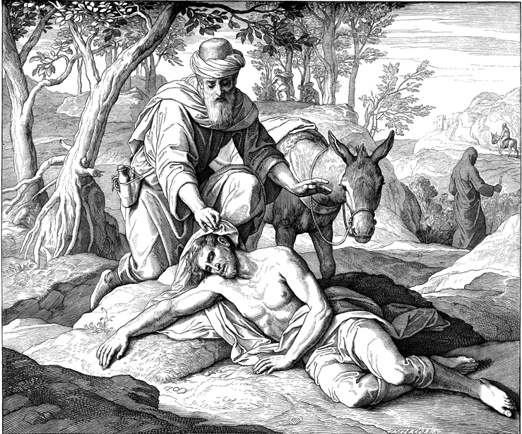
Thirteenth Sunday after Trinity
August 26, 2018

Emmanuel Lutheran Church
4675 Bataan Memorial West
Las Cruces, New Mexico 88012
(575) 382-0220 (church office) / (575) 636-4988 (pastor cell)
www.GodWithUsLC.org

Sts. Peter & Paul Lutheran Mission
Silver City, New Mexico
www.peterandpaullutheran.org

Rev. Paul A. Rydecki, Pastor
member of the Evangelical Lutheran Diocese of North America (ELDoNA)

ANNOUNCEMENTS
Welcome! Emmanuel is a liturgical, traditional, historical, evangelical, catholic, orthodox, confessional Lutheran congregation, in communion with the Evangelical Lutheran Diocese of North America (ELDoNA). We believe that the Bible is the very Word of God, inspired and without any errors. We confess the truth of Scripture according to the Lutheran Book of Concord of 1580, without exception or reservation. We observe the calendar of the traditional Church Year and follow the Historic Lectionary. We celebrate the Divine Service (also known as the Mass) every Sunday and on other festivals, and we welcome visitors to hear the Word of God with us.
With regard to Holy Communion, we ask our visitors to respect our practice of closed Communion, which means that only communicant members of our congregation or of other congregations in communion with us are invited to commune at the Lord’s Table here, after they have been examined and absolved. Classes are offered throughout the year by the pastor so that those who are interested in joining our Communion fellowship have the opportunity to learn about the Christian faith and our confession of it.
The Order of Service is The Order of Holy Communion (page 15) from The Lutheran Hymnal (TLH). The Scriptures are read from the New King James Version (NKJV). The Propers (the parts that change from week to week) are noted on the following page of this Service Folder.
Sunday School for the children will begin on Sunday, Sept. 9.

EVENTS IN THE NEAR FUTURE…
Sun., Sept. 2 - Bible class, 9 AM
- Divine Service 10:15 AM (Trinity 14)

PROPERS Trinity 13

HYMNS
OPENING HYMN TLH #295 - The Law of God Is Good and Wise
HYMN (after the Creed) TLH #347 - Jesus, Priceless Treasure
HYMN (after General Prayer) TLH #408 - Jesus Christ My Pride and Glory
DISTRIBUTION HYMNS TLH #307 - Draw Nigh and Take TLH #311 - Jesus Christ, Our Blessed Savior

First: Lev. 18:1-5 Epistle: Gal. 3:15-22 Gospel: Luke 10:23-37

The Order of Holy Communion begins on p. 15 of The Lutheran Hymnal.
THE INTROIT (after general Absolution) Ps. 74:20, 21, 22, 23; 74:1-2, 19, 21
P (Antiphon) Have respect to Your covenant, | O Lord; *
Oh, do not let the oppressed | return ashamed!
Arise, O God, plead Your | own cause; *
Do not forget the voice of | Your enemies.
C O God, why have You cast us off for- | ever? *
Why does Your anger smoke against the sheep | of Your pasture?
GLORIA PATRI (p.16): Glory be to the Father, and to the Son, and to the Holy Ghost; as it was in the beginning, is now, and ever shall be, world without end. Amen.
P (Antiphon)
The service continues with The Kyrie, p. 17.
THE GRADUAL (after the First Lesson) Ps. 74:20, 21, 22, 23
P Have respect to Your covenant, | O Lord; *
Oh, do not let the oppressed | return ashamed!
C Arise, O God, plead Your | own cause; *
Do not forget the voice of | Your enemies.
HALLELUJAH (after the Epistle) Ps. 88:1
P Alle- | luia! *
Al- | — leluia!
C O Lord, God of my sal- | vation, *
I have cried out day and night before You. | Alleluia!
The service continues with The Triple Hallelujah and Gospel, TLH pp.20-21.
God’s Word at Home

Bible Reading: Isaiah 36-49

Small Catechism: Tenth Commandment
You shall not covet your neighbor’s wife, manservant, maidservant, animals, or anything that is his.
What does this mean?
We should fear and love God, that we do not unharness, coerce, or alienate from our neighbor his wife, servants or animals; but urge them to stay and do their duty.

Bible Passages:
1 Corinthians 11:27-28 Therefore whoever eats this bread or drinks this cup of the Lord in an unworthy manner will be guilty of the body and blood of the Lord. But let a man examine himself, and so let him eat of the bread and drink of the cup.
1 Corinthians 12:3 No one speaking by the Spirit of God calls Jesus accursed, and no one can say that Jesus is Lord except by the Holy Spirit.

