Service Folder
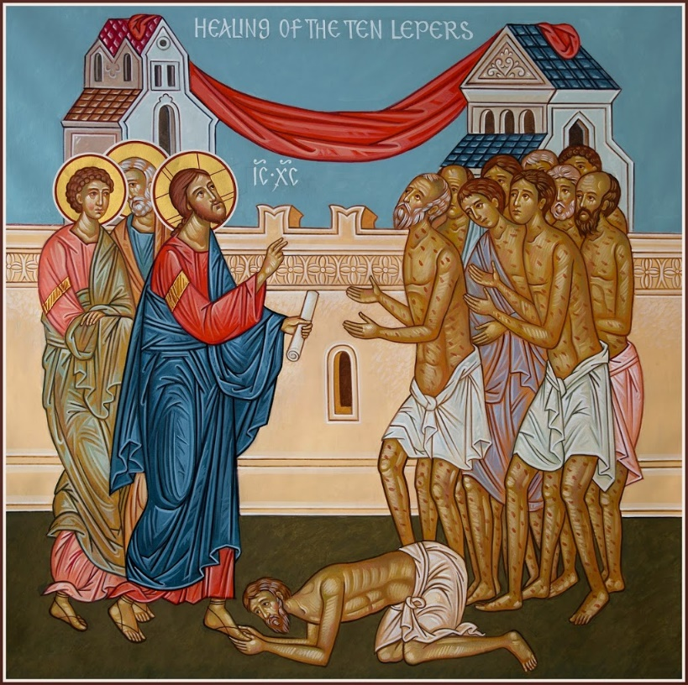
Fourteenth Sunday after Trinity
September 2, 2018
Emmanuel Lutheran Church
4675 Bataan Memorial West
Las Cruces, New Mexico 88012
(575) 382-0220 (church office) / (575) 636-4988 (pastor cell)
www.GodWithUsLC.org

Sts. Peter & Paul Lutheran Mission
Silver City, New Mexico
www.peterandpaullutheran.org

Rev. Paul A. Rydecki, Pastor
member of the Evangelical Lutheran Diocese of North America (ELDoNA)

ANNOUNCEMENTS
Welcome! Emmanuel is a liturgical, traditional, historical, evangelical, catholic, orthodox, confessional Lutheran congregation, in communion with the Evangelical Lutheran Diocese of North America (ELDoNA). We believe that the Bible is the very Word of God, inspired and without any errors. We confess the truth of Scripture according to the Lutheran Book of Concord of 1580, without exception or reservation. We observe the calendar of the traditional Church Year and follow the Historic Lectionary. We celebrate the Divine Service (also known as the Mass) every Sunday and on other festivals, and we welcome visitors to hear the Word of God with us.
With regard to Holy Communion, we ask our visitors to respect our practice of closed Communion, which means that only communicant members of our congregation or of other congregations in communion with us are invited to commune at the Lord’s Table here, after they have been examined and absolved. Classes are offered throughout the year by the pastor so that those who are interested in joining our Communion fellowship have the opportunity to learn about the Christian faith and our confession of it.
The Order of Service is The Order of Holy Communion (page 15) from The Lutheran Hymnal (TLH). The Scriptures are read from the New King James Version (NKJV). The Propers (the parts that change from week to week) are noted on the following page of this Service Folder.

EVENTS IN THE NEAR FUTURE…
Tues., Sept. 4 - Catechism class, 4:30 PM
Sun., Sept. 9 - Bible class & Sunday School, 9 AM
- Divine Service 10:15 AM (Trinity 15)

PROPERS Trinity 14

HYMNS
OPENING HYMN TLH #33 - The Lord Hath Helped Me Hitherto
HYMN (after the Creed) TLH #25 - I Will Sing My Maker's Praises
HYMN (after General Prayer) TLH #417 - How Can I Thank Thee, Lord
DISTRIBUTION HYMN TLH #315 - I Come, O Savior, to Thy Table

First: Jer. 17:13-14 Epistle: Gal. 5:16-24 Gospel: Luke 17:11-19

The Order of Holy Communion begins on p. 15 of The Lutheran Hymnal.
THE INTROIT (after general Absolution) Psalm 84:9-10; Psalm 84:1
P (Antiphon) O GOD, behold our shield, and look upon the face of Your a- | nointed. *
For a day in Your courts is better | than a thousand.
C How lovely is Your tabernacle, O Lord | of hosts! *
My soul longs, yes, even faints for the | courts of the Lord;
GLORIA PATRI (p.16): Glory be to the Father, and to the Son, and to the Holy Ghost; as it was in the beginning, is now, and ever shall be, world without end. Amen.
P (Antiphon)
The service continues with The Kyrie, p. 17.
THE GRADUAL (after the First Lesson) Psalm 92:1-2
P It is good to give thanks to | the Lord, *
And to sing praises to Your | name, O Most High;
C To declare Your lovingkindness in the | morning, *
And Your faithful- | ness every night.
THE HALLELUJAH (after the Epistle) Psalm 65:1
P Alle- | luia! *
Al- | — leluia!
C Praise is awaiting You, O God, in | Zion; *
And to You the vow shall be performed. | Alleluia!
The service continues with The Triple Hallelujah and The Gospel, TLH pp.20-21.

God’s Word at Home

Bible Reading: Isaiah 50-63

Small Catechism: Conclusion, Part 1
What does God say about all these commandments?
He says: “I, the Lord, your God, am a jealous God, who visits the sin of the fathers upon their children who hate Me, to the third and fourth generation; but to those who love Me and keep My commandments, I do good for a thousand generations.”

Bible Passages:
1 Corinthians 13:13 And now abide faith, hope, love, these three; but the greatest of these is love.
2 Corinthians 5:14-15 For the love of Christ compels us, because we judge thus: that if One died for all, then all died; and He died for all, that those who live should live no longer for themselves, but for Him who died for them and rose again.

