Service Folder
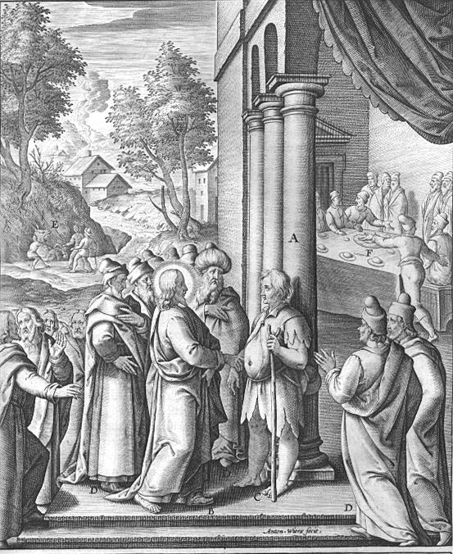
Seventeenth Sunday after Trinity
September 23, 2018
Emmanuel Lutheran Church
4675 Bataan Memorial West
Las Cruces, New Mexico 88012
(575) 382-0220 (church office) / (575) 636-4988 (pastor cell)
www.GodWithUsLC.org

Sts. Peter & Paul Lutheran Mission
Silver City, New Mexico
www.peterandpaullutheran.org

Rev. Paul A. Rydecki, Pastor
member of the Evangelical Lutheran Diocese of North America (ELDoNA)

ANNOUNCEMENTS
Welcome! Emmanuel is a liturgical, traditional, historical, evangelical, catholic, orthodox, confessional Lutheran congregation, in communion with the Evangelical Lutheran Diocese of North America (ELDoNA). We believe that the Bible is the very Word of God, inspired and without any errors. We confess the truth of Scripture according to the Lutheran Book of Concord of 1580, without exception or reservation. We observe the calendar of the traditional Church Year and follow the Historic Lectionary. We celebrate the Divine Service (also known as the Mass) every Sunday and on other festivals, and we welcome visitors to hear the Word of God with us.
With regard to Holy Communion, we ask our visitors to respect our practice of closed Communion, which means that only communicant members of our congregation or of other congregations in communion with us are invited to commune at the Lord’s Table here, after they have been examined and absolved. Classes are offered throughout the year by the pastor so that those who are interested in joining our Communion fellowship have the opportunity to learn about the Christian faith and our confession of it.
The Order of Service is The Order of Holy Communion (page 15) from The Lutheran Hymnal (TLH). The Scriptures are read from the New King James Version (NKJV). The Propers (the parts that change from week to week) are noted on the following page of this Service Folder.

EVENTS IN THE NEAR FUTURE…
Sun., Sept. 30 - Sunday School & Bible Class, 9 AM
- Divine Service, 10:15 AM (Trinity 18)

PROPERS Trinity 17

HYMNS
OPENING HYMN TLH #465 - Christ Is Our Cornerstone
HYMN (after the Creed) TLH #329 - From Depths of Woe I Cry to Thee
HYMN (after General Prayer) TLH #524 - In Thee, Lord (st. 1-4)
DISTRIBUTION HYMNS TLH #324 - Jesus Sinners Doth Receive
TLH #321 - O Faithful God Thanks Be to Thee

First: 1 Sam. 2:1-10 Epistle: Eph. 4:1-6 Gospel: Luke 14:1-11

The Order of Holy Communion begins on p. 15 of The Lutheran Hymnal.
THE INTROIT (after general Absolution) Psalm 119:137, 124a; Psalm 119:1
P (Antiphon) RIGHTEOUS are You, | O Lord, *
And upright | are Your judgments.
Deal with Your | servant * According | to Your mercy.
C Blessèd are the undefiled in | the way, *
Who walk in the | Law of the Lord!
GLORIA PATRI (p.16): Glory be to the Father, and to the Son, and to the Holy Ghost; as it was in the beginning, is now, and ever shall be, world without end. Amen.
P (Antiphon)
The service continues with The Kyrie, p. 17.
THE GRADUAL (after the First Lesson) Psalm 33:12, 6
P Blessèd is the nation whose God is | the Lord, *
The people He has chosen as His own | inheritance.
C By the word of the Lord the heavens | were made, *
And all the host of them by the | breath of His mouth.
THE HALLELUJAH (after the Epistle) Psalm 118:16
P Alle- | luia. *
Al- | — le-lu-ia.
C The right hand of the Lord is ex- | alted; *
The right hand of the Lord does valiantly. | Alleluia!
The service continues with The Triple Hallelujah and Gospel, p.20-21 in the hymnal.

God’s Word at Home

Bible Reading: Jeremiah 24-36

Small Catechism: Creed, First Article, Part 2
He also richly and daily provides me with clothing and shoes, food and drink, house and yard, wife and children, land, cattle, and all that I have—with all the needs and necessities of this body and life; He shields me against all danger and guards and protects me from all evil;

Bible Passages:
Galatians 3:10 For as many as are of the works of the law are under the curse; for it is written, “Cursed is everyone who does not continue in all things which are written in the book of the law, to do them.”
Galatians 3:11 But that no one is justified by the law in the sight of God is evident, for “the just shall live by faith.”
Galatians 3:13 Christ has redeemed us from the curse of the law, having become a curse for us (for it is written, “Cursed is everyone who hangs on a tree”).

