Service Folder
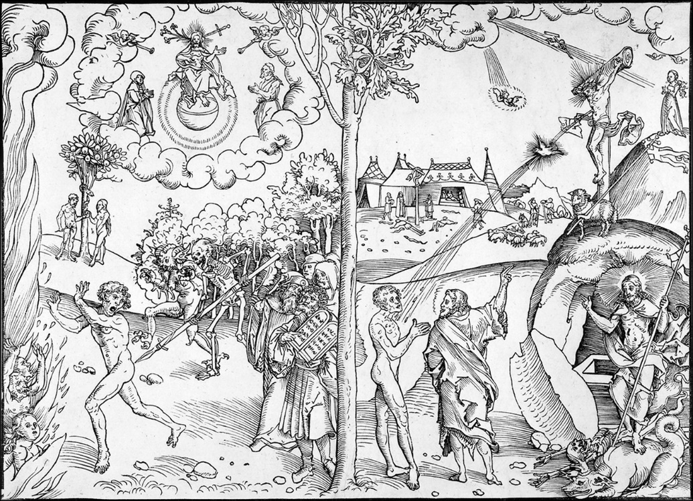
Eighteenth Sunday after Trinity
September 30, 2018

Emmanuel Lutheran Church
4675 Bataan Memorial West
Las Cruces, New Mexico 88012
(575) 382-0220 (church office) / (575) 636-4988 (pastor cell)
www.GodWithUsLC.org

Sts. Peter & Paul Lutheran Mission
Silver City, New Mexico
www.peterandpaullutheran.org

Rev. Paul A. Rydecki, Pastor
member of the Evangelical Lutheran Diocese of North America (ELDoNA)

ANNOUNCEMENTS
Welcome! Emmanuel is a liturgical, traditional, historical, evangelical, catholic, orthodox, confessional Lutheran congregation, in communion with the Evangelical Lutheran Diocese of North America (ELDoNA). We believe that the Bible is the very Word of God, inspired and without any errors. We confess the truth of Scripture according to the Lutheran Book of Concord of 1580, without exception or reservation. We observe the calendar of the traditional Church Year and follow the Historic Lectionary. We celebrate the Divine Service (also known as the Mass) every Sunday and on other festivals, and we welcome visitors to hear the Word of God with us.
With regard to Holy Communion, we ask our visitors to respect our practice of closed Communion, which means that only communicant members of our congregation or of other congregations in communion with us are invited to commune at the Lord’s Table here, after they have been examined and absolved. Classes are offered throughout the year by the pastor so that those who are interested in joining our Communion fellowship have the opportunity to learn about the Christian faith and our confession of it.
The Order of Service is The Order of Holy Communion (page 15) from The Lutheran Hymnal (TLH). The Scriptures are read from the New King James Version (NKJV). The Propers (the parts that change from week to week) are noted on the following page of this Service Folder.

EVENTS IN THE NEAR FUTURE…
Sun., Oct. 7 - Sunday School & Bible Class, 9 AM
- Divine Service, 10:15 AM (Trinity 19)

PROPERS Trinity 18

HYMNS
OPENING HYMN TLH #293 - O Holy Spirit, Grant Us Grace
HYMN (after the Creed) TLH #295 - The Law of God Is Good and Wise
HYMN (after General Prayer) TLH #349 - Jesus, Thy Boundless Love
DISTRIBUTION HYMNS TLH #313 - O Lord We Praise Thee
TLH #316 - O Living Bread from Heaven

First: Deut. 10:12-21 Epistle: 1 Cor. 1:4-9 Gospel: Matt. 22:34-46

The Order of Holy Communion begins on p. 15 of The Lutheran Hymnal.
THE INTROIT (after general Absolution) Ecclesiasticus 36:16-17; Psalm 122:1
P (Antiphon) REWARD, O Lord, those who wait | for You: *
And let Your prophets | be found faithful.
Hear the prayer of Your | servants, *
And of Your peo- | ple Israel.
C I was glad when they said | to me, *
“Let us go into the | house of the Lord.”
GLORIA PATRI (p.16): Glory be to the Father, and to the Son, and to the Holy Ghost; as it was in the beginning, is now, and ever shall be, world without end. Amen.
P (Antiphon)
The service continues with The Kyrie, p. 17.
THE GRADUAL (after the First Lesson) Ps. 122:1,7
P I was glad when they said | to me, *
“Let us go into the | house of the Lord.”
C “Peace be within | your walls, *
Prosperity within | your palaces.”
THE HALLELUJAH (after the Epistle) Ps. 117:1
P Alle- | luia. *
Al- | — le-lu-ia.
C Praise the Lord, all you | Gentiles! *
Laud Him, all you peoples! | Alleluia!
The service continues with The Triple Hallelujah and Gospel, p.20-21 in the hymnal.
God’s Word at Home

Bible Reading: Jeremiah 37-49

Small Catechism: Creed, First Article, Part 3
And all this He does out of pure fatherly, divine goodness and mercy, without any merit or worthiness in me; for all this it is my duty to thank and praise, to serve and obey Him. This is most certainly true.

Bible Passages:
Galatians 3:26-27 For you are all sons of God through faith in Christ Jesus. For as many of you as were baptized into Christ have put on Christ.
Galatians 4:4-5 But when the fullness of the time had come, God sent forth His Son, born of a woman, born under the law, to redeem those who were under the law, that we might receive the adoption as sons.
Galatians 6:6 Let him who is taught the word share in all good things with him who teaches.

