Service Folder
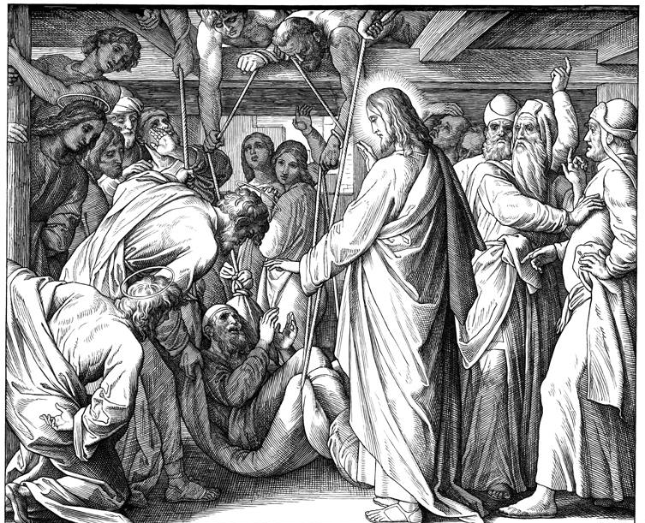
Ninteenth Sunday after Trinity
October 7, 2018

Emmanuel Lutheran Church
4675 Bataan Memorial West
Las Cruces, New Mexico 88012
(575) 382-0220 (church office) / (575) 636-4988 (pastor cell)
www.GodWithUsLC.org

Sts. Peter & Paul Lutheran Mission
Silver City, New Mexico
www.peterandpaullutheran.org

Rev. Paul A. Rydecki, Pastor
member of the Evangelical Lutheran Diocese of North America (ELDoNA)

ANNOUNCEMENTS
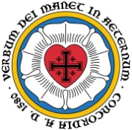
Welcome! Emmanuel is a liturgical, traditional, historical, evangelical, catholic, orthodox, confessional Lutheran congregation, in communion with the Evangelical Lutheran Diocese of North America (ELDoNA). We believe that the Bible is the very Word of God, inspired and without any errors. We confess the truth of Scripture according to the Lutheran Book of Concord of 1580, without exception or reservation. We observe the calendar of the traditional Church Year and follow the Historic Lectionary. We celebrate the Divine Service (also known as the Mass) every Sunday and on other festivals, and we welcome visitors to hear the Word of God with us.
With regard to Holy Communion, we ask our visitors to respect our practice of closed Communion, which means that only communicant members of our congregation or of other congregations in communion with us are invited to commune at the Lord’s Table here, after they have been examined and absolved. Classes are offered throughout the year by the pastor so that those who are interested in joining our Communion fellowship have the opportunity to learn about the Christian faith and our confession of it.
The Order of Service is The Order of Holy Communion (page 15) from The Lutheran Hymnal (TLH). The Scriptures are read from the New King James Version (NKJV). The Propers (the parts that change from week to week) are noted on the following page of this Service Folder.

EVENTS IN THE NEAR FUTURE…
Sun., Oct. 14 - Sunday School & Bible Class, 9 AM
- Divine Service, 10:15 AM (Trinity 20)

PROPERS Trinity 19

HYMNS
OPENING HYMN TLH #524 - In Thee Lord Have I Put My Trust (st. 1-3)
HYMN (after the Creed) TLH #319 - In Thee Alone O Christ My Lord
HYMN (after General Prayer) TLH #321 - O Faithful God Thanks Be to Thee
DISTRIBUTION HYMN TLH #331 - Yea as I Live Jehovah Saith TLH #324 - Jesus Sinners Doth Receive

First: Is. 44:21-23 Epistle: Eph. 4:22-28 Gospel: Matt. 9:1-8

The Order of Holy Communion begins on p. 15 of The Lutheran Hymnal.
THE INTROIT (after general Absolution) Psalm 35:3b; 34:17; 48:14a; 78:1
P (Antiphon) SAY TO my soul, “I am your sal- | vation.” *
The righteous cry out, | and the Lord hears.
He delivers them out of all their | troubles. *
For this is God, our God forev- | er and ever.
C Give ear, O my people, to | my law; *
Incline your ears to the | words of my mouth.
GLORIA PATRI (p.16): Glory be to the Father, and to the Son, and to the Holy Ghost; as it was in the beginning, is now, and ever shall be, world without end. Amen.
P (Antiphon)
The service continues with The Kyrie, p. 17.
THE GRADUAL (after the First Lesson) Psalm 141:2
P Let my prayer be set before You as | incense, *
C The lifting up of my hands as the even- | ing sacrifice.
THE HALLELUJAH (after the Epistle) Psalm 98:1a
P Alleluia! Alleluia! Oh, sing to the Lord a | new song! *
C For He has done marvelous things. | Alleluia!
The service continues with The Triple Hallelujah and Gospel, p.20-21 in the hymnal.
God’s Word at Home

Bible Reading: Jeremiah 50 – Ezekiel 5

Small Catechism: Creed, Second Article, Part 1
And in Jesus Christ, His only Son, our Lord; who was conceived by the Holy Spirit, born of the Virgin Mary; suffered under Pontius Pilate, was crucified, died and was buried; He descended into hell; the third day He rose again from the dead; He ascended into heaven and sits at the right hand of God the Father Almighty; from there He shall come to judge the living and the dead.
What does this mean?
I believe that Jesus Christ, true God, begotten of the Father from eternity, and also true man, born of the Virgin Mary, is my Lord; who has redeemed me, a lost and condemned person, purchased and won me from all sins, from death, and from the power of the devil; not with gold or silver, but with His holy, precious blood and with His innocent suffering and death;

Bible Passages:
Ephesians 1:4 He chose us in Him before the foundation of the world, that we should be holy and without blame before Him in love.
Ephesians 1:22-23 And He put all things under His feet, and gave Him to be head over all things to the church, which is His body, the fullness of Him who fills all in all.

