Service Folder

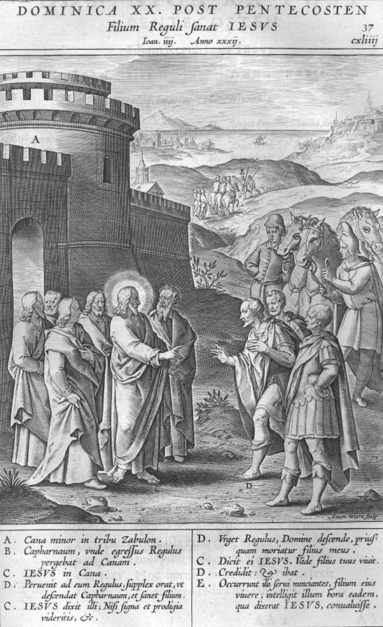

Twenty-first Sunday after Trinity

October 21, 2018

**Emmanuel Lutheran Church**

4675 Bataan Memorial West

Las Cruces, New Mexico 88012

(575) 382-0220 (church office) / (575) 636-4988 (pastor cell)

www.GodWithUsLC.org

**Sts. Peter & Paul Lutheran Mission**

Silver City, New Mexico

www.peterandpaullutheran.org

Rev. Paul A. Rydecki, Pastor

member of the Evangelical Lutheran Diocese of North America (ELDoNA)

## ANNOUNCEMENTS

**Welcome!** Emmanuel is a liturgical, traditional, historical, evangelical, catholic, orthodox, confessional Lutheran congregation, in communion with the Evangelical Lutheran Diocese of North America (ELDoNA). We believe that the Bible is the very Word of God, inspired and without any errors. We confess the truth of Scripture according to the Lutheran Book of Concord of 1580, without exception or reservation. We observe the calendar of the traditional Church Year and follow the Historic Lectionary. We celebrate the Divine Service (also known as the Mass) every Sunday and on other festivals, and we welcome visitors to hear God’s Word with us.

With regard to Holy Communion, we ask our visitors to respect our practice of *closed Communion*, which means that only communicant members of our congregation or of other congregations in communion with us are invited to commune at the Lord’s Table here, after they have been examined and absolved. Classes are offered throughout the year by the pastor so that those who are interested in joining our Communion fellowship have the opportunity to learn about the Christian faith and our confession of it.

**The Order of Service** is *The Order of Holy Communion* (page 15) from *The Lutheran Hymnal* (TLH). The Scriptures are read from the New King James Version (NKJV). The Propers (the parts that change from week to week) are noted on the following page of this Service Folder.

**EVENTS IN THE NEAR FUTURE…**

Sun., Oct. 28 - Bible Class/Sunday School, 9 AM

- Divine Service, 10:15 AM (Reformation)

**PROPERS Trinity 21**

**HYMNS**

**OPENING HYMN** *TLH #381 - I Know My Faith Is Founded*

**HYMN** *(after the Creed)**TLH #353 - Lord Jesus Christ My Savior Blest*

**HYMN** *(after General Prayer) TLH #529 - I Leave All Things to God's Direction*

**DISTRIBUTION HYMN** *TLH #385 - Now I Have Found the Firm Foundation*

**First:** *Hosea 13:14* **Epistle:** *Eph. 6:10-17* **Gospel:** *John 4:46-54*

*The Order of Holy Communion begins on p. 15 of The Lutheran Hymnal.*

**THE INTROIT** *(after general Absolution)**Apocryphal Esther 13:9,10,11; Ps. 119:1*

P *(Antiphon)* The whole world is in Your power; O Lord, | King Almighty, \*

No one | can gainsay — You.

For You have made heaven and earth, and all the wondrous things un- | der the heaven. \*

You | are Lord of — all!

PsalmTone_Gregorian05.TIF

C **Blessèd are the unde- | filed in the way, \***

**Who walk in the | law of the — Lord!**

**GLORIA PATRI** (p.16): **Glory be to the Father, and to the Son, and to the Holy Ghost; as it was in the beginning, is now, and ever shall be, world without end. Amen.**

P *(Antiphon)*

*The service continues with The Kyrie, p. 17.*

**THE GRADUAL** *(after the First Lesson)**Ps. 90:1-2*

P Lord, You have been | our dwelling place \*

In all | genera- -tions.

C **Before the mountains were brought forth, before You ever had formed the | earth and the world, \***

**Even from everlasting to everlast- | ing, You are — God.**

**THE HALLELUJAH** *(after the Epistle)**Ps. 125:1*

P Al- | - leluia. \*

Al- | - lelu- -ia.

C **Those who trust in the Lord are | like Mount Zion, \***

**Which cannot be moved, but abides forever. | Allelu- -ia.**

*The service continues with The Triple Hallelujah and Gospel, p.21-22 in the hymnal.*

God’s Word at Home

**Bible Reading**: Ezekiel 19-32

**Small Catechism**: Creed, Third Article, Part 1

**I believe in the Holy Spirit; the holy Christian Church, the communion of saints; the forgiveness of sins, the resurrection of the body; and the life everlasting. Amen.**

*What does this mean?*

I believe that I cannot by my own reason or strength believe in Jesus Christ, my Lord, or come to Him; but the Holy Spirit has called me by the Gospel, enlightened me with His gifts, sanctified and preserved me in the true faith; just as He calls, gathers, enlightens and sanctifies the whole Christian Church on earth, and preserves it with Jesus Christ in the one true faith.

**Bible Passages**:

Ephesians 2:8-10 For by grace you have been saved through faith, and that not of yourselves; it is the gift of God, not of works, lest anyone should boast. For we are His workmanship, created in Christ Jesus for good works, which God prepared beforehand that we should walk in them.