Service Folder

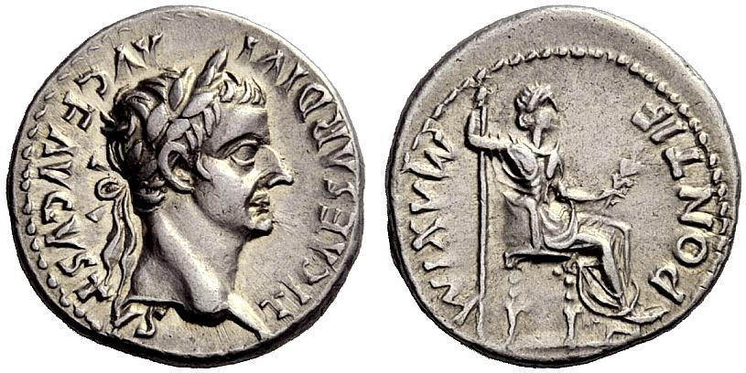

Twenty-Third Sunday after Trinity
November 4, 2018

Emmanuel Lutheran Church
4675 Bataan Memorial West
Las Cruces, New Mexico 88012
(575) 382-0220 (church office) / (575) 636-4988 (pastor cell)
www.GodWithUsLC.org

Sts. Peter & Paul Lutheran Mission
Silver City, New Mexico
www.peterandpaullutheran.org

Rev. Paul A. Rydecki, Pastor
member of the Evangelical Lutheran Diocese of North America (ELDoNA)

ANNOUNCEMENTS
Welcome! Emmanuel is a liturgical, traditional, historical, evangelical, catholic, orthodox, confessional Lutheran congregation, in communion with the Evangelical Lutheran Diocese of North America (ELDoNA). We believe that the Bible is the very Word of God, inspired and without any errors. We confess the truth of Scripture according to the Lutheran Book of Concord of 1580, without exception or reservation. We observe the calendar of the traditional Church Year and follow the Historic Lectionary. We celebrate the Divine Service (also known as the Mass) every Sunday and on other festivals, and we welcome visitors to hear God’s Word with us.
With regard to Holy Communion, we ask our visitors to respect our practice of closed Communion, which means that only communicant members of our congregation or of other congregations in communion with us are invited to commune at the Lord’s Table here, after they have been examined and absolved. Classes are offered throughout the year by the pastor so that those who are interested in joining our Communion fellowship have the opportunity to learn about the Christian faith and our confession of it.
The Order of Service is The Order of Holy Communion (page 15) from The Lutheran Hymnal (TLH). The Scriptures are read from the New King James Version (NKJV). The Propers (the parts that change from week to week) are noted on the following page of this Service Folder.
EVENTS IN THE NEAR FUTURE…
Sun., Nov. 11 - Bible Class/Sunday School, 9AM
- Divine Service, 10:15 AM (Trinity 25)
Thur., Nov. 15 - Early Thanksgiving Divine Service, 6:30PM
Sun., Nov. 18 - Catechism Service (Pastor in Oregon)
Sun., Nov. 25 - Bible Class/Sunday School, 9AM
- Divine Service, 10:15 AM (Trinity 27)

PROPERS Trinity 23

HYMNS
OPENING HYMN TLH #6 - Kyrie! God, Father in Heaven Above
HYMN (after the Creed) TLH #223 - We Thank Thee Jesus Dearest Friend
HYMN (after General Prayer) TLH #41 - Wondrous King All-Glorious
DISTRIBUTION HYMNS TLH #314 - Lord Jesus Christ, We Humbly Pray
TLH #309 - O Jesus, Blessed Lord, to Thee

First: Is. 32:1-8 Epistle: Phil. 3:17-21 Gospel: Matt. 22:15-22

The Order of Holy Communion begins on p. 15 of The Lutheran Hymnal.
THE INTROIT (after general Absolution) Jer. 29:11a, 12, 14b; Psalm 85:1
P (Antiphon) FOR I know the thoughts that I think toward | you, says the Lord, * Thoughts of peace and | not of e- -vil,
Then you will call upon Me and go and pray to Me, and I will | listen
to you. * And I will bring you back from your captivity; I will gather you from all the nations and from | all the pla- - ces.
C Lord, You have been favora- | ble to Your land; *
You have brought back the captivi- | ty of Ja- -cob.
GLORIA PATRI (p.16): Glory be to the Father, and to the Son, and to the Holy Ghost; as it was in the beginning, is now, and ever shall be, world without end. Amen.
P (Antiphon)
The service continues with The Kyrie, p. 17.
THE GRADUAL (after the First Lesson) Psalm 44:78
P You have saved us from | our enemies, *
And have put to shame those | who hated — us.
C In God we | boast all day long, *
And praise Your | name forev- -er.
THE HALLELUJAH (after the Epistle) Psalm 115:11
P Al- | -- leluia. *
Al- | -- lelu- -ia.
C You who fear the Lord, | trust in the Lord; *
He is their help and their shield. | Allelu- -ia!
The service continues with the Triple Hallelujah and The Gospel, p.20 in the hymnal.
We believe, teach and confess…

from the Apology of the Augsburg Confession: Art. XVI
The adversaries accept Article XVI without exception. In it we have confessed that it is lawful for the Christian to hold public office, sit in judgment, determine matters by the imperial laws and other laws currently in force, set just punishments, engage in just wars, act as a soldier, make legal contracts, hold property, take an oath (when public officials require it), and contract marriage. Finally, we have confessed that legitimate public ordinances are good creations of God and divine ordinances, which a Christian can safely use. This entire topic about the distinction between the spiritual kingdom of Christ and a political kingdom has been explained in the literature of our writers. Christ’s kingdom is spiritual. This means that the knowledge of God, the fear of God and faith, eternal righteousness, and eternal life begin in the heart. Meanwhile, Christ’s kingdom allows us outwardly to use legitimate political ordinances of every nation in which we live, just as it allows us to use medicine or the art of building, or food, drink, and air. Neither does the Gospel offer new laws about the public state, but commands that we obey present laws, whether they have been framed by heathens or by others. It commands that in this obedience we should exercise love. Carlstadt was crazy to impose on us Moses’ judicial laws. Our theologians have written more fully about these subjects. They have done so because the monks spread many deadly opinions in the Church. They called holding property in common the governance of the Gospel. They said that not holding property, or not acquitting oneself at law, were evangelical counsels. These opinions greatly cloud over the Gospel and the spiritual kingdom and are dangerous to the commonwealth. For the Gospel does not destroy the state or the family, but rather approves them and asks us to obey them as a divine ordinance, not only because of punishment, but also because of conscience.
The Gospel does not introduce laws about the public state, but preaches the forgiveness of sins and the beginning of a new life in the hearts of believers. Besides, the Gospel not only approves outward governments, but also subjects us to them (Romans 13:1). In a similar way we have been necessarily placed under the laws of seasons, the changes of winter and summer, as divine ordinances. The Gospel forbids private remedy. Christ instills this often so that the apostles do not think they should seize the governments from those who held otherwise, just as the Jewish people dreamed about the kingdom of the Messiah. Christ did this so that the apostles might know they should teach that the spiritual kingdom does not change the public state.

