Service Folder
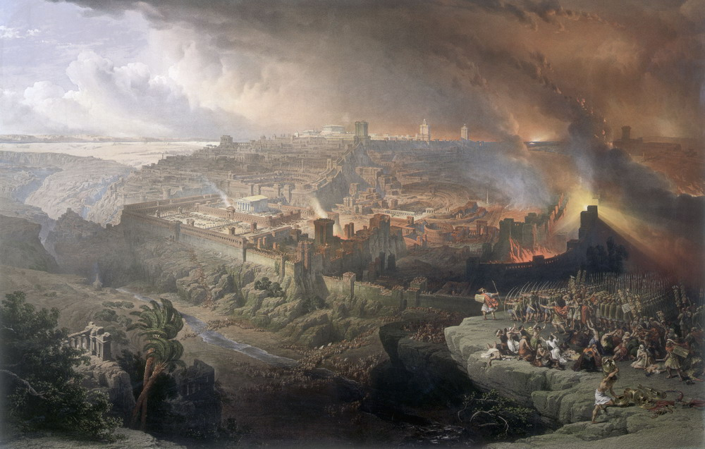
Third to Last Sunday after Trinity
November 11, 2018

Emmanuel Lutheran Church
4675 Bataan Memorial West
Las Cruces, New Mexico 88012
(575) 382-0220 (church office) / (575) 636-4988 (pastor cell)
www.GodWithUsLC.org

Sts. Peter & Paul Lutheran Mission
Silver City, New Mexico
www.peterandpaullutheran.org

Rev. Paul A. Rydecki, Pastor
member of the Evangelical Lutheran Diocese of North America (ELDoNA)

ANNOUNCEMENTS
Welcome! Emmanuel is a liturgical, traditional, historical, evangelical, catholic, orthodox, confessional Lutheran congregation, in communion with the Evangelical Lutheran Diocese of North America (ELDoNA). We believe that the Bible is the very Word of God, inspired and without any errors. We confess the truth of Scripture according to the Lutheran Book of Concord of 1580, without exception or reservation. We observe the calendar of the traditional Church Year and follow the Historic Lectionary. We celebrate the Divine Service (also known as the Mass) every Sunday and on other festivals, and we welcome visitors to hear God’s Word with us.
With regard to Holy Communion, we ask our visitors to respect our practice of closed Communion, which means that only communicant members of our congregation or of other congregations in communion with us are invited to commune at the Lord’s Table here, after they have been examined and absolved. Classes are offered throughout the year by the pastor so that those who are interested in joining our Communion fellowship have the opportunity to learn about the Christian faith and our confession of it.
The Order of Service is The Order of Holy Communion (page 15) from The Lutheran Hymnal (TLH). The Scriptures are read from the New King James Version (NKJV). The Propers (the parts that change from week to week) are noted on the following page of this Service Folder.

EVENTS IN THE NEAR FUTURE…
Thur., Nov. 15 - Thanksgiving Divine Service, 6 PM, followed by dessert
Sun., Nov. 18 - No Bible Class or Sunday School
- Catechism Service, 10:15 AM
Sun., Nov. 25 - Sunday School & Bible Class, 9 AM
- Divine Service, 10:15 AM (Trinity 27)
Sun., Dec. . 2 - Sunday School & Bible Class, 9 AM
- Divine Service, 10:15 AM (Advent 1)
- Annual Congregational Assembly, after the service

PROPERS Trinity 25

HYMNS
OPENING HYMN TLH #260 - O Lord Look Down from Heaven Behold
HYMN (after the Creed) TLH #393 - From God Shall Naught Divide Me
HYMN (after General Prayer) TLH #407 - Farewell I Gladly Bid Thee
DISTRIBUTION HYMNS TLH #446 - Rise, My Soul, to Watch and Pray
TLH #310 - Thy Table I Approach

First: Is. 49:12-17 Epistle: 1 Th. 4:13-18 Gospel: Matt. 24:15-28

The Order of Holy Communion begins on p. 15 of The Lutheran Hymnal.
THE INTROIT (after general Absolution) Psalm 31:9a, 15b, 17a; Psalm 31:1
P (Antiphon) HAVE MERcy on me, O Lord, for I | am in trouble; *
Deliver me from the hand of my enemies, and from those who | persecute me. —
Do not let me be | ashamed, O Lord, *
For I have | called upon You. —
C In You, O Lord, | I put my trust; *
Let me nev- | er be ashamed;—
GLORIA PATRI (p.16): Glory be to the Father, and to the Son, and to the Holy Ghost; as it was in the beginning, is now, and ever shall be, world without end. Amen.
P (Antiphon)
THE GRADUAL (after the First Lesson) Psalm 74:4,2
P Your enemies roar in the midst of | Your meeting place; *
They set up their | banners for signs. —
C Remember Your congregation, which You have | purchased of old, *
The tribe of Your inheritance, which | You have redeemed. —
THE HALLELUJAH (after the Epistle) Ps. 46:4
P Al- | - leluia. *
Al- | - leluia. —
C There is a river whose streams shall make glad the | city of God, *
The holy place of the tabernacle of the Most High. | Alleluia. —
The service continues with The Triple Hallelujah and Gospel, p.20 in the hymnal.

God’s Word at Home

Bible Reading: Daniel 12 – Hosea 12

Small Catechism: Lord’s Prayer, First Petition, Part 1
Hallowed be Thy name.
What does this mean?
God’s name is certainly holy in itself; but we ask in this prayer that it may be made holy among us also.

Bible Passages:
Ephesians 5:1-2 Therefore be imitators of God as dear children. And walk in love, as Christ also has loved us and given Himself for us, an offering and a sacrifice to God for a sweet-smelling aroma.
Ephesians 5:22-24 Wives, submit to your own husbands, as to the Lord. For the husband is head of the wife, as also Christ is head of the church; and He is the Savior of the body. Therefore, just as the church is subject to Christ, so let the wives be to their own husbands in everything.

