Service Folder
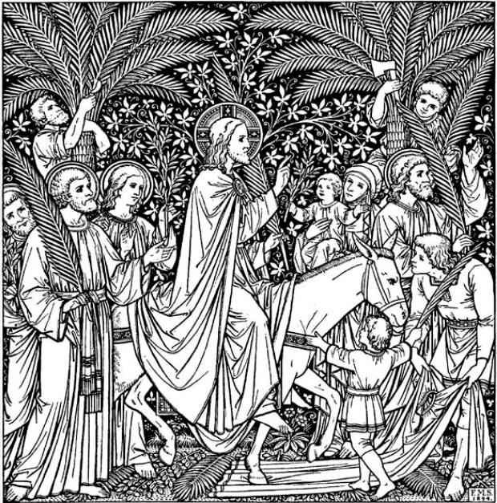
The First Sunday in Advent
Ad Te Levavi – “To You, O Lord, I lift up my soul”
December 2, 2018
Emmanuel Lutheran Church
4675 Bataan Memorial West
Las Cruces, New Mexico 88012
(575) 382-0220 (church office) / (575) 636-4988 (pastor cell)
www.GodWithUsLC.org

Sts. Peter & Paul Lutheran Mission
Silver City, New Mexico
www.peterandpaullutheran.org

Rev. Paul A. Rydecki, Pastor
member of the Evangelical Lutheran Diocese of North America (ELDoNA)

ANNOUNCEMENTS
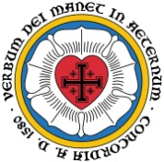
Welcome! Emmanuel is a liturgical, traditional, historical, evangelical, catholic, orthodox, confessional Lutheran congregation, in communion with the Evangelical Lutheran Diocese of North America (ELDoNA). We believe that the Bible is the very Word of God, inspired and without any errors. We confess the truth of Scripture according to the Lutheran Book of Concord of 1580, without exception or reservation. We observe the calendar of the traditional Church Year and follow the Historic Lectionary. We celebrate the Divine Service (also known as the Mass) every Sunday and on other festivals, and we welcome visitors to hear the Word of God with us.
With regard to Holy Communion, we ask our visitors to respect our practice of closed Communion, which means that only communicant members of our congregation or of other congregations in communion with us are invited to commune at the Lord’s Table here, after they have been examined and absolved. Classes are offered throughout the year by the pastor so that those who are interested in joining our Communion fellowship have the opportunity to learn about the Christian faith and our confession of it.
The Order of Service is The Order of Holy Communion (page 15) from The Lutheran Hymnal (TLH). The Scriptures are read from the New King James Version (NKJV). The Propers (the parts that change from week to week) are noted on the following page of this Service Folder.
Note: The Gloria in Excelsis is omitted during the Advent season.
EVENTS IN THE NEAR FUTURE…
TODAY - Congregational Meeting, after the service
Wed., Dec. 5 - Advent Supper, 5:30 PM
- Advent Vespers, 6:15 PM
Sun., Dec. 9 - Bible Class/Sunday School, 9AM
- Divine Service, 10:15 AM (Advent 2)
- Church Christmas party @ David & Marti’s, 12:30 PM
Wed., Dec 12 - Advent Supper, 5:30 PM
- Advent Vespers, 6:15 PM
Wed., Dec. 19 - Advent Supper, 5:30 PM
- Advent Vespers, 6:15 PM
Mon., Dec. 24 - Christmas Eve Vespers, 6 PM
Tues., Dec. 25 - Christmas Day Divine Service, 10:15 AM

PROPERS Advent 1

OPENING HYMN Fling Wide the Doors (back page)
HYMN (after the Creed) TLH #58 - O Lord How Shall I Meet Thee (st. 1-5)
HYMN (after General Prayer) TLH #58 - O Lord How Shall I Meet Thee (st. 6-9)
DISTRIBUTION HYMNS TLH #55 - Come, Thou Precious Ransom, Come
TLH #57 - O Bride of Christ, Rejoice

Epistle: Romans 13:11-14 Gospel: Matthew 21:1-9

The Order of Holy Communion begins on p. 15 of The Lutheran Hymnal.
INTROIT (after the general Absolution) Ps. 25:1-3a; Ps. 25:4, 5b, 21-22
After the Refrain is introduced one time (1x) by the organ/guitar, all join to sing it three times (3x). The Psalm verses and Gloria Patri are spoken while the music plays softly in the background. Then the Refrain is sung by all twice (2x) more.
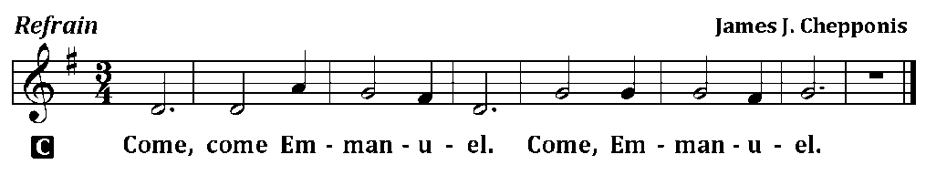
C (Sing Refrain 3x while the Pastor sings the first line of the Psalm: To You, O Lord, I lift up my soul.)
P TO YOU, O Lord, I lift up my soul.
C O my God, I trust in You; Let me not be ashamed;
P Let not my enemies triumph over me.
C Let no one who waits on You be ashamed.
P Show me Your ways, O Lord; Teach me Your paths.
C For You are the God of my salvation; On You I wait all the day.
P Let integrity and uprightness preserve me, For I wait for You.
C Redeem Israel, O God, Out of all their troubles.
C Glory be to the Father and to the Son and to the Holy Ghost;
as it was in the beginning, is now, and ever shall be, world without end. Amen. (Sing Refrain 2x)
The service continues with The Kyrie on p.17, followed by the Salutation & Collect.
THE GRADUAL & HALLELUJAH (after the Epistle) Ps. 25:3a, 4; Ps. 85:7
P Let no one who waits on You be | ashamed, O Lord.
Show me Your ways, O Lord; | teach me Your paths. __
C Alleluia. Alleluia. Show us | Your mercy, Lord,
And grant us Your salvation. | Alleluia. __
The service continues with The Triple Hallelujah and The Gospel, p. 20-21.

