Service Folder
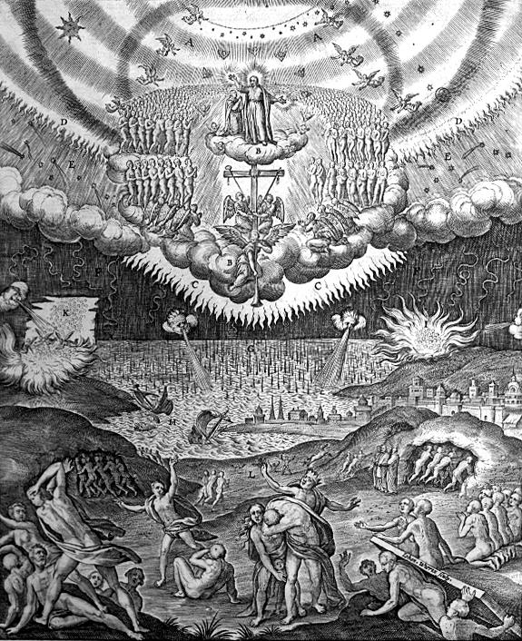
The Second Sunday in Advent
Populus Sion – “Daughter of Zion, behold!”
December 9, 2018

Emmanuel Lutheran Church
4675 Bataan Memorial West
Las Cruces, New Mexico 88012
(575) 382-0220 (church office) / (575) 636-4988 (pastor cell)
www.GodWithUsLC.org

Sts. Peter & Paul Lutheran Mission
Silver City, New Mexico
www.peterandpaullutheran.org

Rev. Paul A. Rydecki, Pastor
member of the Evangelical Lutheran Diocese of North America (ELDoNA)

ANNOUNCEMENTS
Welcome! Emmanuel is a liturgical, traditional, historical, evangelical, catholic, orthodox, confessional Lutheran congregation, in communion with the Evangelical Lutheran Diocese of North America (ELDoNA). We believe that the Bible is the very Word of God, inspired and without any errors. We confess the truth of Scripture according to the Lutheran Book of Concord of 1580, without exception or reservation. We observe the calendar of the traditional Church Year and follow the Historic Lectionary. We celebrate the Divine Service (also known as the Mass) every Sunday and on other festivals, and we welcome visitors to hear the Word of God with us.
With regard to Holy Communion, we ask our visitors to respect our practice of closed Communion, which means that only communicant members of our congregation or of other congregations in communion with us are invited to commune at the Lord’s Table here, after they have been examined and absolved. Classes are offered throughout the year by the pastor so that those who are interested in joining our Communion fellowship have the opportunity to learn about the Christian faith and our confession of it.
The Order of Service is The Order of Holy Communion (page 15) from The Lutheran Hymnal (TLH). The Scriptures are read from the New King James Version (NKJV). The Propers (the parts that change from week to week) are noted on the following page of this Service Folder.
Note: The Gloria in Excelsis is omitted during the Advent season.
EVENTS IN THE NEAR FUTURE…
TODAY - Church Christmas party @ David & Marti’s, 12:30 PM
Wed., Dec 12 - Advent Supper, 5:30 PM
- Advent Vespers, 6:15 PM
Sun., Dec. 16 - Bible Class/Sunday School, 9AM
- Divine Service, 10:15 AM (Advent 3)
Wed., Dec. 19 - Advent Supper, 5:30 PM
- Advent Vespers, 6:15 PM
Sun., Dec. 23 - Bible Class & Sunday School, 9AM
- Divine Service, 10:15 AM (Advent 4)
Mon., Dec. 24 - Christmas Eve Vespers, 6 PM
Tues., Dec. 25 - Christmas Day Divine Service, 10:15 AM
Sun., Dec. 30 - No Bible Class or Sunday School
- Divine Service, 10:15 AM (Sunday after Christmas)
Tues., Jan. 1 - Matins for the Circumcision of Our Lord, 10:15 AM

PROPERS Advent 2

HYMNS
OPENING HYMN TLH #69 - Arise Sons of the Kingdom
HYMN (after the Creed) TLH #612 - That Day of Wrath, That Dreadful Day
HYMN (after General Prayer) TLH #613 - Jerusalem the Golden
DISTRIBUTION HYMN TLH #306 - Lord Jesus Christ Thou Hast Prepared

Epistle: Romans 15:4-13 Gospel: Luke 21:25-36

The Order of Holy Communion begins on p. 15 of The Lutheran Hymnal.
INTROIT (after The Confession of Sins) Is. 30:29-30, 62:11; Ps. 80:1,3,14,17
After the Refrain is introduced one time (1x) by the organ/guitar, all join to sing it three times (3x). The Psalm verses and Gloria Patri are spoken while the music plays softly in the background. Then the Refrain is sung by all twice (2x) more.
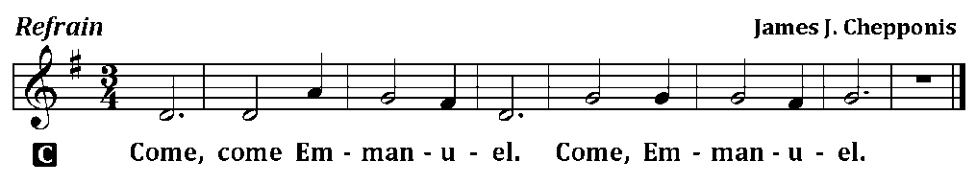
C (Sing Refrain 3x while the Pastor sings the first line of the Psalm: O Daughter of Zion, Behold!)
P Daughter of Zion, Behold,
C Surely your salvation is coming.
P The Lord will cause His glorious voice to be heard,
C And you shall have gladness of heart.
P Give ear, O Shepherd of Israel, You who lead Jacob like a flock.
C Restore us, O God; cause Your face to shine, and we shall be saved!
P Return, we beseech You, O God of Hosts,
C Look down from heaven and see.
P Let Your hand be upon the Man of Your right hand,
C Upon the Son of Man whom You made strong for Yourself.
C Glory be to the Father and to the Son and to the Holy Ghost; as it was in the beginning, is now, and ever shall be, world without end. Amen.
C (Sing Refrain 2x)
The service continues with The Kyrie on p.17, followed by the Salutation & Collect.
After the Epistle follows the Gradual & Hallelujah (next page).

THE GRADUAL & HALLELUJAH (after the Epistle) Ps. 50:2-3,5; Lk. 21:26c-27
P Out of Zion, the perfec- | tion of beauty,
God will shine forth: | Our God shall come. __
Gather My saints toge- | ther unto Me,
Those who have made a covenant with Me | by sacrifice. __
C Alleluia. Alleluia. The powers of heaven | will be shaken.
Then they will see the Son of Man coming in a cloud with power and great glory. | Alleluia. __
The service continues with The Triple Hallelujah and The Gospel, p. 20-21.

God’s Word at Home

Bible Reading: Zechariah 4 – Malachi 3

Small Catechism: Lord’s Prayer, Third Petition, Part 2
How is this done?
When God breaks and hinders every evil plan and will—like the will of the devil, the world and our flesh—that would keep us from hallowing God’s name and prevent His kingdom from coming; and when He strengthens and keeps us steadfast in His Word and faith, until the end. This is His good and gracious will.

Bible Passages:
Philippians 2:8-11 And being found in appearance as a man, He humbled Himself and became obedient to the point of death, even the death of the cross. Therefore God also has highly exalted Him and given Him the name which is above every name, that at the name of Jesus every knee should bow, of those in heaven, and of those on earth, and of those under the earth, and that every tongue should confess that Jesus Christ is Lord, to the glory of God the Father.

