Service Folder
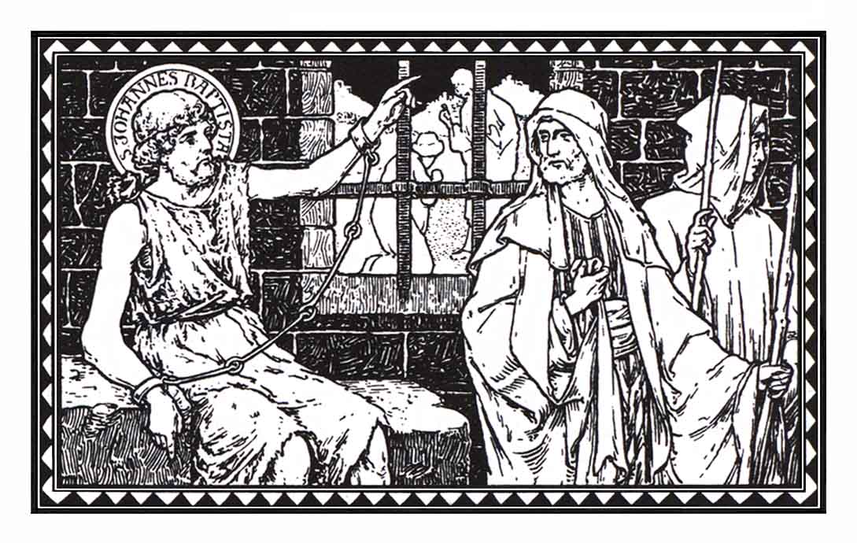
The Third Sunday in Advent
Gaudete – “Rejoice!”
December 16, 2018

Emmanuel Lutheran Church
4675 Bataan Memorial West
Las Cruces, New Mexico 88012
(575) 382-0220 (church office) / (575) 636-4988 (pastor cell)
www.GodWithUsLC.org

Sts. Peter & Paul Lutheran Mission
Silver City, New Mexico
www.peterandpaullutheran.org

Rev. Paul A. Rydecki, Pastor
member of the Evangelical Lutheran Diocese of North America (ELDoNA)

ANNOUNCEMENTS
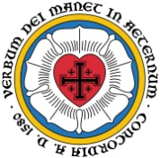
Welcome! Emmanuel is a liturgical, traditional, historical, evangelical, catholic, orthodox, confessional Lutheran congregation, in communion with the Evangelical Lutheran Diocese of North America (ELDoNA). We believe that the Bible is the very Word of God, inspired and without any errors. We confess the truth of Scripture according to the Lutheran Book of Concord of 1580, without exception or reservation. We observe the calendar of the traditional Church Year and follow the Historic Lectionary. We celebrate the Divine Service (also known as the Mass) every Sunday and on other festivals, and we welcome visitors to hear God’s Word with us.
With regard to Holy Communion, we ask our visitors to respect our practice of closed Communion, which means that only communicant members of our congregation or of other congregations in communion with us are invited to commune at the Lord’s Table here, after they have been examined and absolved. Classes are offered throughout the year by the pastor so that those who are interested in joining our Communion fellowship have the opportunity to learn about the Christian faith and our confession of it.
The Order of Service is The Order of Holy Communion (page 15) from The Lutheran Hymnal (TLH). The Scriptures are read from the New King James Version (NKJV). The Propers (the parts that change from week to week) are noted on the following page of this Service Folder.
Note: The Gloria in Excelsis is omitted during the Advent season.

EVENTS IN THE NEAR FUTURE…
Wed., Dec. 19 - Advent Supper, 5:30 PM
- Advent Vespers, 6:15 PM
Sun., Dec. 23 - Bible Class/Sunday School, 9AM
- Divine Service, 10:15 AM (Advent 4)
Mon., Dec. 24 - Christmas Eve Vespers, 6 PM
Tues., Dec. 25 - Christmas Day Divine Service, 10:15 AM
Sun., Dec. 30 - No Sunday School or Bible Class
- Divine Service, 10:15 AM (Sunday after Christmas)
Tues., Jan. 1 - Matins for the Circumcision of Our Lord, 10:15 AM
Sun., Jan. 6 - No Sunday School, Bible Class, or Service
Tues., Jan. 8 - Divine Service, 6 PM (Epiphany, observed)

PROPERS Advent 3

OPENING HYMN TLH #62 - Oh Come Oh Come Emmanuel
HYMN (after the Creed) God’s Only Son, Our Savior (back page)
HYMN (after General Prayer) TLH #65 - When Sinners See Their Lost Condition
DISTRIBUTION HYMNS TLH #75 - Ye Sons of Men, Oh, Hearken
TLH #66 - Hark the Glad Sound! The Savior Comes

Epistle: 1 Corinthians 4:1-5 Gospel: Matthew 11:2-10

The Order of Holy Communion begins on p. 15 of The Lutheran Hymnal.
INTROIT Phil. 4:4-5; Ps. 85:1,2,6,8
After the Refrain is introduced one time (1x) by the organ/guitar, all join to sing it three times (3x). The Psalm verses and Gloria Patri are spoken while the music plays softly in the background. Then the Refrain is sung by all twice (2x) more.
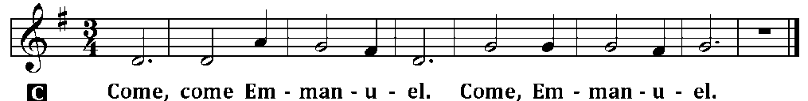

C (Sing Refrain 3x while the Pastor sings the first line of the Psalm: Rejoice, rejoice in the Lord!)
P Rejoice in the Lord always. Again I will say, rejoice!
C Let your gentleness be known to all men. The Lord is at hand.
P Be anxious for nothing, but in everything by prayer and supplication, with thanksgiving,
C let your requests be made known to God;
P LORD, You have been favorable to Your land;
C You have brought back the captivity of Jacob.
P You have forgiven the iniquity of Your people;
C You have covered all their sin.
P Will You not revive us again,
C that Your people may rejoice in You?
P I will hear what God the Lord will speak,
C for He will speak peace to His people.
C Glory be to the Father and to the Son and to the Holy Ghost;
as it was in the beginning, is now, and ever shall be, world without end. Amen.
C (Sing Refrain 2x)
The service continues with The Kyrie on p.17, followed by the Salutation & Collect.
THE GRADUAL & HALLELUJAH (after the Epistle) Ps. 80:1b, 2b, 1a; 80:2b

P You who dwell between the cher- | ubim, shine forth! * Stir up | Your strength and come! __
Give ear, O Shepherd | of Israel, * You who lead Jo- | seph like a flock. __
C Alleluia. Alleluia. | Stir up Your strength,
and come and save us! | Alleluia. __
The service continues with The Triple Hallelujah and The Gospel, p. 20-21.

